

DEPARTMENT OF MANAGEMENT STUDIES
WORKSHOP REPORT

TITLE: ART OF ACHIEVING YOUR DREAMS

PROGRAM DETAILS
Date: 16.02.2026
Time: 10.00 AM to 2.30 PM
Venue: Chamber 3, JEC

EVENT POSTER
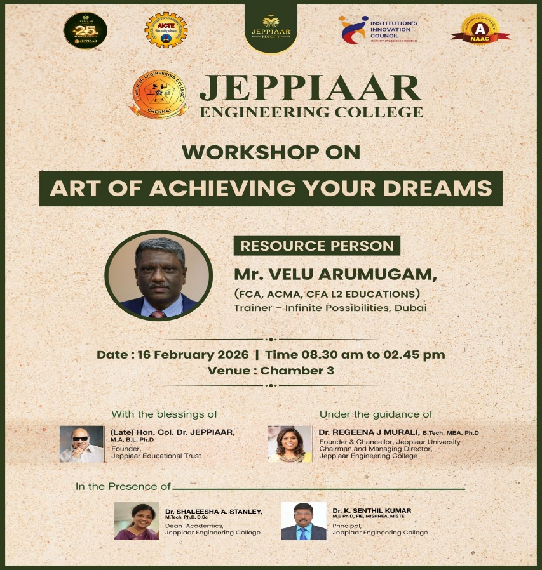

SPEAKER PROFILE
NAME | Mr.Velu Arumugam
DESIGNATION | Trainer - Infinite Possibilities
ORGANIZATION | Infinite Possibilities, Dubai

CONTENT
The Department of Management Studies, Jeppiaar Engineering College, organized a workshop titled “Art of Achieving Your Dreams” on 16th February 2026 for the first-year MBA students. The session was conducted by Velu Arumugam, an experienced trainer in motivation and personal development.
The programme commenced with Tamil Thai Vazhthu as a mark of respect to cultural tradition, followed by the introduction of the resource person. The session was then handed over to the speaker, who began by sharing insights on the importance of having clear goals and a strong vision to achieve success.
During the workshop, the speaker emphasized that achieving dreams requires clarity, determination, and consistent effort. He highlighted the importance of self-belief, positive thinking, patience, and perseverance in overcoming challenges. He also explained how proper planning, time management, and continuous learning contribute to both personal and professional growth.
A key focus of the session was the role of a positive mindset. The speaker explained that optimism improves mental well-being, enhances decision-making, and helps individuals handle stress effectively. Students were encouraged to focus on solutions rather than problems and to take consistent action toward their goals.

Workshop Activities
As part of the session, the speaker conducted practical activities to enhance self-awareness and goal clarity. Students were given a six-page self-analysis worksheet to reflect on their strengths, weaknesses, aspirations, and future goals. Additionally, students were instructed to create a vision board using charts, printed images, and creative cut-outs. This activity helped students visually represent their dreams and plan actionable steps toward achieving them.
The workshop was highly interactive and engaging, with active student participation throughout the session. These activities enabled students to connect theoretical concepts with personal application, making the session more impactful.
PHOTOS OF THE EVENT

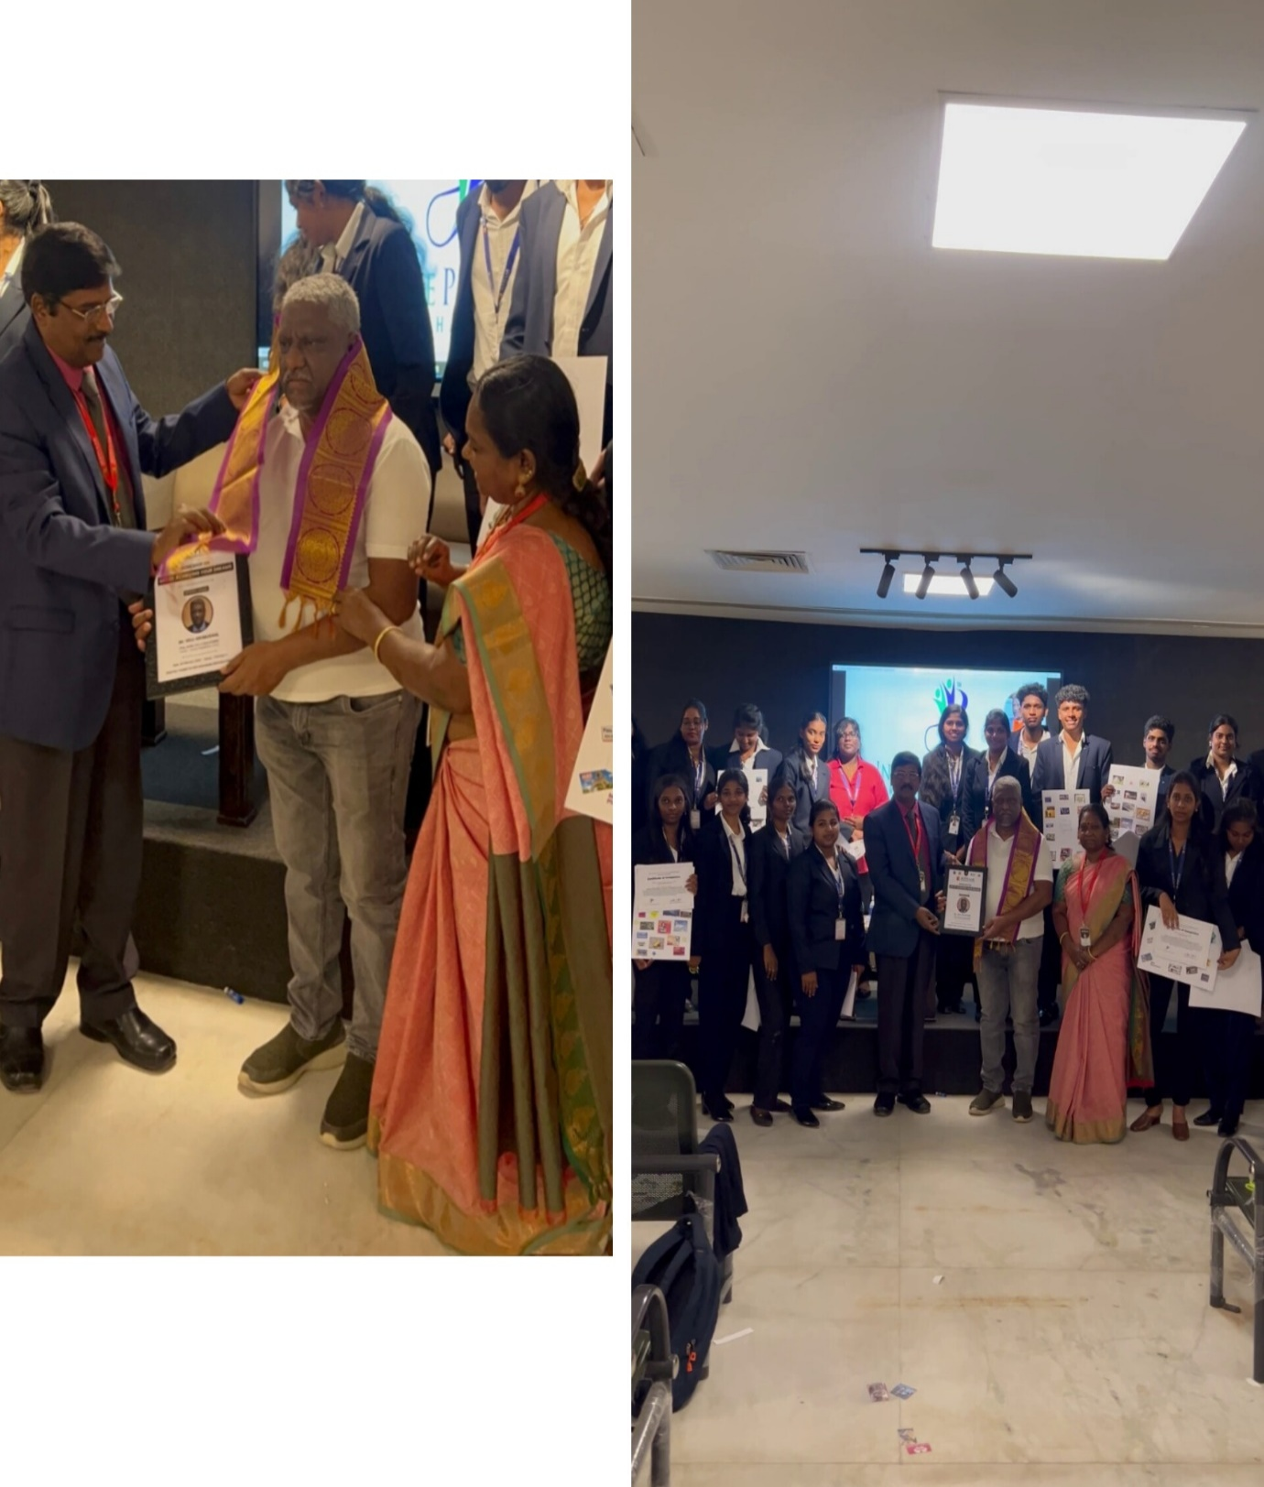

OUTCOME OF THE ACTIVITY
The workshop enabled students to develop a clear understanding of goal setting and the importance of self-belief in achieving success. Through the self-analysis activity, students gained deeper insight into their strengths, weaknesses, and personal aspirations. The vision board exercise helped them translate their dreams into visual and actionable goals, enhancing clarity and focus. The session also improved their positive thinking, motivation, and resilience to face challenges. Overall, the workshop strengthened students’ confidence, planning ability, and commitment toward achieving both personal and professional goals.

