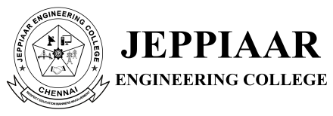

DEPARTMENT OF MANAGEMENT STUDIES
WORKSHOP REPORT

TITLE: HR INSIGHTS SERIES

PROGRAM DETAILS
Date: 04.02.2026
Time: 10.00 AM to 2.30 PM
Venue: TedX Hall, JEC

EVENT POSTER
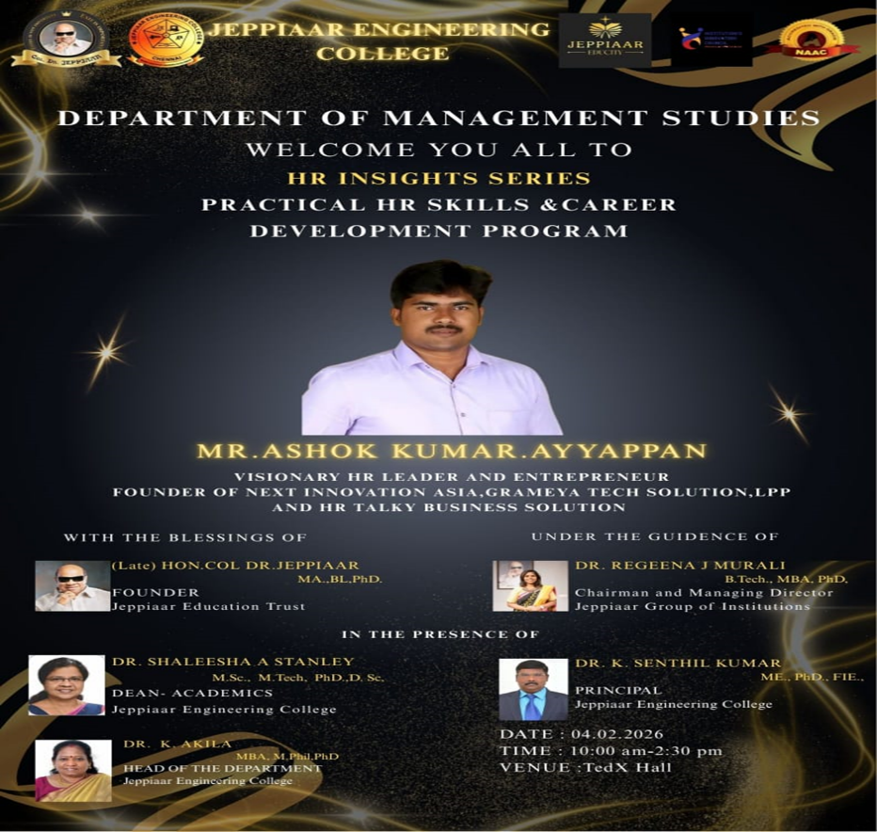

SPEAKER PROFILE
NAME | Mr.Ashok Kumar.Ayyappan
DESIGNATION | Visionary HR Leader & Entrepreneur
ORGANIZATION | HR TALKY Business Solutions and Next Innovation Asia

CONTENT
A workshop titled “HR Insights Series” was organized by the Department of Management Studies, Jeppiaar Engineering College, on 4th February 2026 at the Tedx Hall for first-year MBA students. The session was delivered by Mr.Ashok Kumar Ayyappan.
The programme began with Tamil Thai Vazhthu, followed by the felicitation of the guest. The speaker shared his professional journey and provided practical insights into key HR concepts such as labour laws, employee engagement, compensation, promotions, rewards, standard operating procedures, and work-life balance. He also highlighted modern HR trends including digital transformation, HR analytics, and employee-centric practices.
The interactive session enhanced students’ understanding of real-world HR practices and industry expectations. It contributed to the development of management knowledge, analytical and decision-making skills, communication, leadership, professional ethics, and digital competency.
Overall, the workshop was informative and engaging, helping students bridge the gap between theoretical learning and corporate requirements.

PHOTOS OF THE EVENT
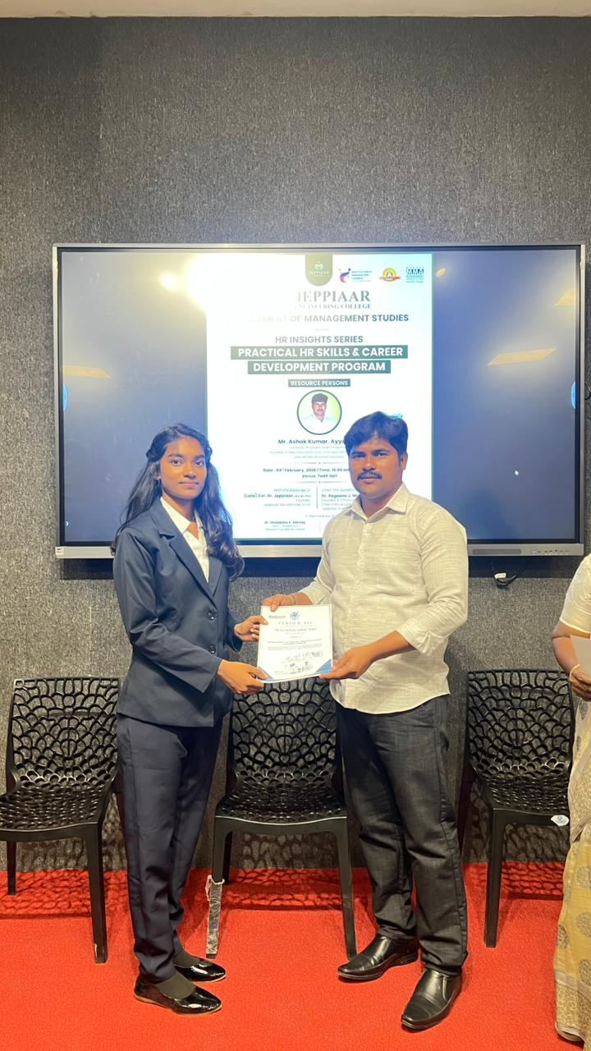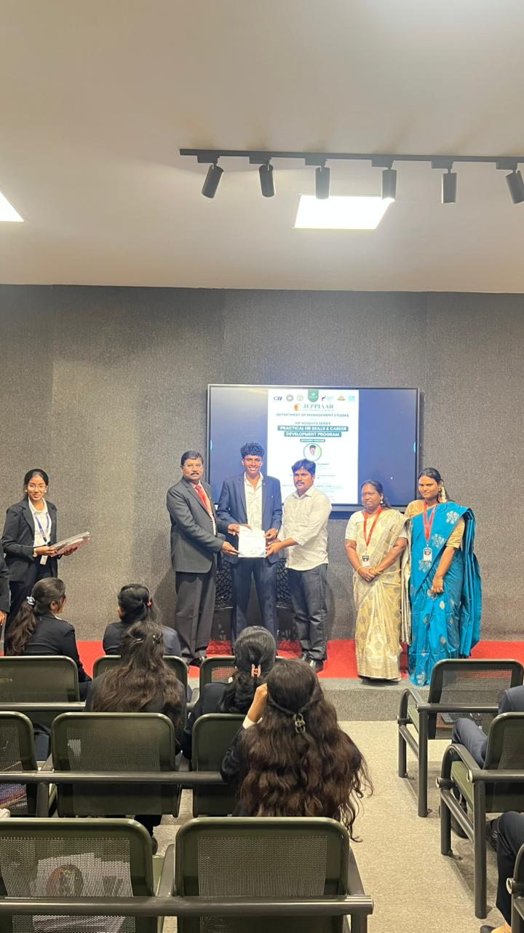
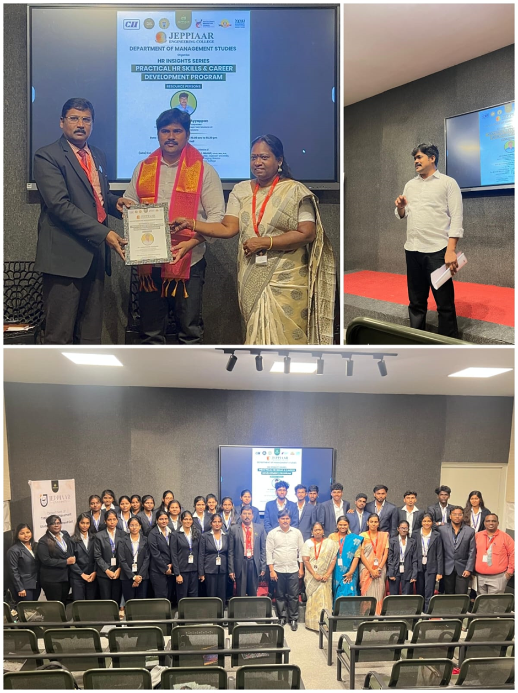

OUTCOME OF THE ACTIVITY
The workshop enabled students to gain a practical understanding of key Human Resource Management concepts such as labour laws, employee engagement, compensation management, and workplace practices. It enhanced their awareness of real-world HR functions and current industry expectations, while also improving their analytical thinking and problem-solving abilities. The interactive nature of the session strengthened their communication and interpersonal skills, and provided exposure to modern HR trends, including digital tools and analytics. Overall, the workshop helped students develop leadership qualities, professional attitude, and confidence, preparing them to adapt effectively to corporate environments and pursue careers in the HR domain.

