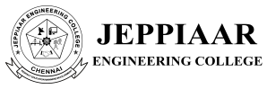

DEPARTMENT OF MANAGEMENT STUDIES
INDUSTRIAL VISIT REPORT
Academic Year 2025-2026

SI.NO | DATE | BATCH | COMPANY NAME & PLACE
1 | 27.10.2025 | 2024-2026 | Vidiem Sirungundram
2 | 01.12.2025 | 2025-2027 | Vidiem Sirungundram
3 | 03.02.2026 | 2025-2027 | Aavin Diary, Sholinganallur, Chennai.
4 | 05.02.2026 | 2025-2027 | The New Indian Express, Ambattur,  Chennai.

DATE: | 27.10.2025
PLACE VISITED: | VIDIEM , SIRUNGUNDRAM
MBA | II Year (Batch 2024-2026)

ABOUT INDUSTRIAL VISIT
The MBA Department organized an Industrial Visit to VIDIEM (Maya Appliances), Sirunkundram, on 10th October 2025 for the II Year MBA students. VIDIEM (Maya Appliances) is a well-known manufacturing unit involved in producing high-quality kitchen appliances. The company emphasizes innovation, quality assurance, operational efficiency, and customer satisfaction. The facility at Sirunkundram is equipped with modern machinery and follows standardized production and safety practices.The visit was planned with the objective of bridging the gap between theoretical knowledge and practical industrial exposure. Upon arrival, the students were welcomed by the industry representatives, followed by an introductory session explaining the company’s background, vision, mission, and product portfolio.
The visit included:
- A detailed explanation of the manufacturing process
- Demonstration of assembly lines and production flow
- Insights into quality control and testing procedures
- Explanation of inventory management and supply chain practices
- Discussion on human resource management, safety measures, and workplace discipline
Students actively interacted with industry officials and clarified their doubts regarding production, management strategies, and career opportunities in the manufacturing sector.

LIST OF STUDENTS ATTENDED
SL. No. | STUDENT NAME
 | ABINISHA B
 | AROCKIA JOYSEE I
 | ATCHAY G
 | BASTIN RAJA M
 | BIBIN SONI T
 | DEEPUMON.SK
 | DIVYADHARSHINI
 | DURGA T
 | GAYATHRI E
 | HARIKRISHNAN V
 | JEFRIN JENISH.J
 | JERARD.P
 | KATVIN A
 | SEENUMON
 | KISHORE M
 | LAVANYA R
 | MARIA SABITHA RAJ S
 | MOHANA SUNDARAM A
 | MRUDHULLA R
 | PAVITHRA G
 | PRABAKARAN D
 | SATHYA
 | PRAKASH RAJ. M
 | PRIYADHARSHINI S
 | RAJKUMAR S
 | RAMITHA M
 | SARAVANAN C
 | RANJTHKUMAR K
 | SHARMILA N
 | SENTAMIZH SELVI
 | SHEIK IMAM S
 | SHERMI JOSIL.J
 | SIVA
 | THIRIPURA SUNDHARI R
 | VISHWA.E

INDUSTRIAL VISIT APPROVAL PROOF

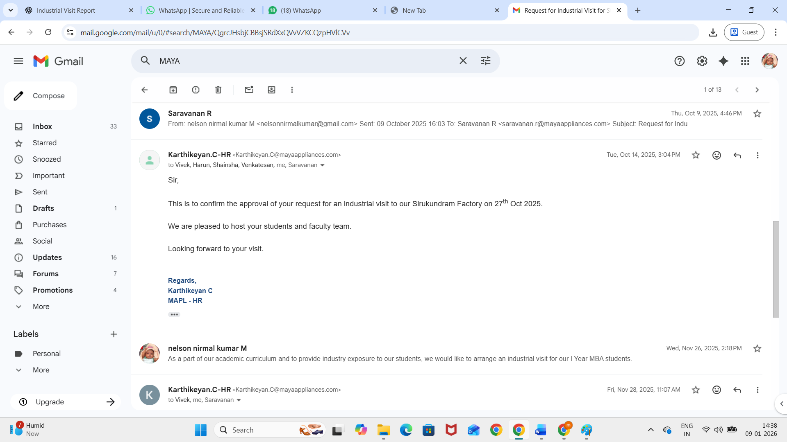

INDUSTRIAL VISIT PHOTOS

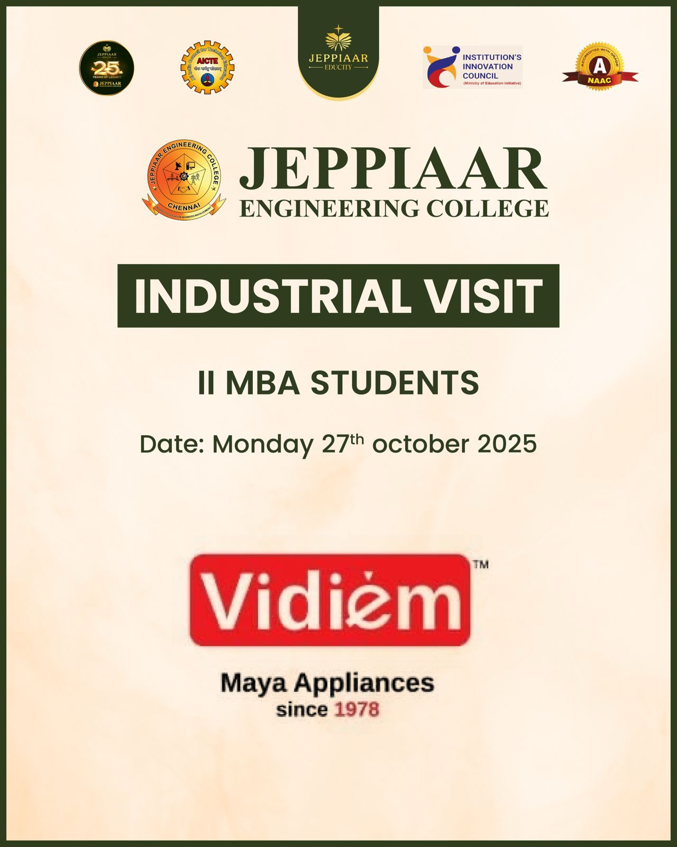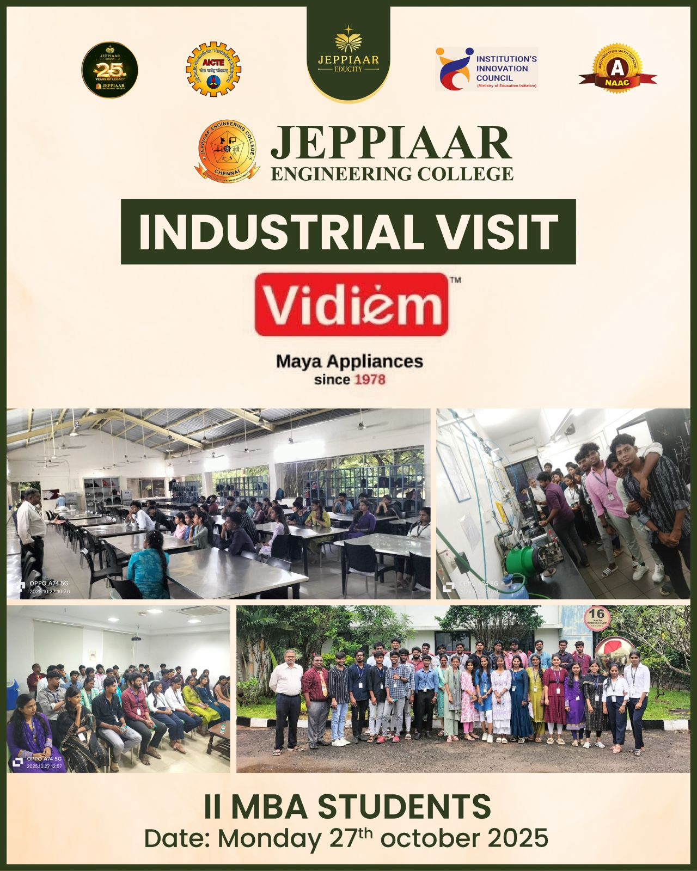
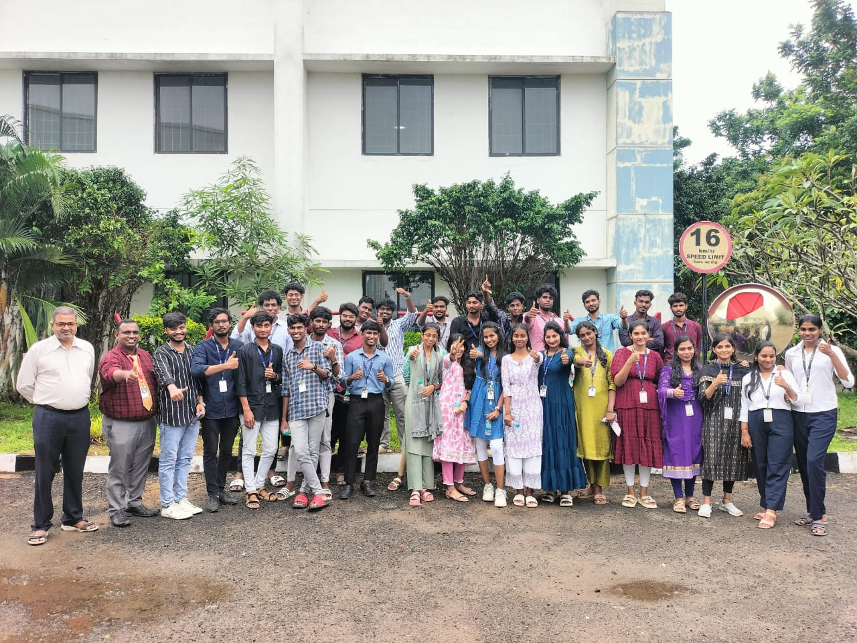

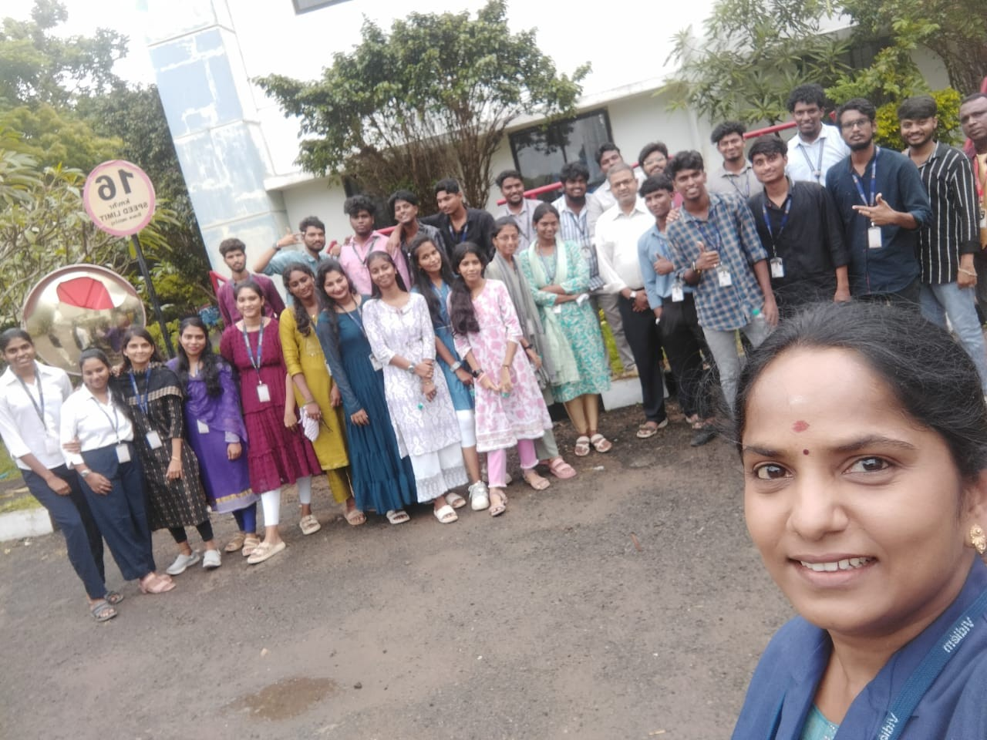

OUTCOME :

S.No | Outcome | PO
1 | Students were able to understand business practices of a manufacturing company. | PO 1
2 | Students observed and listened to managerial issues in the manufacturing company. | PO2
3 | Students had a chance to interact with employees and coordinators of Maya appliances | PO3
4 | The practical exposure to manufacturing unit operation might enhance the students ability to take up challenging assignments | PO6

DATE: | 01.12.2025
PLACE VISITED: | VIDIEM , SIRUNGUNDRAM
MBA | I Year (Batch 2025-2027)

ABOUT INDUSTRIAL VISIT
The MBA Department organized an Industrial Visit to VIDIEM (Maya Appliances), Sirunkundram, on 10th October 2025 for the I Year MBA students. VIDIEM (Maya Appliances) is a well-known manufacturing unit involved in producing high-quality kitchen appliances. The company emphasizes innovation, quality assurance, operational efficiency, and customer satisfaction. The facility at Sirunkundram is equipped with modern machinery and follows standardized production and safety practices.The visit was planned with the objective of bridging the gap between theoretical knowledge and practical industrial exposure. Upon arrival, the students were welcomed by the industry representatives, followed by an introductory session explaining the company’s background, vision, mission, and product portfolio.

The visit included:
- A detailed explanation of the manufacturing process
- Demonstration of assembly lines and production flow
- Insights into quality control and testing procedures
- Explanation of inventory management and supply chain practices
- Discussion on human resource management, safety measures, and workplace discipline
Students actively interacted with industry officials and clarified their doubts regarding production, management strategies, and career opportunities in the manufacturing sector.

LIST OF STUDENTS ATTENDED

SL.NO | REGISTER NUMBER | STUDENT NAME
1 | 310825631001 | ABISHEK R
2 | 310825631003 | ANAND A
3 | 310825631004 | ARAVIND A
4 | 310825631005 | ARUNA DEVI T
5 | 310825631006 | GUHAN S
6 | 310825631007 | HARISH ANTONY J
7 | 310825631008 | HEMAMALUINI S
8 | 310825631009 | JOSPHIN DENOSA J
9 | 310825631010 | KRITHIKA R
10 | 310825631011 | LIBIYA J
11 | 310825631012 | MARY JOHNSILY M
12 | 310825631014 | MONISHA T
13 | 310825631015 | MOTHILAL G
14 | 310825631017 | PAVITHRA M
15 | 310825631018 | PRIYA V
16 | 310825631019 | PRIYADHARSHINI B
17 | 310825631020 | SABITHA R
18 | 310825631021 | SAKTHI ABINAYA M
19 | 310825631022 | SNEHA N
20 | 310825631023 | SURYA M
21 | 310825631024 | SWATHI R
22 | 310825631025 | SWATHI S
23 | 310825631026 | SWATHY A
24 | 310825631027 | THASHKROWN T
25 | 310825631028 | THIVYA R
26 | 310825631029 | VASANTHA S E
27 | 310825631030 | VIVEKA A
28 | 310825631031 | YUVANTHI R
29 | 310825631032 | YUVASRI A

INDUSTRIAL VISIT APPROVAL PROOF
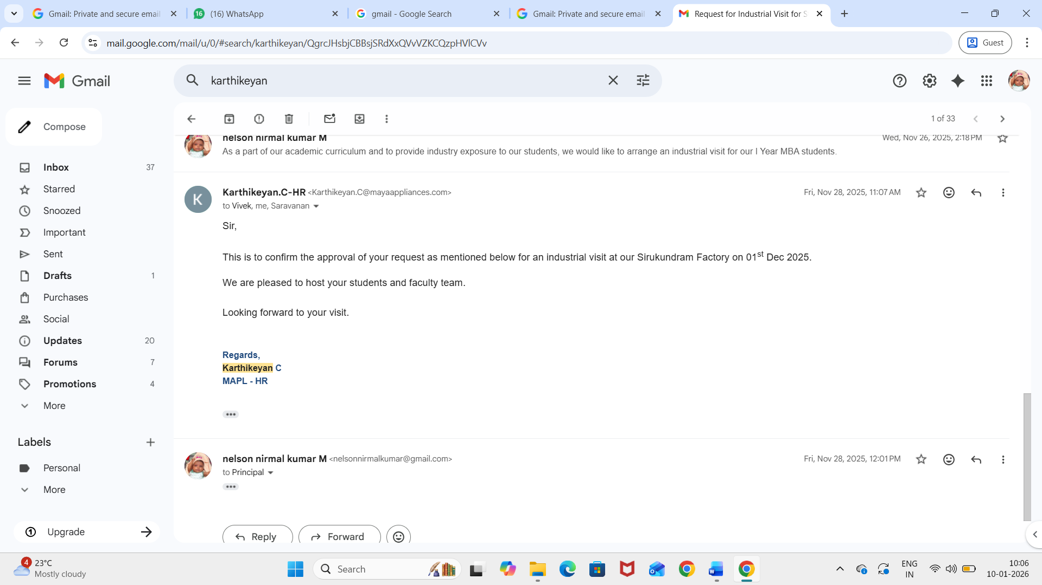

INDUSTRIAL VISIT PHOTOS

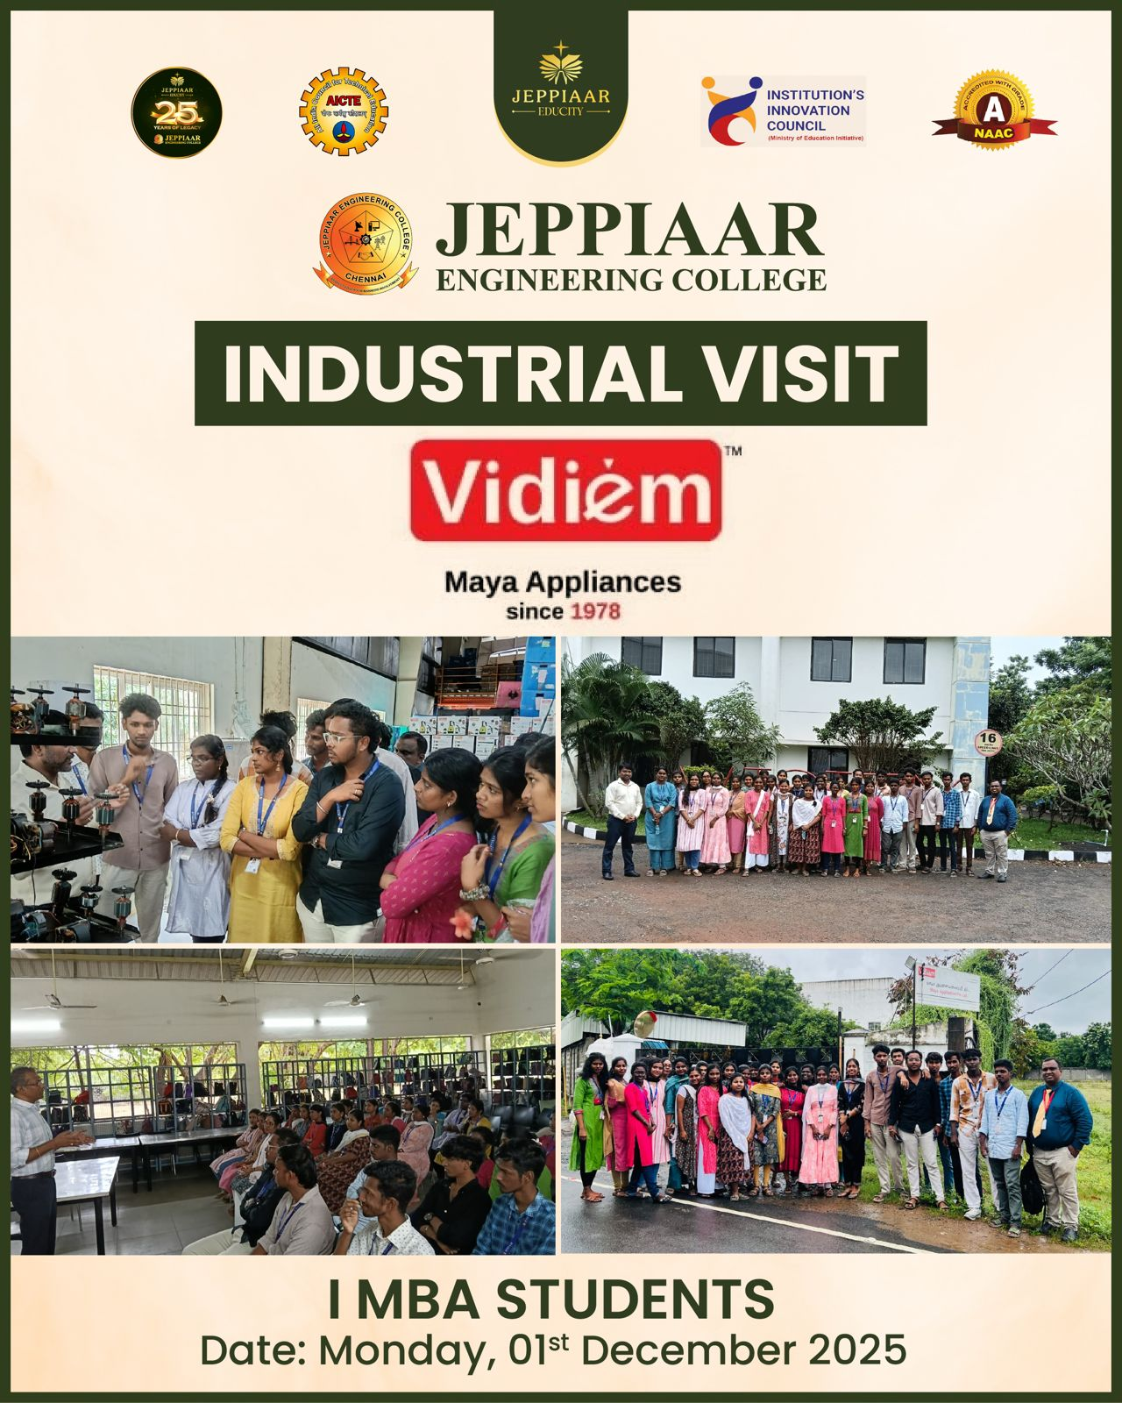

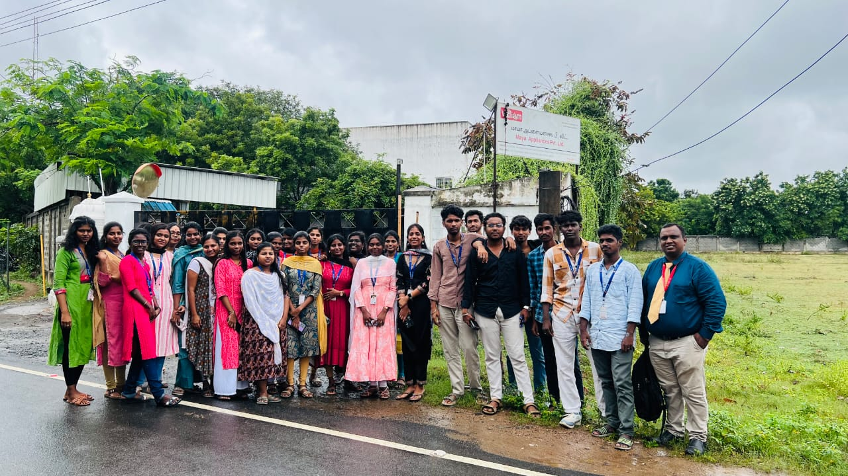

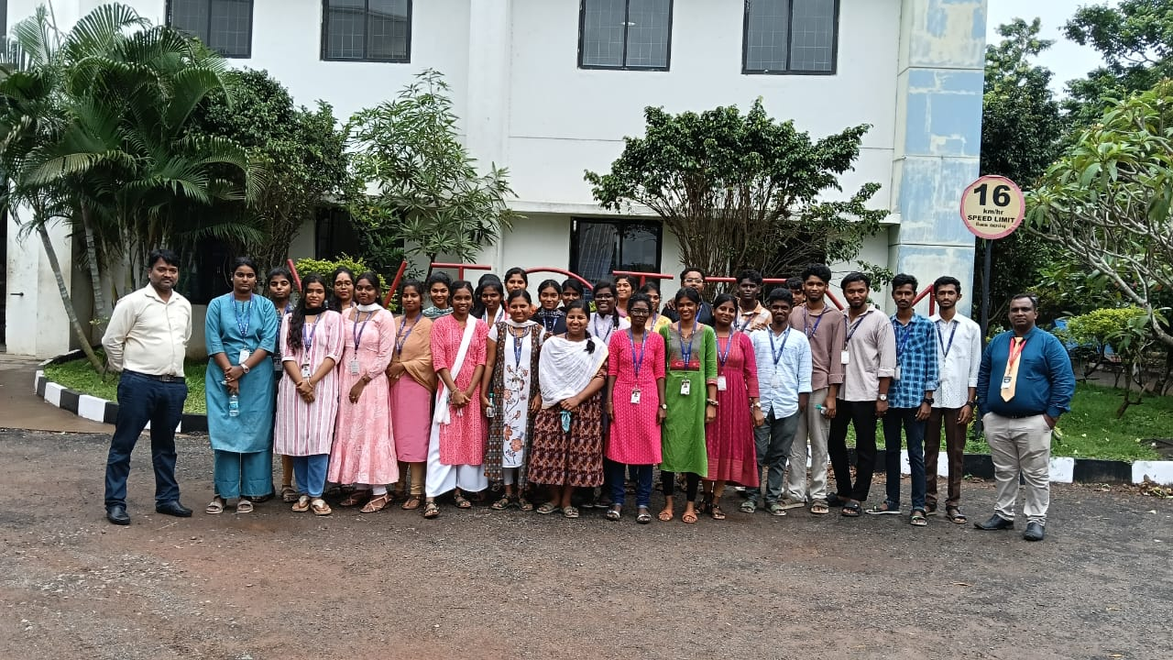

Outcome :

S.No | Outcome | PO
1 | Students were able to understand business practices of a manufacturing company. | PO 1
2 | Students observed and listened to managerial issues in the manufacturing company. | PO2
3 | Students had a chance to interact with employees and coordinators of Maya appliances | PO3
4 | The practical exposure to manufacturing unit operation might enhance the students ability to take up challenging assignments | PO6

DATE: | 03-02-2026
PLACE VISITED: | Aavin Diary, Sholinganallur, Chennai.
MBA | I Year (Batch 2025-2027)

ABOUT INDUSTRIAL VISIT
The MBA Department organized an Industrial Visit to Aavin Diary, Sholinganallur, Chennai, on 3rd February 2026 for the I Year MBA students. Aavin Dairy is a prominent government-operated dairy unit under the Tamil Nadu Cooperative Milk Producers' Federation Limited, widely recognized for producing and distributing hygienic and quality dairy products. The organization focuses on maintaining high standards in milk procurement, processing, packaging, and distribution while ensuring affordability and nutritional value for consumers.
The facility at Sholinganallur is equipped with advanced dairy processing machinery and adheres strictly to food safety regulations and quality assurance practices. The industrial visit was organized with the objective of providing students with practical exposure to dairy technology and bridging the gap between academic learning and real-world industrial operations.
Upon arrival, the students were received by the dairy officials and given a brief introductory session about the history, objectives, and operations of Aavin. The session also covered the cooperative structure, milk sourcing from rural farmers, and the role of Aavin in supporting the dairy industry in Tamil Nadu.
The visit included:
- A detailed explanation of milk procurement and processing stages
- Demonstration of pasteurization, homogenization, and packaging processes
- Insights into quality testing, including fat content and microbial analysis
- Explanation of cold storage, inventory management, and distribution systems
- Discussion on hygiene standards, safety measures, and workforce management
Students observed the systematic flow of operations, from raw milk collection to final product packaging, gaining valuable insight into large-scale dairy production. The emphasis on cleanliness, automation, and quality control highlighted the importance of maintaining strict standards in food processing industries.
The interactive session allowed students to engage with industry professionals, clarify their doubts regarding dairy technology, operational management, and explore career opportunities in the food processing and dairy sector. The visit proved to be highly informative and enhanced the students’ understanding of industrial practices in the dairy industry.
STUDENTS ATTENDANCE

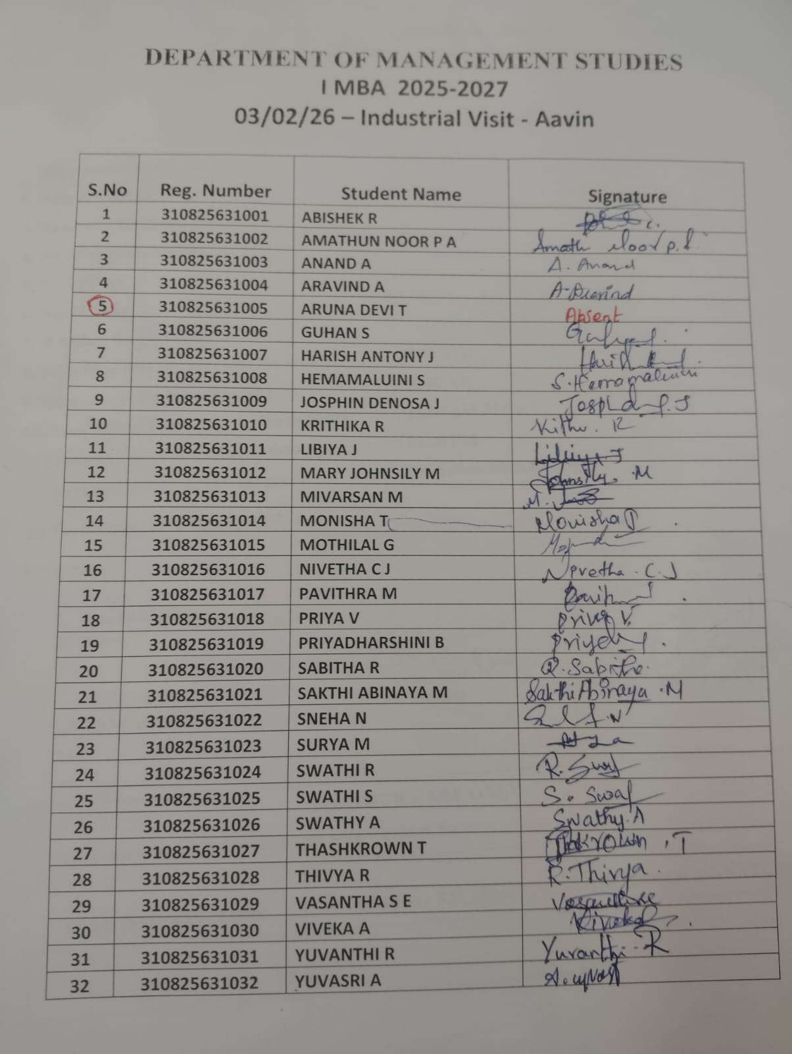

INDUSTRIAL VISIT PERMISSION LETTER

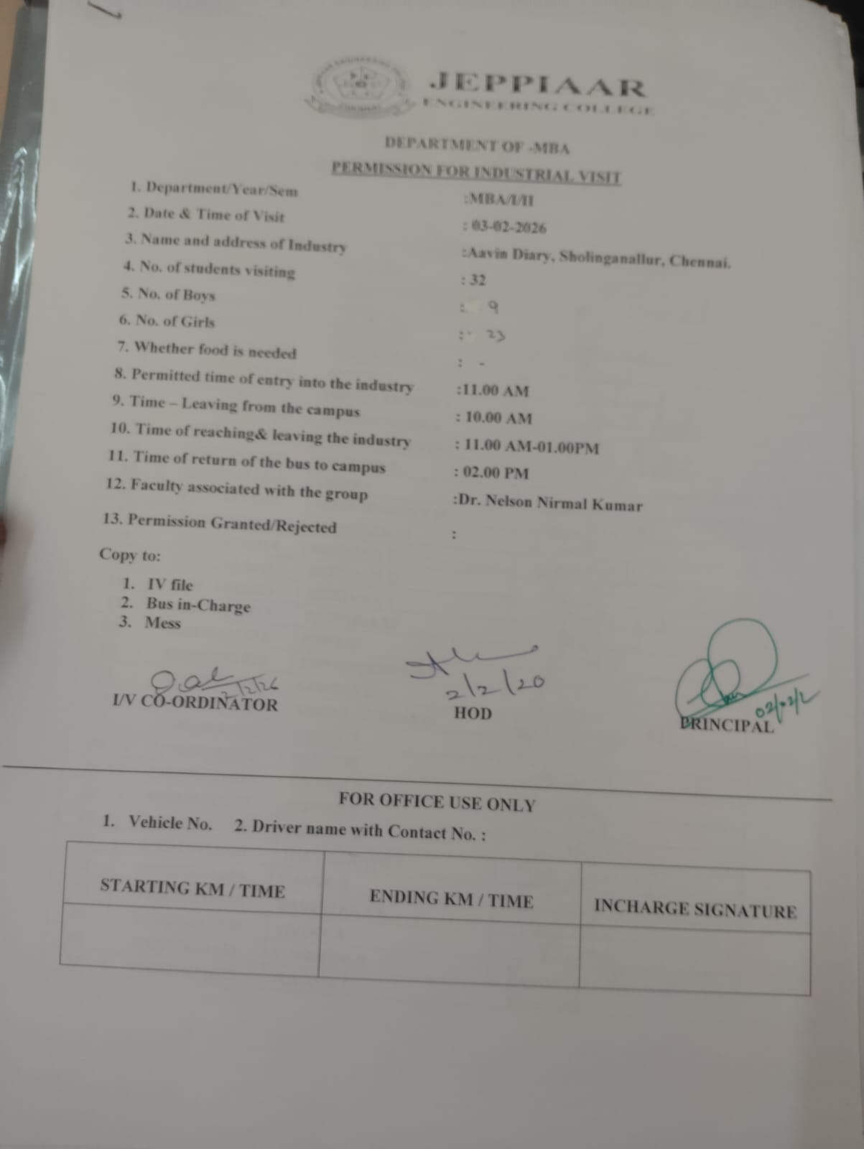

INDUSTRIAL VISIT PHOTOS

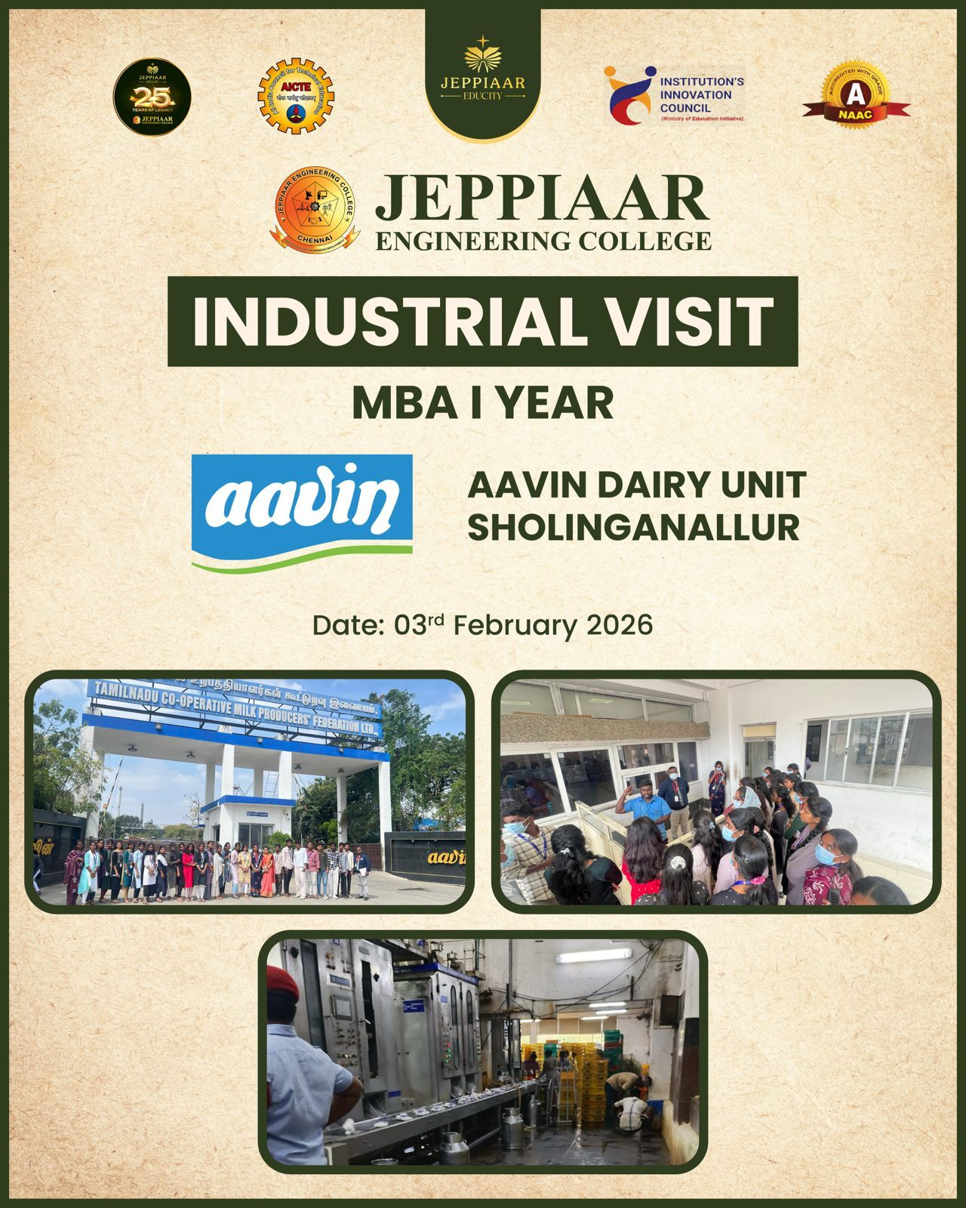

OUTCOME :

S.No | Outcome | PO
1 | Students gained practical knowledge of milk processing techniques such as pasteurization, homogenization, and packaging, enhancing their understanding of dairy technology. | PO 1
2 | The visit provided insights into quality control measures and food safety standards followed in large-scale dairy production. | PO2
3 | Students developed an understanding of supply chain management, including milk procurement, cold storage, and distribution systems. | PO3
4 | The interaction with industry professionals helped students explore career opportunities and understand workplace practices, discipline, and safety in the dairy industry. | PO6

DATE: | 05-02-2026
PLACE VISITED: | The New Indian Express, Ambattur, Chennai.
MBA | I Year (Batch 2025-2027)

ABOUT INDUSTRIAL VISIT
The MBA Department organized an Industrial Visit to The Indian Express, Ambattur, Chennai on 5th February 2026 for the I Year MBA students. The New Indian Express is a leading English-language daily newspaper known for its credible journalism, in-depth reporting, and wide readership across India. The organization focuses on delivering accurate news, maintaining editorial integrity, and adapting to modern digital media trends. The printing facility at Ambattur, Chennai, is equipped with advanced printing technology and follows efficient production and distribution practices.
The visit was organized with the objective of providing students with practical exposure to the media and printing industry, thereby bridging the gap between theoretical knowledge and real-world applications. Upon arrival, the students were welcomed by the staff and given an introductory session outlining the history, mission, and operations of the newspaper, along with insights into its editorial and publishing processes.
The visit included:
• A detailed explanation of the news production cycle, from reporting to editing
• Demonstration of printing processes using high-speed printing machines
• Insights into page layout, design, and digital publishing techniques
• Explanation of circulation, distribution, and supply chain management
• Discussion on editorial policies, ethical journalism, and workplace coordination
Students observed the functioning of large-scale printing presses and understood how newspapers are produced and distributed within tight deadlines. The emphasis on accuracy, time management, and coordination highlighted the dynamic nature of the media industry.
Students actively interacted with media professionals and clarified their doubts regarding journalism practices, printing technology, and career opportunities in the media and communication sector. The visit provided valuable insights and enhanced their understanding of the newspaper industry.
STUDENTS ATTENDANCE
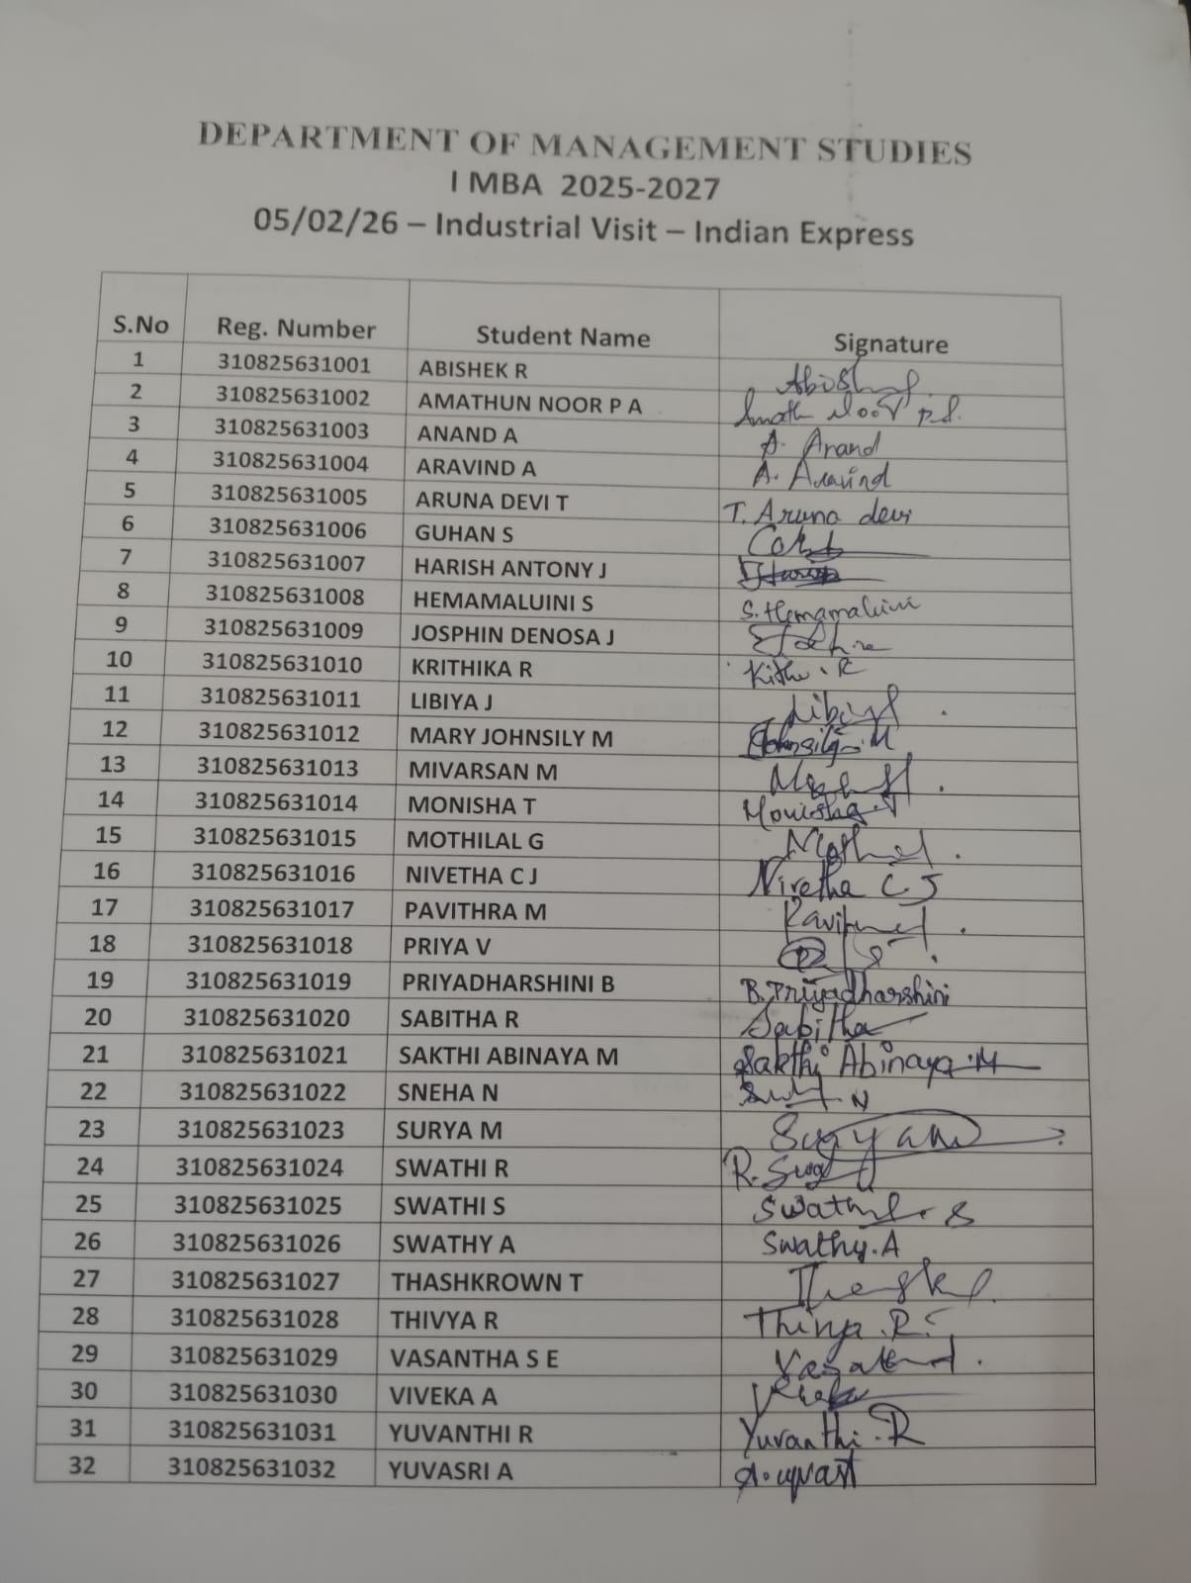

INDUSTRIAL VISIT PERMISSION LETTER

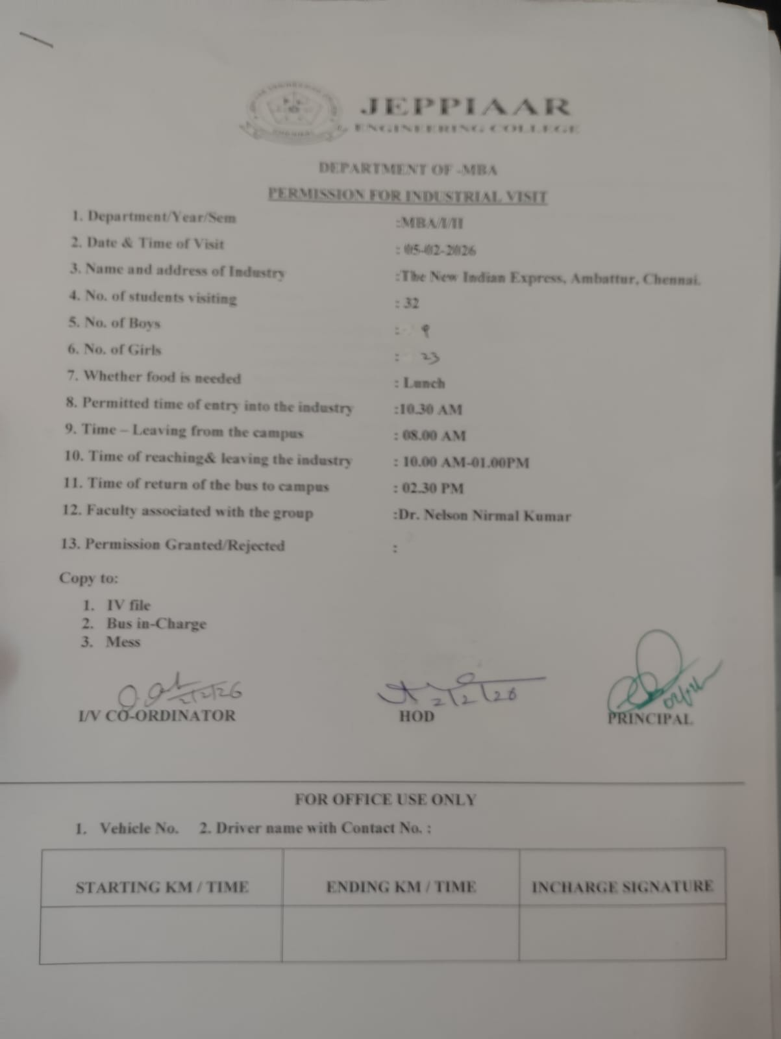

INDUSTRIAL VISIT PHOTOS

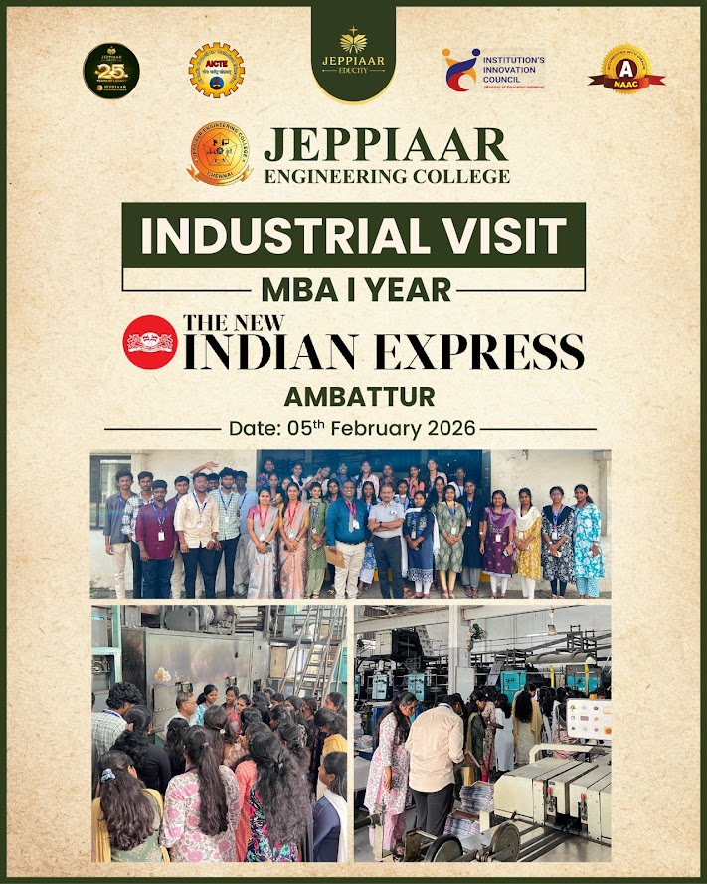

OUTCOME :

S.No | OUTCOME | PO
1 | Students gained a clear understanding of the newspaper production process, including reporting, editing, page design, and printing. | PO1
2 | The visit provided practical exposure to modern printing technologies and high-speed press operations used in the media industry. | PO2
3 | Students developed insights into circulation, distribution systems, and time management required for daily newspaper publishing. | PO3
4 | Interaction with professionals helped students understand ethical journalism practices and explore career opportunities in media and communication fields. | PO6

