

DEPARTMENT OF MANAGEMENT STUDIES

TITLE OF THE EVENT
Central Banking, Monetary Policy & The Future of the Money

DATE AND DURATION OF THE PROGRAM
Date: 28.01.2026
Time: 11.00 AM to 12.30 PM
Venue: Elite Seminar Hall

EVENT POSTER
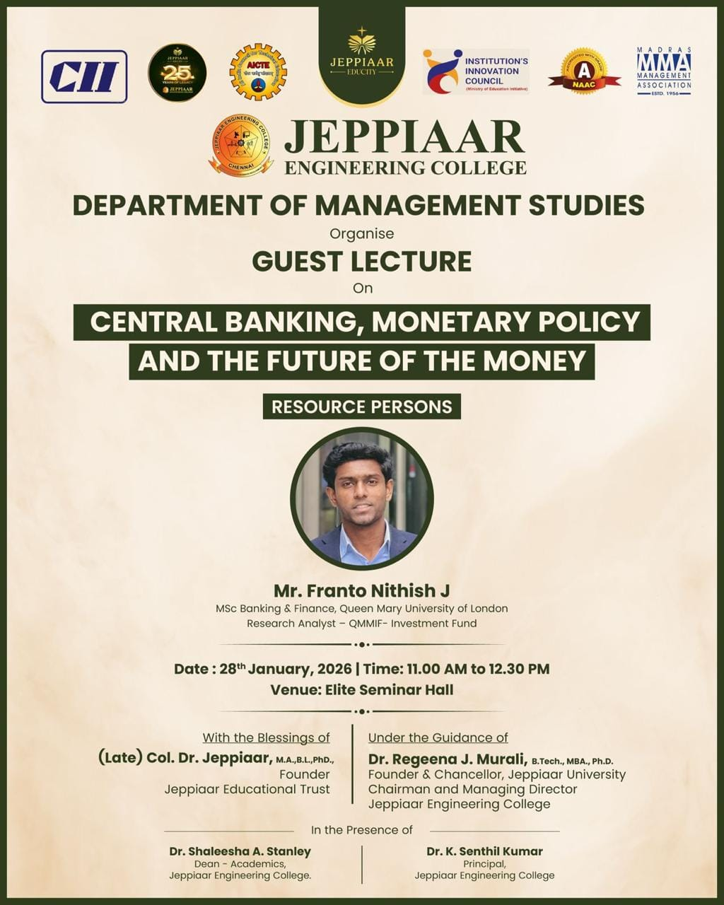

SPEAKER PROFILE
NAME | Mr.Franto Nithish J
DESIGNATION | Research Analyst-QMMIF-Investment Fund

DESCRIPTION
A guest lecture was organized by the Department of Management Studies, Jeppiaar Engineering College, on January 28, 2026, at the Elite Seminar Hall. The session was delivered by a Research Analyst from QMMIF and an MSc Banking & Finance graduate from Queen Mary University of London, who shared both academic and industry insights.
The lecture focused on the role of central banking and monetary policy, highlighting key functions such as controlling money supply, regulating interest rates, and managing inflation. Reference was made to the role of Reserve Bank of India in maintaining economic stability. Various monetary policy tools like repo rate, CRR, SLR, and open market operations were explained with real-world examples.
The speaker also discussed emerging trends such as digital payments, cryptocurrencies, and Central Bank Digital Currencies (CBDCs), emphasizing both opportunities and challenges in the evolving financial landscape.
Overall, the session provided valuable insights into modern banking practices, monetary policy, and future trends, enhancing students’ understanding of the financial sector and career opportunities.

PHOTOS OF THE EVENT
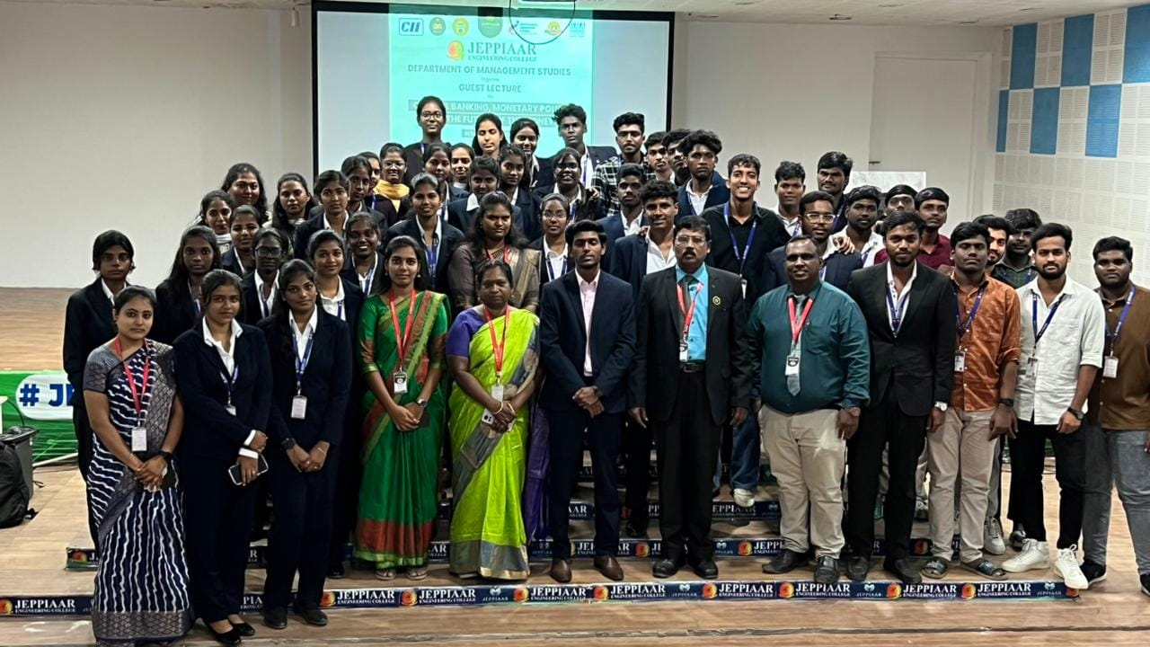
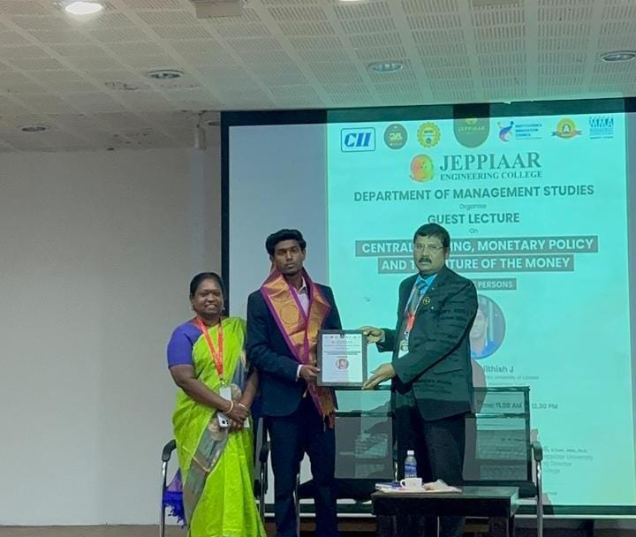

OUTCOME OF THE ACTIVITY

The guest speaker lecture on “Central Banking, Monetary Policy and the Future of Money” provided valuable insights to MBA students on financial governance and economic stability. Referring to the role of the Reserve Bank of India, the speaker explained how monetary tools influence inflation, growth, and liquidity. The session aligned with the program outcomes of the Anna University MBA Regulation syllabus by enhancing analytical ability, strategic thinking, and understanding of macroeconomic policies. Students gained knowledge about digital currencies, financial innovation, and policy decision-making, strengthening their managerial competence and readiness for roles in banking, finance, and corporate sectors.

