

DEPARTMENT OF MANAGEMENT STUDIES

TITLE OF THE EVENT
The Cognitive Power of Positivity

DATE AND DURATION OF THE PROGRAM
Date: 05.11.2025
Time: 10.00 AM to 12.00 PM
Venue: Chamber-4 JEC

EVENT POSTER


SPEAKER PROFILE
NAME | Dr.P.Caroline Jeba
DESIGNATION | Assistant Professor & COE
ORGANIZATION | Stella Matutina College of Education

DESCRIPTION
A guest lecture was organized by the Department of Management Studies, Jeppiaar Engineering College, on November 5, 2025, for MBA students. Caroline Jeba was invited as the Chief Guest to deliver a session on “The Cognitive Power of Positivity.”
The session began with Tamil Thai Vazhthu, followed by the felicitation of the guest. Dr. Jeba explained how positive thinking enhances cognitive functions such as decision-making, creativity, problem-solving, and stress management. She emphasized that positivity helps individuals develop resilience, emotional intelligence, and adaptability in both personal and professional life.

She also highlighted the role of positivity in leadership, teamwork, and workplace productivity, along with practical ways to cultivate a positive mindset through optimism, mindfulness, and self-reflection.Overall, the session was interactive and motivating, encouraging students to adopt positivity as a powerful tool for academic success, career growth, and overall well-being.

PHOTOS OF THE EVENT
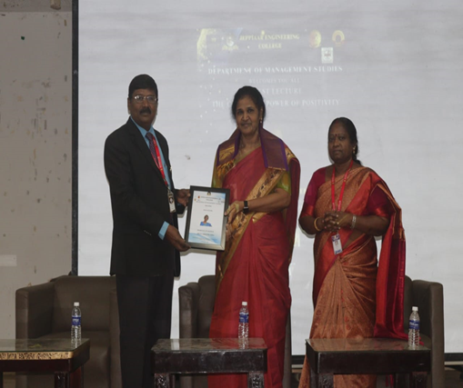

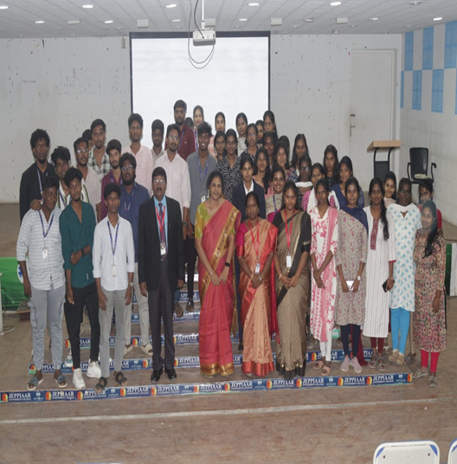

OUTCOME OF THE ACTIVITY

The guest speaker lecture on “The Cognitive Power of Positivity” inspired MBA students to understand how mindset influences leadership, decision-making, and professional growth. Addressing students under the Anna University MBA Regulation syllabus, the speaker emphasized that positive thinking enhances analytical ability, emotional intelligence, teamwork, and resilience—key program outcomes of the curriculum. The session highlighted how optimism strengthens problem-solving skills, strategic thinking, and adaptability in dynamic business environments. Students were encouraged to cultivate a growth mindset, practice constructive communication, and maintain ethical professionalism, thereby preparing themselves to lead confidently and perform effectively in corporate settings.

