
DEPARTMENT OF MANAGEMENT STUDIES

TITLE OF THE EVENT
How Power BI Skills Enhance Employability for MBA Graduates

DATE AND DURATION OF THE PROGRAM
Date: 25.09.2025
Time: 1.00 AM to 2.30 PM
Venue: Elite Seminar Hall, JEC

EVENT POSTER


SPEAKER PROFILE

NAME | Mr.Jesu Jeevian
DESIGNATION | Senior Power BI Developer
ORGANIZATION | IT Industry

DESCRIPTION
A guest lecture was organized by the Department of Management Studies on September 25, 2025, for UG first-year and MBA students. Jesu Jeevian was invited as the Chief Guest to deliver a session on “How Power BI Skills Enhance Employability for MBA Graduates.”
The event began with the Tamil Thai Vazhthu, followed by the felicitation of the guest by the Principal and Head of the Department. The speaker conducted an engaging PPT and demo session on Microsoft Power BI.
He highlighted the importance of data analytics in today’s business world and explained how Power BI helps MBA students apply theoretical knowledge in areas like finance, marketing, and HR through dashboards and reports. He emphasized that Power BI improves decision-making, communication, and problem-solving skills, making students industry-ready.
The session also focused on career opportunities, digital adaptability, and the role of analytics in entrepreneurship. Overall, the lecture conveyed that Power BI is a valuable skill that enhances employability and enables MBA graduates to make data-driven business decisions.

PHOTOS OF THE EVENT
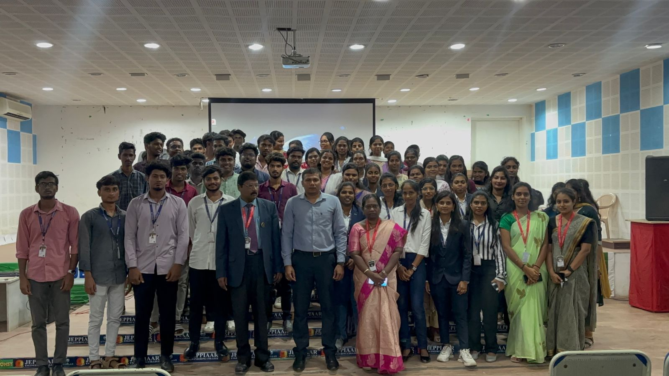
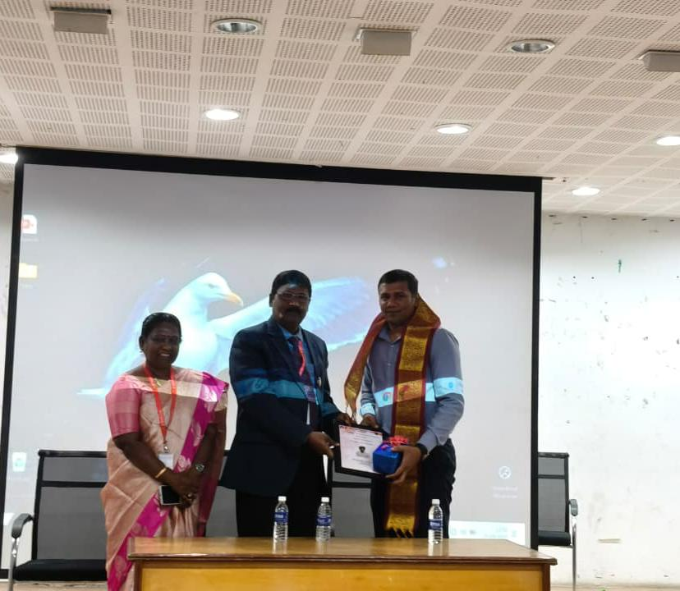

OUTCOME OF THE ACTIVITY
The session on Microsoft Power BI gave MBA students practical exposure to data analytics and business intelligence. It showed how raw data can be converted into dashboards for better decision-making.The session improved students’ analytical thinking, problem-solving, and digital skills, enhancing their employability. By linking theory with real-time data visualization, it helped them gain industry-relevant knowledge.Overall, it encouraged innovation, strategic thinking, and adaptability, preparing students for modern corporate demands.

