
DEPARTMENT OF MANAGEMENT STUDIES
TITLE OF THE EVENT
A Celebrity Talk: Vision to Venture

DATE AND DURATION OF THE PROGRAM
Date: 22.09.2025
Time: 11.30 AM to 12.30 PM
Venue: Col.Dr.Jeppiaar Auditorium

EVENT POSTER
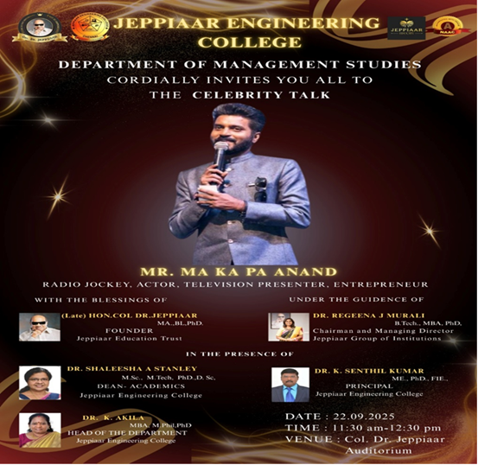

SPEAKER PROFILE

NAME | Mr. Ma Ka Pa ANAND
DESIGNATION | Radio Jockey, Actor, Television Presenter,  Entrepreneur
ORGANIZATION | Media & Film Industry

DESCRIPTION
A guest lecture was organized by the Department of Management Studies on September 22, 2025, for UG first-year and MBA students. Ma Ka Pa Anand was invited as the Chief Guest to speak on the topic “Celebrity Talk.”

He was honored with a memento and shawl by the Dean and Principal. Beginning his session in his usual engaging style, he interacted with the audience and introduced his mobile application, Flykup. He explained its concept, purpose, and how it connects users through digital engagement.

Mr. Anand shared insights into his entrepreneurial journey, highlighting opportunity recognition, innovation, and the role of technology in building digital products. He also discussed challenges like competition, user acquisition, and maintaining consistency.He emphasized the importance of branding, teamwork, and perseverance, and encouraged students to explore entrepreneurship, leverage digital platforms, and develop strong problem-solving skills to succeed in today’s business environment.

ORGANIZING TEAM
MC | Ms.Ramitha
GUEST PROFILE | Ms.Joyice Roshini
VOTE OF THANKS | Ms.Joyice Roshini
REFRESHMENT AND MEMENTO | Mr.Prakash & Mr.Balaji
HOSPITALITY TEAM | Ms.Gayathri
PHOTOGRAPHY TEAM | Mr.Seenumon
TECHNICAL TEAM | Mr.Saravanan.C
PHOTOS OF THE EVENT
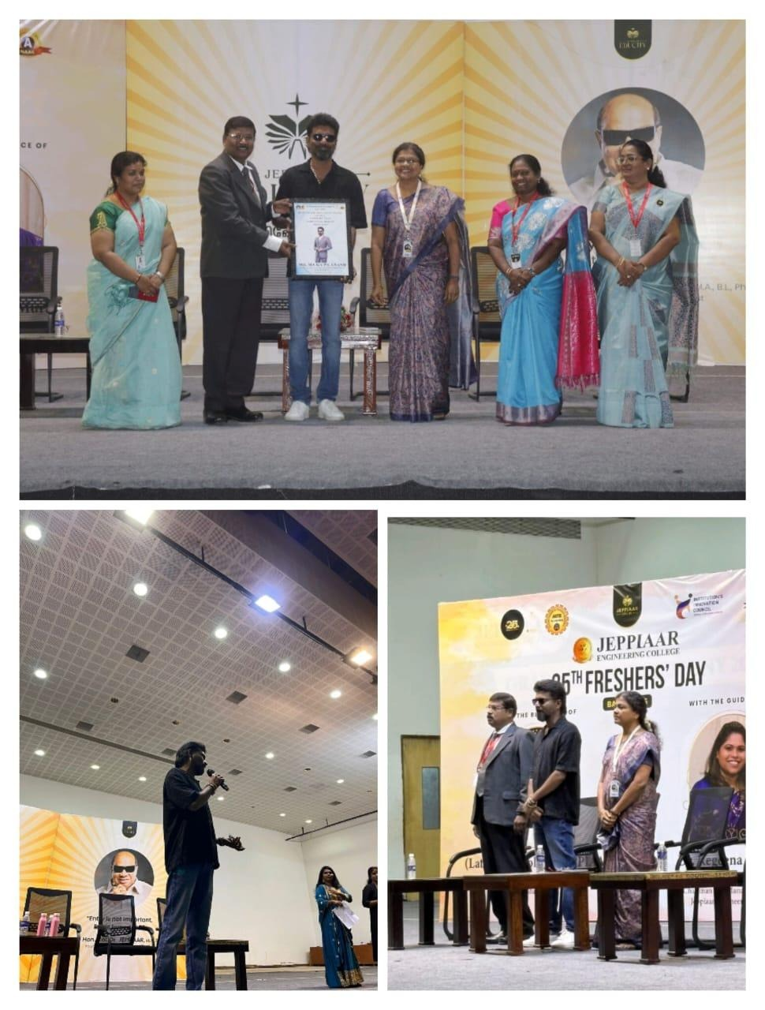

OUTCOME OF THE ACTIVITY

His journey highlights risk-taking ability, market analysis, branding strategy, and effective resource management. Through Flykup, he combined technology adoption with customer-centric value creation. This initiative reflects key program outcomes for MBA students, such as leadership, strategic decision-making, digital adaptability, and the ability to convert creative ideas into sustainable business models.

