

DEPARTMENT OF MANAGEMENT STUDIES

TITLE OF THE EVENT
A Journey of Entrepreneurial Success

DATE AND DURATION OF THE PROGRAM
Date: 11.09.2025
Time: 10.30 AM to 12.30 PM
Venue: Chamber-1 JEC

EVENT POSTER
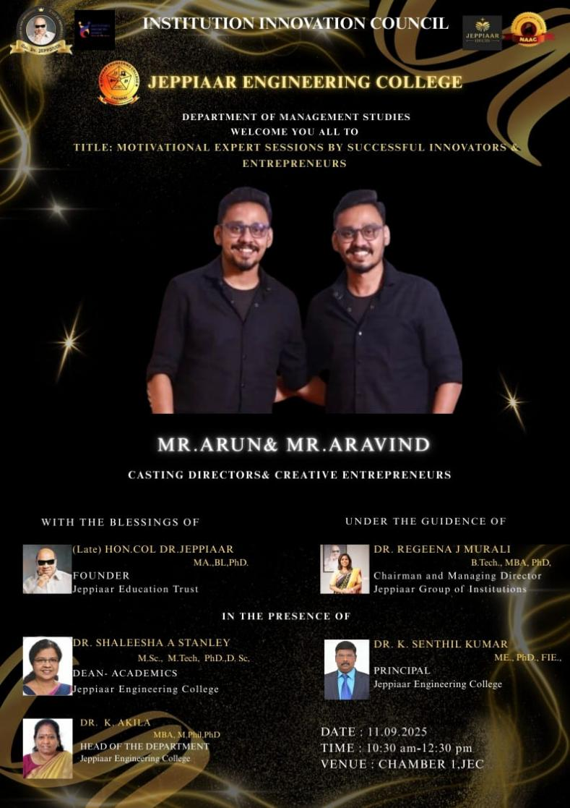

SPEAKER PROFILE
NAME | Mr.ARUN and Mr.ARAVIND
DESIGNATION | Casting Directors & Creative Entrepreneurs
ORGANIZATION | Media & Film Industry
DESCRIPTION
A guest lecture was organized by the Department of Management Studies on September 11, 2025, for MBA students. Arun and Aravind were invited as resource persons, known for their work in reality TV casting, including shows like Bigg Boss Tamil.
They shared their entrepreneurial journey in the entertainment industry, explaining how they started with small events and built a casting and talent management business through creativity, networking, and strategic planning. Their session highlighted talent discovery, digital promotion, and collaboration with production houses.
The speakers discussed challenges in the industry and emphasized key entrepreneurial qualities such as persistence, risk-taking, innovation, and adaptability. The session provided practical insights into real-world business scenarios and encouraged students to explore entrepreneurship beyond traditional careers. It concluded with an interactive Q&A and a vote of thanks.

ORGANIZING TEAM
MBA 2ND YEAR
MC | Ms.Ramitha
GUEST PROFILE | Ms.Joyice Roshini
VOTE OF THANKS | Ms.Arockia Joysee
REFRESHMENT AND MEMENTO | Mr.Prakash & Mr.Balaji
HOSPITALITY TEAM | Ms.Gayathri
PHOTOGRAPHY TEAM | Mr.Seenumon
TECHNICAL TEAM | Mr.Saravanan.C

PHOTOS OF THE EVENT
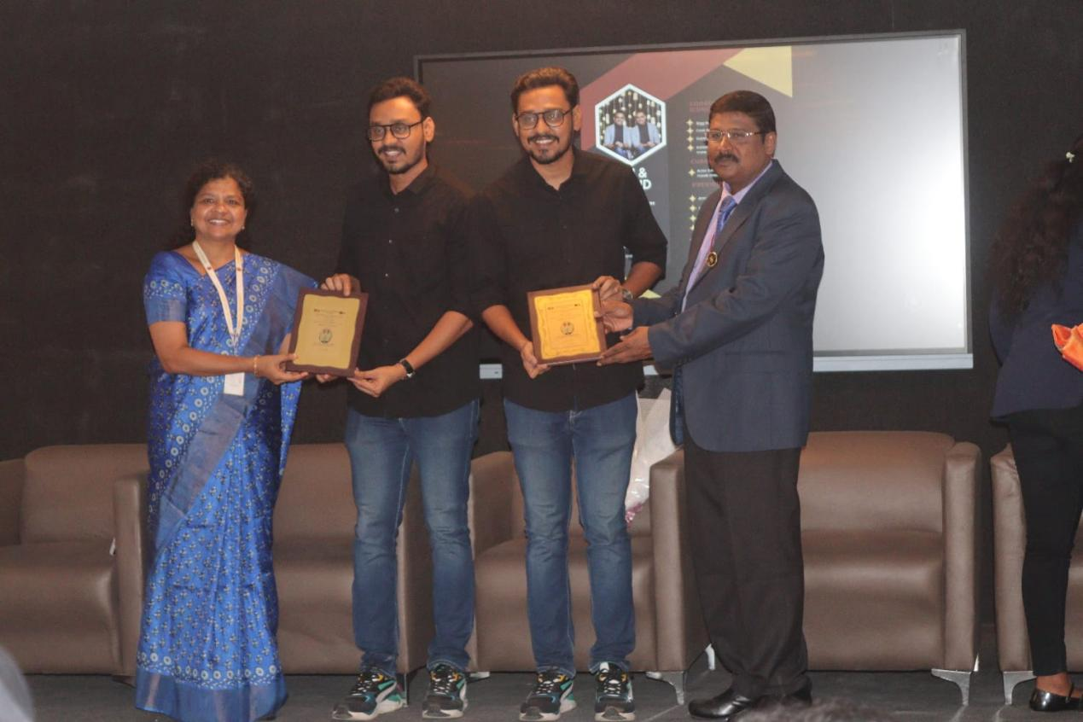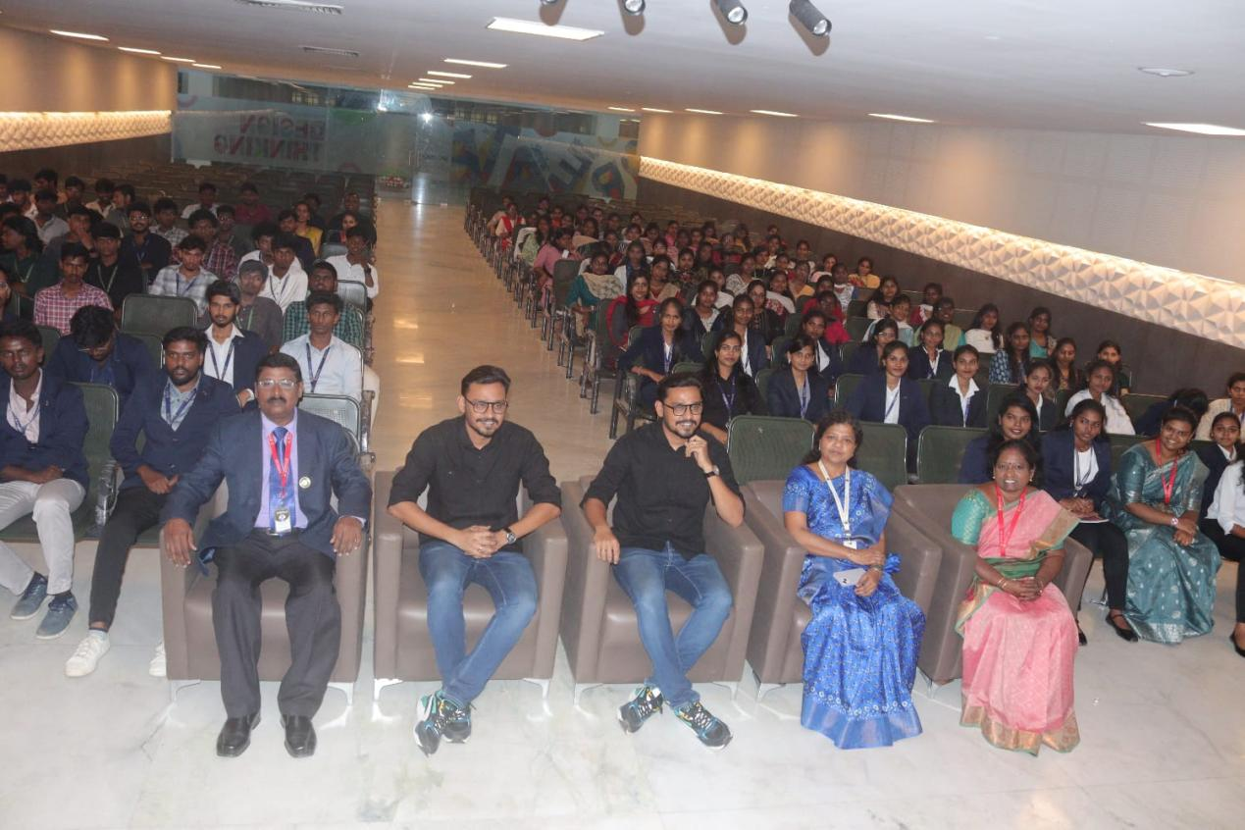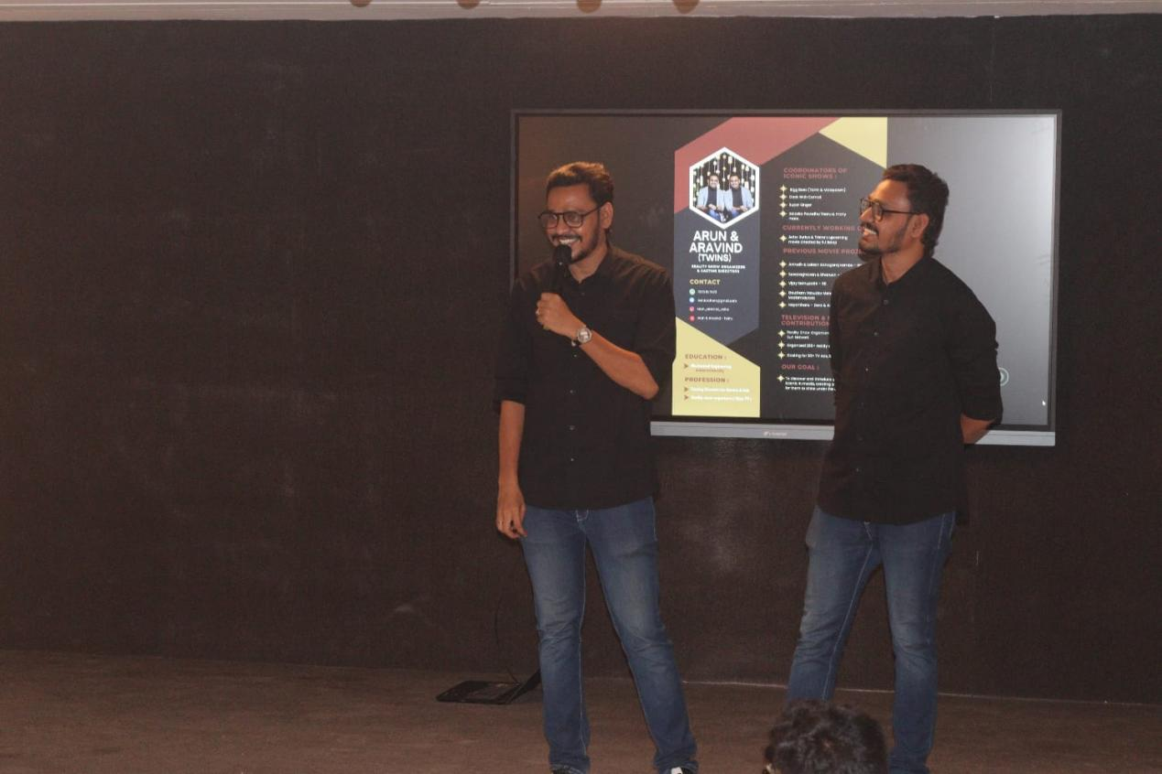

OUTCOME OF THE ACTIVITY

The entrepreneurial journey of Arun and Aravind reflects the core competencies expected from MBA graduates and aligns strongly with program outcomes. Starting from small-scale event coordination, they identified market opportunities in reality TV casting and transformed them into a structured business model. Their success demonstrates key entrepreneurial skills such as opportunity recognition, strategic planning, leadership, risk management, and networking. They applied marketing insights, financial planning, and operational efficiency to scale their venture sustainably. Their journey inspires MBA students to integrate theoretical knowledge with practical execution, fostering innovation, decision-making ability, and ethical professionalism.

