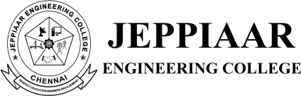

DEPARTMENT OF SCIENCE AND HUMANITIES

A REPORT ON PROJECT EXHIBITION-2022

IYEAR/ ISEMESTERB.E/B.TECH

BATCH:2022-2026

PROJECT EXHIBITION was organized by the Department of Science and Humanities on 10th March 2023. First year students are the participants for the Project Expo conducted in the department of Science and Humanities.
Major objective of organizing this exhibition is to provide a platform, for the young minds to show their talents practically and to outcome their potentialby showcasing their innovative projects on scientific exposure. This provided an opportunity for the students todemonstratetheir learningexperience.
The Project Expo was coordinated by Mrs. K. Subashini, Dr. G. Jagadeesan, DR. F. REGAN MARIA SUNDARRAJ, AssistantProfessor,Departmentof Mathematics and Physics [S&H] in S&H BLOCK from 10.00 – 11.00 AM and witnessed by all faculties of the Department of Science and Humanities.The exhibition generated a high degree of excitement in the first year students. Three batch of students had presented of each two and one.
Project exhibition was judged by Dr. M. Merlin, Professor and Head, Department of Science and Humanities. Best two projects was awarded with a certificate and memento.
Such kind of event motivates the students to learn by self-experience and do some innovative work.

STUDENT CO ORDINATORS DETAILS

S.NO | STUDENTNAME | SECTION/ BRANCH
1 | Prathipan | A/ AIDS
2 | Mathimaran | A/ AIDS
3 | Sownderajan | A/ AIDS
4 | Chaithaniya Kirshna | A/ AIDS

PROJECTEXHIBITIONDETAILS

TEAM No |  | PARTICIPANTS |  | SECTION |  | PROJECT TITLE
1 |  | K. Sakthimahendran |  | C |  | Face Detection
2 |  | R. Sowmiya |  | I |  | DNA working model
3 |  | R. Tejasiri |  | G |  | Conductivity of metals and non metals
 |  | J. Shanmuga Priya |  | G

PRIZEWINNERS:

- K. Sakthimahendran –Face Detection – I PRIZE
- R. Somiya – DNA working model –II PRIZE

The out come of the PROJECT EXPO was that students were able to show their project at higher level and the process boosted their confidence.
ReportPrepared By

Dr. S.R. THILAGAVATHY

PHOTOS
PROJECT EXPO POSTER

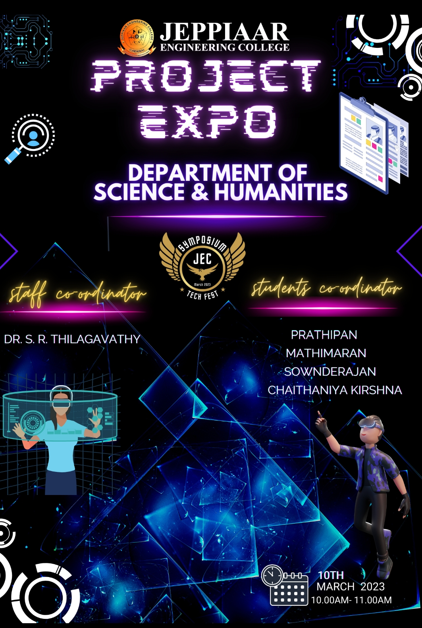

PROJECT EXPO TEAM

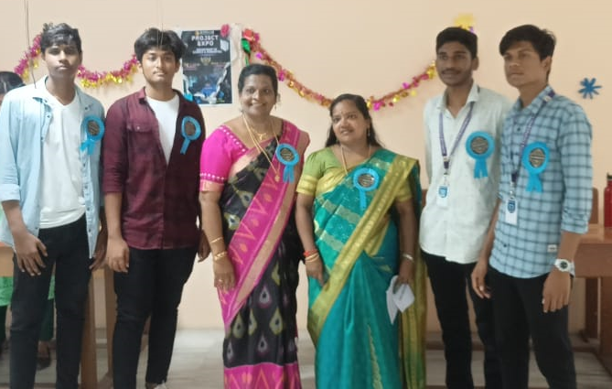

FELICITATING THE JUDGE

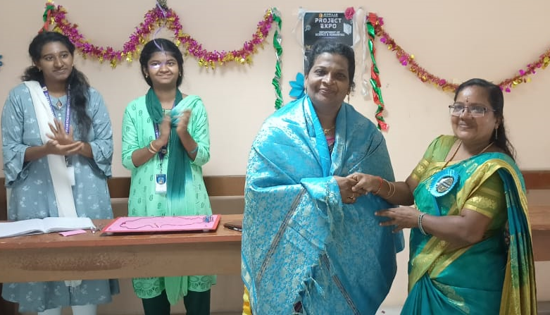

PROJECTS EXPO PHOTO (WITNESSED BY DIRECTOR MAM)

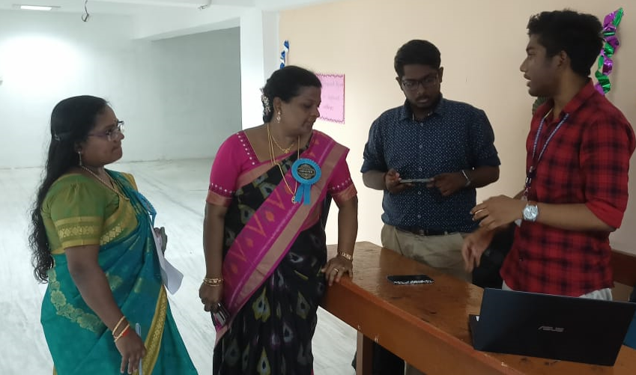

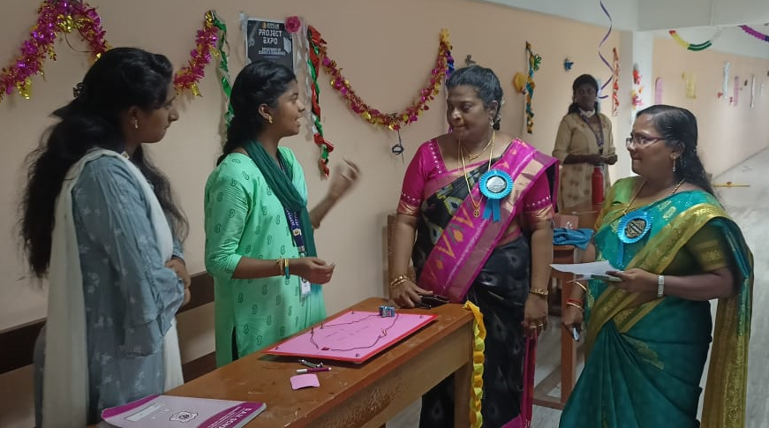

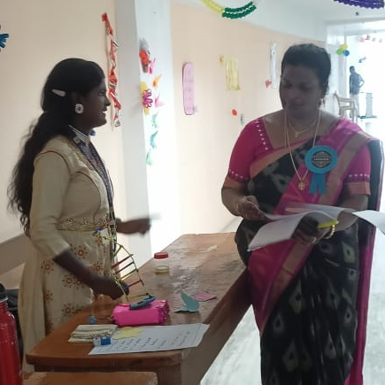

I PRIZE

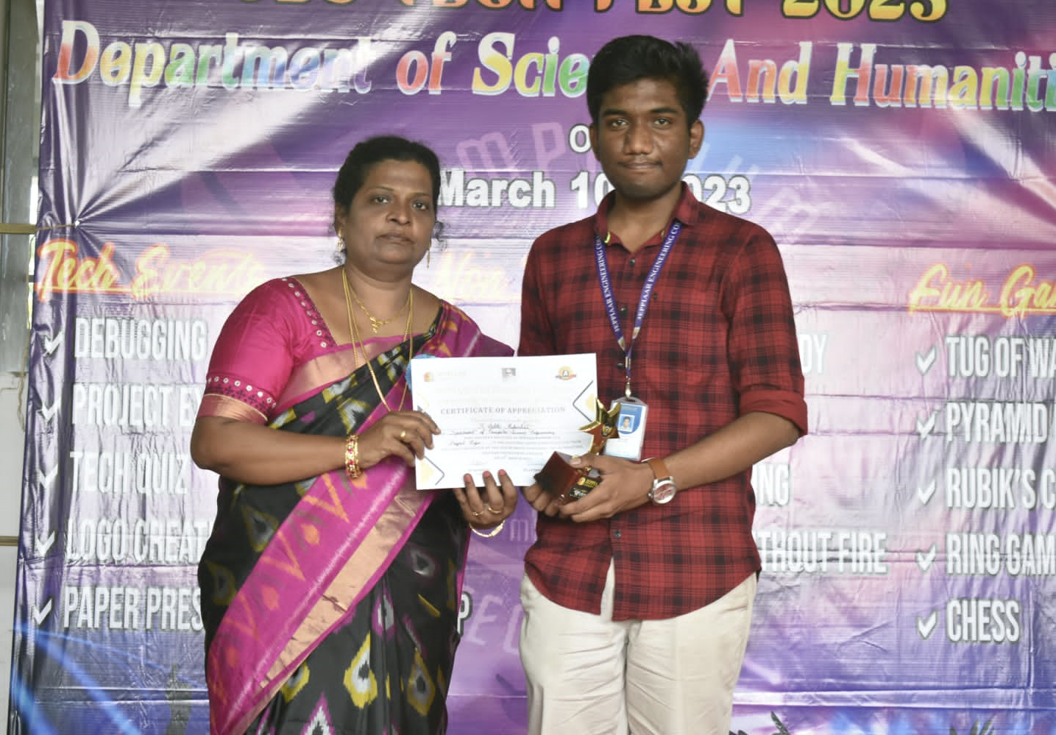

II PRIZE



