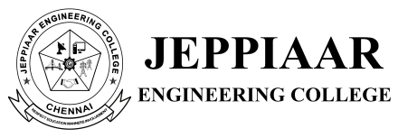

NATIONAL SCIENCE DAY – 2023

ORGANISED BY SCIENCE AND HUMANITIES

28 FEBRUARY 2023

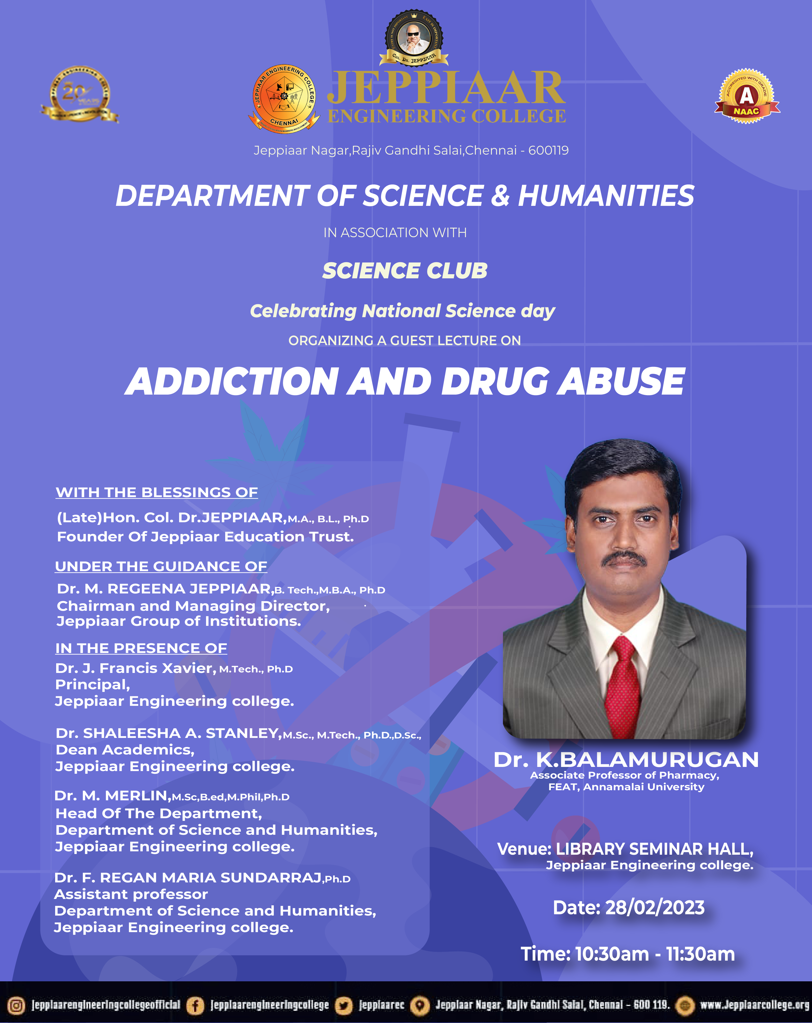
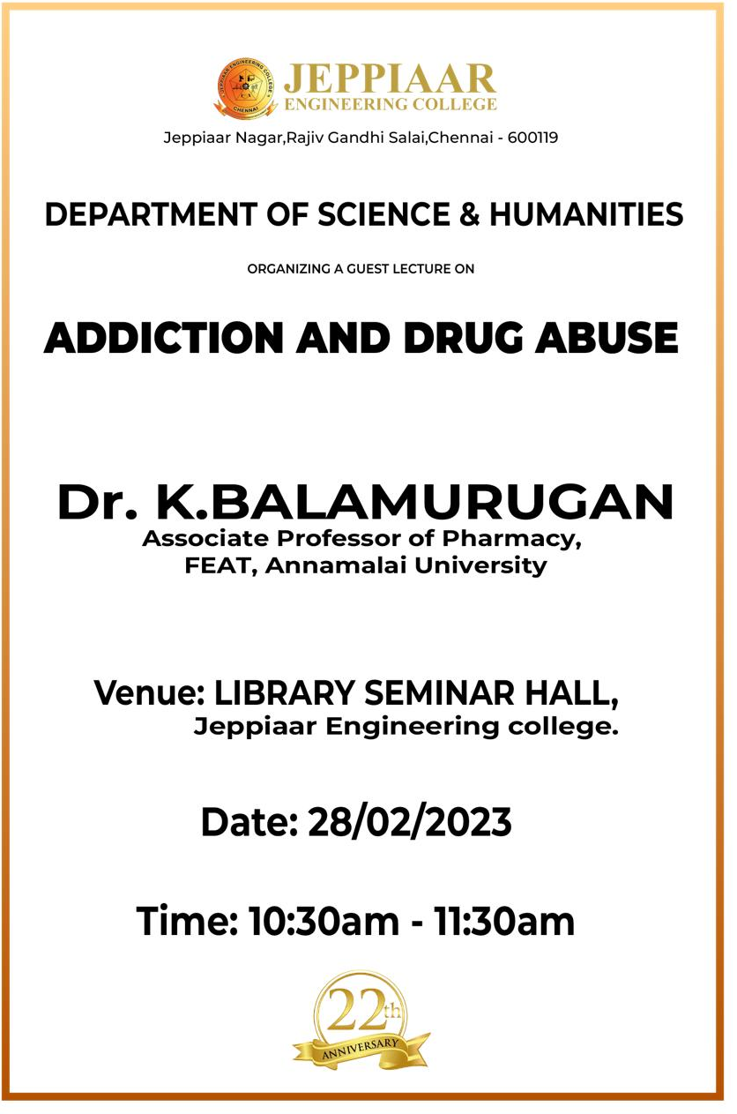

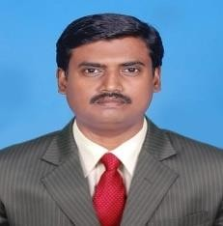
Curriculum vitae

Name | Dr. K.BALAMURUGAN, M.Pharm., (IIT, BHU) Ph.D.,
Field of Specialization | Pharmaceutics
Designation | Associate Professor
Date of Birth | 20.04.1972
Nationality | Indian
Name of the Present institution working | Department of Pharmacy, FEAT, Annamalai University, Annamalai Nagar -608 002, Tamilnadu, India.
Membership | Life member in Indian Pharmaceutical Association.(TN/MDS/LM/0142); Life member in Indian Pharmacological Society. (LK- 339/11.12.2009);  Life member in Pharmacy Graduates Association, Tamilnadu. (LM- 352/18.07.2003).
Academic Qualification:

Sl.no | Degree | University/Institution | Year of Passing
1 | B.Pharm., | Pondicherry University | 1994
2. | M.Pharm., | Indian Institute of Technology (IIT) Banaras Hindu University, U.P. | 1996
3 | Ph.D., | Annamalai University | 2009

Books written: 02
- FOR POST GRADUATE DIPLOMA IN “INTELLECTUAL PROPERTY RIGHTS AND PATENT LAWS” Entitled - Intellectual Issues In Biotechnology, Herbal And Pharmaceutical Products below the titles lessons were prepared by me for Director of distance education students.
  - Importance of IPR in modern era, IPR essential for commercial success of a product / process, Benefits of IPR system-especially the patent system, IPR and globalization of the Pharmaceutical Industry.
  - Role of Patenting in Research and Development of Pharmaceutical and Biotechnology products, Importance and benefits of IPR protection and effects of new IPR laws in drugs and Pharmaceuticals industry in general and herbal drugs. IPR and patent – its relevancy to Ayurvedic system of medicine.
  - Complication in patenting biotech inventions, Generic patent model for biotechnological inventions.
- P.G. diploma in health science (clinical research) Course – I : FOUNDATIONS OF CLINICAL RESEARCH below lessons were prepared by me for Director of distance education students.
- ROLE AND RESPONSIBILITIES OF STAKEHOLDERS

Experience: 26 years

Sl.no | Organization | Year | Post
1. | Shasun Chemicals | 1996- 1998 | Manager Production
2. | Cipla | 1998- 2000 | Executive – Production
3. | Department of Pharmacy  Annamalai University | 2000-2006 | Lecturer/ Coordinator Training &  Placement
4. | Department of Pharmacy Annamalai University | 2006-2013 | Sr.Lecturer/ Coordinator Training & Placement
5. | Department of Pharmacy Annamalai University | 2013 to 2016 | Assistant. Professor
6. | Department of Pharmacy Annamalai University | 2016-till now | Associate Professor

Subjects thought to Students:

  - APH
  - Pharmacology
  - Pathophysiology
  - Pharmaceutics
  - Regulatory affairs

Ph.D., Guidance:

- Ph.D., guided and awarded 11 candidates, Guiding: - :02 candidates
- M.Pharm guided 45 candidates

Projects:

1 .UGC-Major research Project - 8.75 L
2. RUSA – 5.7 L

Paper publications
- International-110
- National: 02

Special lectures delivered: 15

https://www.researchgate.net/profile/Balamurugan-K
Dr.K.Balamurugan. M.Pharm,Ph.D.,
Annamalai University

National Science day was celebrated on 28th February 2023. It is celebrated for Peace and Development highlights the significant role of science in society and the need to engage the wider public in debates on emerging scientific issues. It also underlines the importance and relevance of science in our daily lives.

National Science Day is celebrated to spread the message about the importance of science used in the daily life of the people and popularize science and technology. The day also gives an opportunity to the scientific-minded citizens in the country to showcase their work in organized shows. Students showcase various science projects. National and state science institutions demonstrate their latest researches.
Science club of JEPPIAAR ENGINEERING COLLEGE organized a Science expo on February 28, 2023, titled “NATIONAL SCIENCE DAY in offline mode”.It was well-received by more than 75 participants. DR.F.REGAN MARIA SUNDAR RAJ ,Assistant professor in the Department of Science and Humanities started the session with a warm welcome to all the attendees and also introduced the guest speaker. The session was taken over by the guest speaker Dr.K.BALAMURUGAN Associate Professor Pharmacy, Anamalai University. The lecture opened our eyes towards the fact that technology is making it a better place for us. A lot of the students showcase their science projects and our principal was personally present there to give them positive feedback and motivate them to do better. The chief guest spoke at the end and made us aware about how he became a scientist. Everyone present got a participation certificate. It was an amazing experience that improved our knowledge and skills. The Science expo ended with a question and answer session. This event was a huge success with over 100 participants. The vote of thanks was delivered by DR.M.MERLIN, Associate professor and Head Department of Science and Humanities.
SOCIAL MEDIA LINK OF POSTER:
INSTAGRAM LINK OF THE EVENT
https://www.instagram.com/p/Cpb-06HrvVw/?igshid=MDJmNzVkMjY=
FACEBOOK LINK OF THE EVENT
https://m.facebook.com/story.php?story_fbid=861588531573573&id=100031673018147&mibextid=Nif5oz



