INDUSTRIALVISIT

VENUE: ECOKITCHEN

AIDS (DATE:03/11/2023)

MECH, BIO

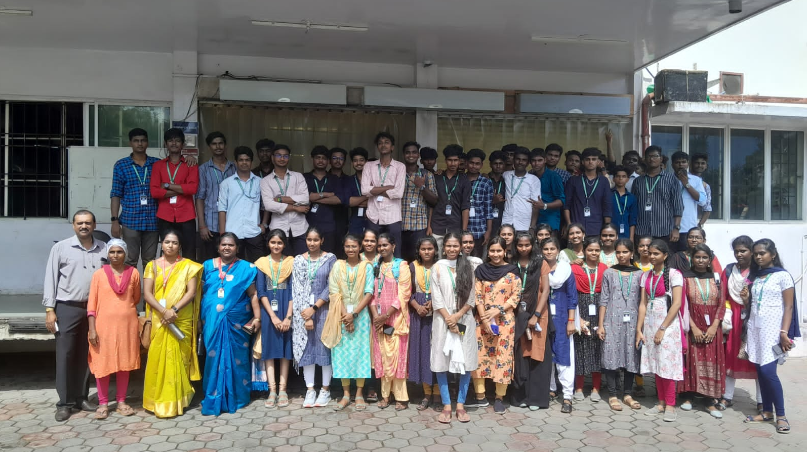

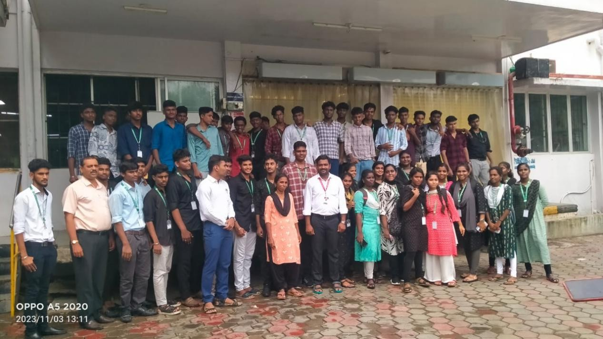

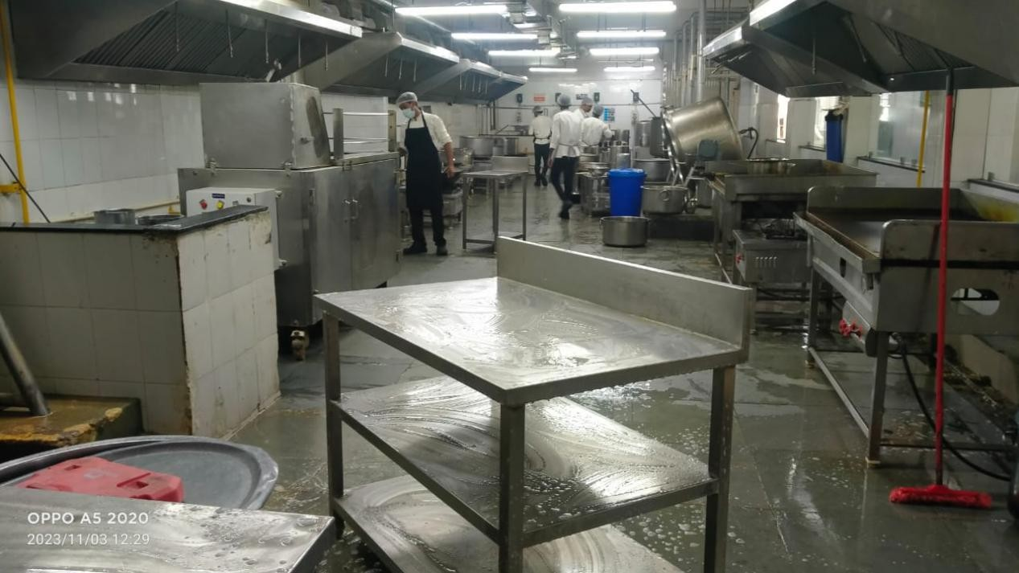

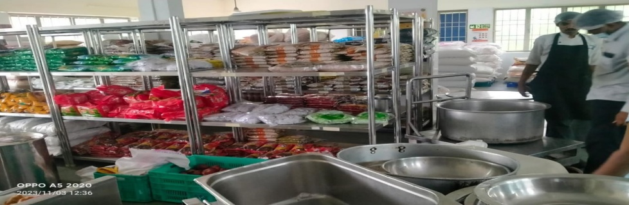

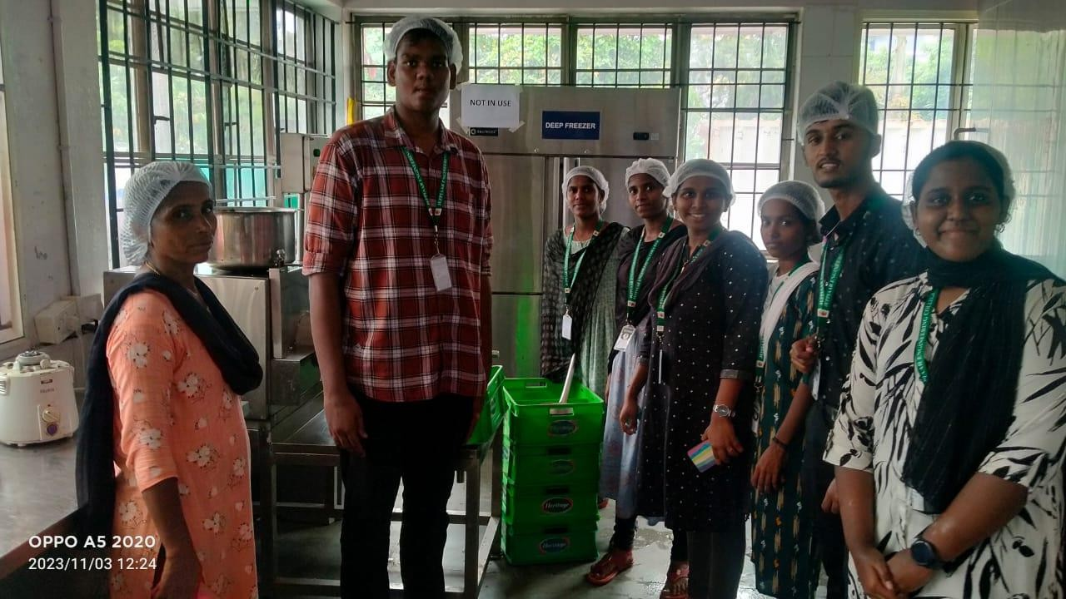

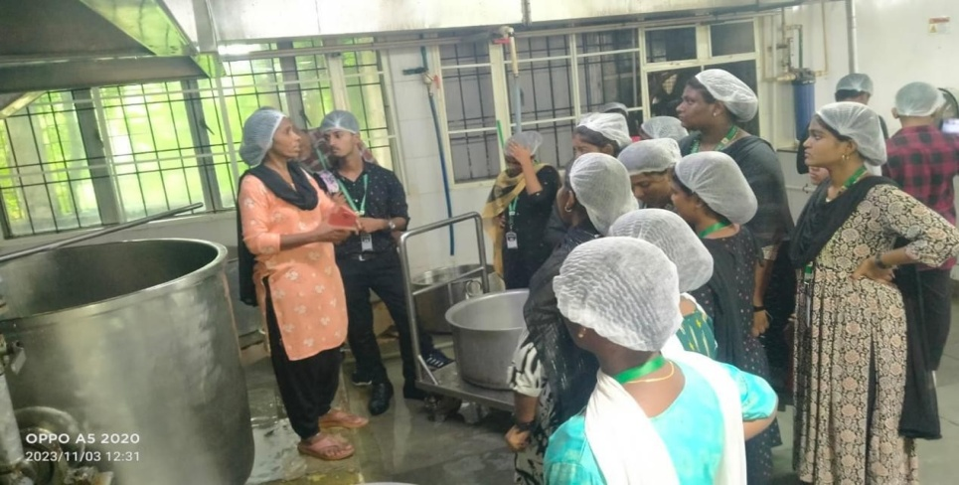

**INDUSTRIAL VISIT**

**VENUE:CODE BIND TECHNOLOGIES**

T.NAGAR

CSE and IT

01/11/2023

TAMBARAM

ECE

DATE:07/11/2023

