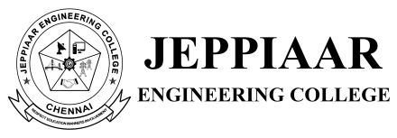

CHRISTMAS DAY CELEBRATION – 2022

ORGANISED BY SCIENCE AND HUMANITIES

22 DECEMBER 2022

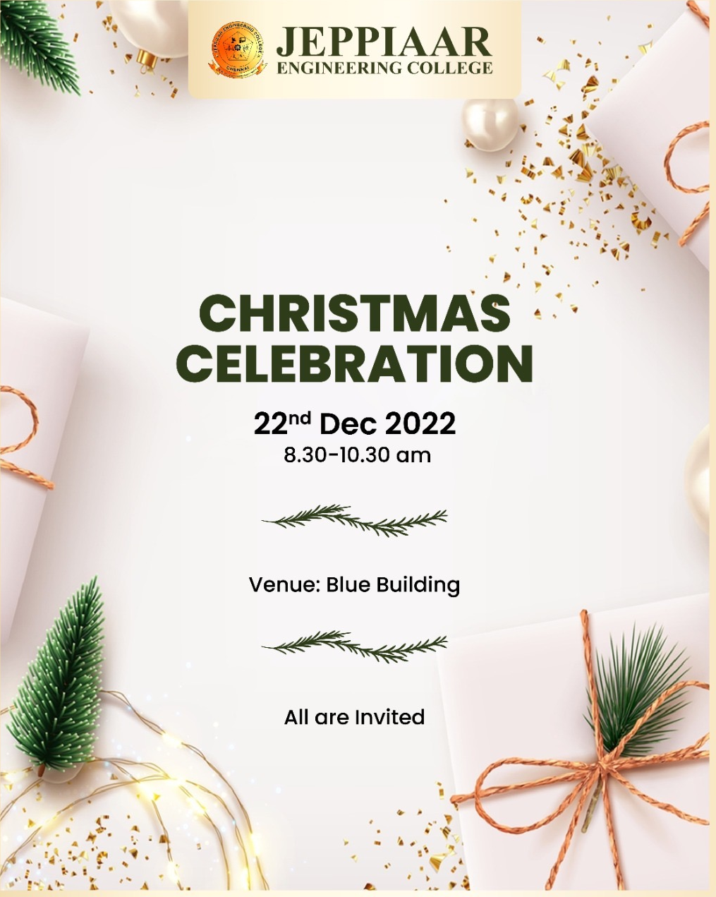

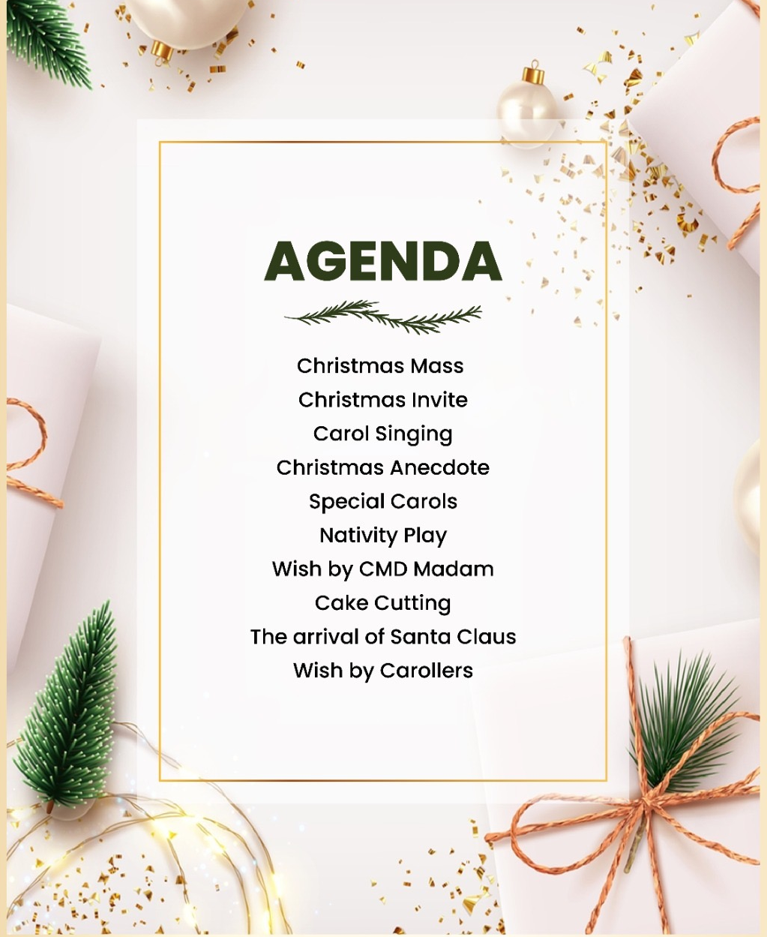

Christmas celebration was celebrated on 22nd December 2022. First in the Christmas Mass, prayer was done by father. After Christmas mass Christmas invite was given by Yasmeen of ECE Department, I year student. Then a beautiful Tamil speech about Christ birth was given by Maria Rejo. J, of IT Department. This was followed by English speech about Christ birth by Sherly, CSE Department. Then Carol song was sung by students. Then a small nativity play was played by first year students, which was followed by carol song, sung by students, Director mam and Professors. Next in the program, Director mam and students has cut the cake. Finally Santa claus arrived with chocolates and gifts.

