DEPARTMENT OF COMPUTER SCIENCE AND ENGINEERING

CCS370- UI and UX DESIGN

QUESTION BANK

III YEAR A&B | BATCH:2021-2025

Vision of Institution
To build Jeppiaar Engineering College as an Institution of Academic Excellence in Technical education and Management education and to become a World Class University.
Mission of Institution
M1 | To excel in teaching and learning, research and innovation by promoting the principles of scientific analysis and creative thinking
M2 | To participate in the production, development and dissemination of knowledge and interact with national and international communities
M3 | To equip students with values, ethics and life skills needed to enrich their lives and enable them to meaningfully contribute to the progress of society
M4 | To prepare students for higher studies and lifelong learning, enrich them with the practical and entrepreneurial skills necessary to excel as future professionals and contribute to Nation’s economy

Program Outcomes (POs)
PO1 | Engineering knowledge: Apply the knowledge of mathematics, science, engineering fundamentals, and an engineering specialization to the solution of complex engineering problems.
PO2 | Problem analysis: Identify, formulate, review research literature, and analyze complex engineering problems reaching substantiated conclusions using first principles of mathematics, natural sciences, and engineering sciences.
PO3 | Design/development of solutions: Design solutions for complex engineering problems and design system components or processes that meet the specified needs with appropriate consideration for the public health and safety, and the cultural, societal, and environmental considerations
PO4 | Conduct investigations of complex problems: Use research-based knowledge and research methods including design of experiments, analysis and interpretation of data, and synthesis of the information to provide valid conclusions.
PO5 | Modern tool usage: Create, select, and apply appropriate techniques, resources, and modern engineering and IT tools including prediction and modeling to complex engineering activities with an understanding of the limitations.
PO6 | The engineer and society: Apply reasoning informed by the contextual knowledge to assess societal, health, safety, legal and cultural issues and the consequent responsibilities relevant to the professional engineering practice.
PO7 | Environment and sustainability: Understand the impact of the professional engineering solutions in societal and environmental contexts, and demonstrate the knowledge of, and need for sustainable development.
PO8 | Ethics: Apply ethical principles and commit to professional ethics and responsibilities and norms of the engineering practice.
PO9 | Individual and team work: Function effectively as an individual, and as a member or leader in diverse teams, and in multidisciplinary settings.
PO10 | Communication: Communicate effectively on complex engineering activities with the engineering community and with society at large, such as, being able to comprehend and write effective reports and design documentation, make effective presentations, and give and receive clear instructions.
PO11 | Project management and finance: Demonstrate knowledge and understanding of the engineering and management principles and apply these to one’s own work, as a member and leader in a team, to manage projects and in multidisciplinary environments.
PO12 | Life-long learning: Recognize the need for, and have the preparation and ability to engage in independent and life-long learning in the broadest context of technological change.
Vision of Department
To emerge as a globally prominent department, developing ethical computer professionals, innovators and entrepreneurs with academic excellence through quality education and research.
Mission of Department
M1 | To create computer professionals with an ability to identify and formulate the engineering problems and also to provide innovative solutions through effective teaching learning process.
M2 | To strengthen the core-competence in computer science and engineering and to create an ability to interact effectively with industries.
M3 | To produce engineers with good professional skills, ethical values and life skills for the betterment of the society.
M4 | To encourage students towards continuous and higher level learning on technological advancements and provide a platform for employment and self-employment.

Program Educational Objectives (PEOs)
PEO1 | To address the real time complex engineering problems using innovative approach with strong core computing skills.
PEO2 | To apply core-analytical knowledge and appropriate techniques and provide solutions to real time challenges of national and global society
PEO3 | Apply ethical knowledge for professional excellence and leadership for the betterment of the society.
PEO4 | Develop life-long learning skills needed for better employment and entrepreneurship

Program Specific Outcomes (PSOs)
Students will be able to
PSO1 | An ability to understand the core concepts of computer science and engineering and to enrich problem solving skills to analyze, design and implement software and hardware based systems of varying complexity.
PSO2 | To interpret real-time problems with analytical skills and to arrive at cost effective and optimal solution using advanced tools and techniques.
PSO3 | An understanding of social awareness and professional ethics with practical proficiency in the broad area of programming concepts by lifelong learning to inculcate employment and entrepreneurship skills.

Unit - 1 Foundations of Design

UI vs UX Design- Core Stages of Design Thinking – Divergent and Convergent Thinking – Brain storming and Game Storming – Observational Empathy

2 Marks

What is user interface (UI)?
The user interface (UI) is the point of human-computer interaction and communication in a device. This can include display screens, keyboards,
a mouse and the appearance of a desktop. It is also the way through which a user interacts with an application or a website.

The growing dependence of many businesses on web applications and mobile applications has led many companies to place increased priority on UI in an effort to improve the user's overall experience.

What are Types of user interfaces
The various types of user interfaces include:

- graphical user interface (GUI)
- command line interface (CLI)
- menu-driven user interface
- touch user interface
- voice user interface (VUI)
- form-based user interface
- natural language user interface

Mention the examples of user interfaces
Some examples of user interfaces include:

- computer mouse

- remote control
- virtual reality
- ATMs
- speedometer
- the old iPod click wheel
Websites such as Airbnb, Dropbox and Virgin America display strong user interface design. Sites like these have created pleasant, easily operable, user- centered designs (UCD) that focus on the user and their needs.

- What is User Experience (UX) Design?

User experience (UX) design is the process design teams use to create products that provide meaningful and relevant experiences to users. UX design involves the design of the entire process of acquiring and integrating the product, including aspects of branding, design, usability and function.

Designing an experience includes not only making the software easy to use but also designing the other experiences related to the product, for example, the marketing campaign, the packaging and after-sales support. Most importantly, UX design is concerned with delivering solutions that address pain points and needs.
After all, no one will use a product that serves no purpose.

- What is User Experience (UX) Design?

User experience (UX) design is the process design teams use to create products that provide meaningful and relevant experiences to users. UX design involves the design of the entire process of acquiring and integrating the product, including aspects of branding, design, usability and function.

Designing an experience includes not only making the software easy to use but also designing the other experiences related to the product, for example, the marketing campaign, the packaging and after-sales support. Most importantly, UX design is concerned with delivering solutions that address pain points and needs.
After all, no one will use a product that serves no purpose.

- What UX Designers Do Goes Beyond UI Design

“User Experience Design” is often used interchangeably with terms such as “User Interface Design” and “Usability.” However, while usability and user interface (UI) design are important aspects of UX design, they are subsets of it.

A UX designer is concerned with the entire process of acquiring and integrating a product, including aspects of branding, design, usability and function. It’s a story that begins before the device is even in the user’s hands.

“No product is an island. A product is more than the product. It is a cohesive, integrated set of experiences. Think through all of the stages of a product or service – from initial intentions through final reflections, from the first usage to help, service, and maintenance. Make them all work together seamlessly.”
- UX Designers Consider the Why, What, and How of Product Use

As a UX designer, you should consider the Why, What and How of product use. The Why involves the users’ motivations for adopting a product, whether they relate to a task they wish to perform with it or to values and views that users associate with the ownership and use of the product. The What addresses the things people can do with a product—its functionality. Finally, the How relates to the design of functionality in an accessible and aesthetically pleasant way.

UX designers start with the Why before determining the What and then, finally, the How to create products that users can form meaningful experiences with. In software designs, you must ensure the product’s “substance” comes through an existing device and offers a seamless, fluid experience.

- Why UX Design is User-Centered

Since UX design encompasses the entire user journey, it’s a multidisciplinary field–UX designers come from various backgrounds such as visual design, programming, psychology and interaction design. To design for human users also means working with a heightened scope regarding accessibility and
accommodating many potential users’ physical limitations, such as reading small text.

A UX designer’s typical tasks vary but often include user research,
creating personas, designing wireframes and interactive prototypes, and testing designs. These tasks can vary significantly from one organization to the next. Still, they always demand designers to be the users’ advocates and keep their needs at the center of all design and development efforts. That’s also why most UX designers work in some form of user-centered work process and keep channeling

- What is Design thinking?
Design thinking’s value as a world-improving, driving force in business (global heavyweights such as Google, Apple and Airbnb have wielded it to notable effect) matches its status as a popular subject at leading international universities. With design thinking, teams have the freedom to generate ground-breaking solutions. Using it, your team can get behind hard-to-access insights and apply a collection of hands-on methods to help find innovative answers.
- Why Is Design Thinking so Important?

Design thinking is essential in UX design to adapt to rapid changes in users' behaviors and environments. Since its inception by Herbert A. Simon in 1969, it has evolved and been embraced across various fields. Today, organizations use it to solve complex problems and cater to human needs. Design teams leverage design thinking to tackle challenging issues and prioritize user-centric solutions. It encourages "thinking outside the box," leading to improved UX research, prototyping, and usability testing to meet users' evolving needs effectively.

- Differentiate between Divergence vs convergence
Divergence and convergence are like the inhale and exhale of the design thinking process. Divergence creates space and possibilities, while convergence brings focus and direction. Designers move back and forth between these two processes throughout the design thinking process, building on the insights and ideas generated during each cycle to refine and improve the solution.

Note: Divergent and convergent phases are non-linear, meaning that when facilitating this process, you may move back and forth as you discover new insights during convergence.

- What is divergence?

Divergence is the process of exploring and generating a wide range of ideas and possibilities without any judgment or criticism. Divergent thinking allows designers to expand the possibilities and consider different perspectives, angles, and dimensions of the problem.

/

- What is convergence?

Convergent thinking refers to the process of selecting, evaluating, and refining the most promising ideas from the divergent phase. It involves narrowing down and refining possibilities by selecting the best ideas and combining them to create a coherent and effective solution.

- Benefits of divergent and convergent thinking

  - Increased creativity and innovation
  - Better decision-making
  - Human-centered design
  - Enhanced problem-solving
  - Improved collaboration

- What is Brainstorming?
Brainstorming is a method design teams use to generate ideas to solve clearly defined design problems. In controlled conditions and a free-thinking environment, teams approach a problem by such means as “How Might We” questions. They produce a vast array of ideas and draw links between them to find potential solutions.

- What is gamestorming?

Gamestorming is a form of brainstorming that leverages the use of games.
As we all know, playing games enforces rules, effectively helping to overcome the usual brainstorming limitations. The way brainstorming avoids conflicts is by shifting group and thought dynamics.

To give you a real life example, at Collaboard we need to coordinate employees across multiple locations, and found that gamestorming (especially when facilitated through our app Collaboard) makes it easier to handle collaborative and creative processes.

What is Observational empathy
Key aspects of observational empathy include:

- **Active Observation**:

- **Listening and Note-taking**:

- **Contextual Understanding**:

- **Identifying Unspoken Needs**:

- **Avoiding Assumptions**:

15 Marks

History of UI
In early computers, there was very little user interface except for a few buttons at an operator's console. Many of these early computers used punched cards, prepared using keypunch machines, as the primary method of input for computer programs and data. While punched cards have been essentially obsolete in computing since 2012, some voting machines still use a punched card system.

The user interface evolved with the introduction of the command line interface, which first appeared as a nearly blank display screen with a line for user input. Users relied on a keyboard and a set of commands to navigate exchanges of information with the computer. This command line interface led to one in which menus (lists of choices written in text) predominated.
Finally, the GUI arrived, originating mainly in Xerox's Palo Alto Research Center (PARC), adopted and enhanced by Apple and effectively standardized by Microsoft in its Windows operating systems.

Graphical UIs
Elements of a GUI include such things as windows, pull-down menus, buttons, scroll bars and icons. With the increasing use of multimedia as part of the GUI, sound, voice, motion video and virtual reality are increasingly becoming the GUI for many applications.

Mobile UIs

The emerging popularity of mobile applications has also affected UI, leading to something called mobile UI. Mobile UI is specifically concerned with creating usable, interactive interfaces on the smaller screens of smartphones and tablets and improving special features, like touch controls.

User Experience (UX) Design?

User experience (UX) design is the process design teams use to create products that provide meaningful and relevant experiences to users. UX design involves the design of the entire process of acquiring and integrating the product, including aspects of branding, design, usability and function.

Designing an experience includes not only making the software easy to use but also designing the other experiences related to the product, for example, the marketing campaign, the packaging and after-sales support. Most importantly, UX design is concerned with delivering solutions that address pain points and needs.
After all, no one will use a product that serves no purpose.

What UX Designers Do Goes Beyond UI Design

“User Experience Design” is often used interchangeably with terms such as “User Interface Design” and “Usability.” However, while usability and user interface (UI) design are important aspects of UX design, they are subsets of it.

A UX designer is concerned with the entire process of acquiring and integrating a product, including aspects of branding, design, usability and function. It’s a story that begins before the device is even in the user’s hands.

“No product is an island. A product is more than the product. It is a cohesive, integrated set of experiences. Think through all of the stages of a product or service – from initial intentions through final reflections, from the first usage to help, service, and maintenance. Make them all work together seamlessly.”

— Don Norman, inventor of the term “User Experience.”

Products that provide a great user experience (e.g., the iPhone) are thus designed with the product’s consumption or use in mind and the entire process of acquiring, owning and even troubleshooting it. Similarly, UX designers don’t just focus on creating usable products; they concentrate on other aspects of the user experience, such as pleasure, efficiency and fun. Consequently, there is no single definition of a good user experience. Instead, a good user experience meets a particular user’s needs in the specific context where they use the product.

A UX designer attempts to answer the question: "How can we make the experience of interacting with a computer, a smartphone, a product, or a service as intuitive, smooth and pleasant as possible?"

UX Design—A Formal Definition

The International Organization for Standardization (ISO) defines user experience as:
“A person's perceptions and responses that result from the use or anticipated use of a product, system or service.”

- ISO 9241-210, Ergonomics of human-system interaction—Part 210: Human- centered design for interactive systems

We can break this definition into two parts:

  - A person’s perceptions and responses.
  - The use of a product, system or service.

In user experience, designers do not have much control over a person’s perceptions and responses—the first part of the definition. For example, they cannot control how someone feels, moves their fingers or controls their eyes as they use a product. However, designers can control how the product, system or service behaves and looks—the second part of the definition.

“One cannot design a user experience, only design for a user experience. In particular, one cannot design a sensual experience, but only create the design features that can evoke it.”

- Jeff Johnson, Assistant Professor in the Computer Science Department of the University of San Francisco

The simplest way to think about user experience design is as a verb and a noun. A UX designer designs (verb)—ideates, plans, changes—the things that affect the user experience (noun)—perceptions and responses to a system or service.
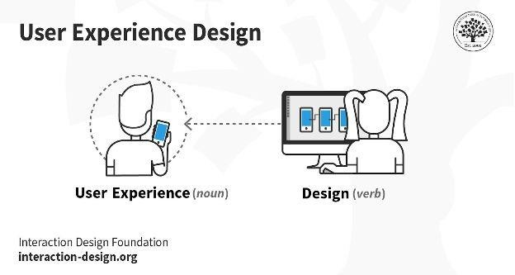

The simplest way to think about user experience design is as a verb and a noun.

For example, when using a physical device, such as a computer mouse, we can control some aspects of the product that influence whether the user enjoys looking at, feeling and holding it:

  - The way it fits in their hand. Is it snug? Is it too big and cumbersome?
  - The weight. Does it affect their ability to move it as they wish?
  - Its ease of use. Can they use it automatically, or do they have to think hard about it to achieve a goal?

When a person uses a digital product, such as a computer application, a few aspects that we can influence include:

  - How intuitively they can navigate through the system.
  - The cues that help guide them to their goal.
  - The visibility of the essential aspects of a task at the appropriate time.

UX Designers Consider the Why, What, and How of Product Use

As a UX designer, you should consider the Why, What and How of product use. The Why involves the users’ motivations for adopting a product, whether they relate to a task they wish to perform with it or to values and views that users associate with the ownership and use of the product. The What addresses the things people can do with a product—its functionality. Finally, the How relates to the design of functionality in an accessible and aesthetically pleasant way.

UX designers start with the Why before determining the What and then, finally, the How to create products that users can form meaningful experiences with. In software designs, you must ensure the product’s “substance” comes through an existing device and offers a seamless, fluid experience.

Why UX Design is User-Centered

Since UX design encompasses the entire user journey, it’s a multidisciplinary field–UX designers come from various backgrounds such as visual design, programming, psychology and interaction design. To design for human users also means working with a heightened scope regarding accessibility and
accommodating many potential users’ physical limitations, such as reading small text.

A UX designer’s typical tasks vary but often include user research,
creating personas, designing wireframes and interactive prototypes, and testing designs. These tasks can vary significantly from one organization to the next. Still, they always demand designers to be the users’ advocates and keep their needs at the center of all design and development efforts. That’s also why most UX designers work in some form of user-centered work process and keep channeling

their best-informed efforts until they address all of the relevant issues and user needs optimally.
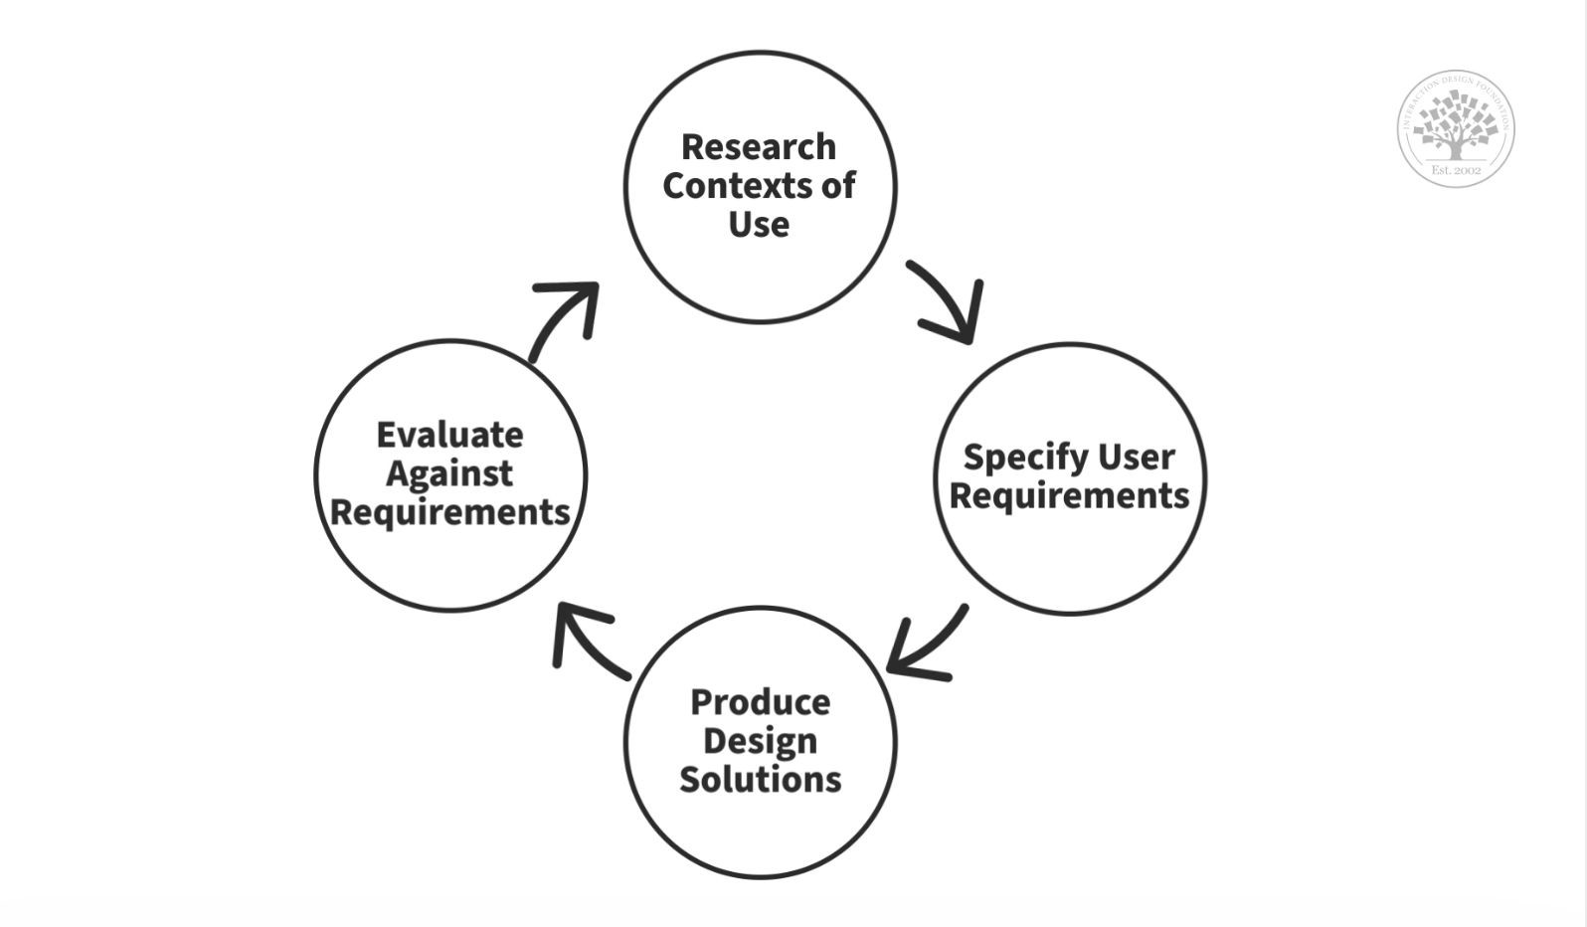
© Interaction Design Foundation, CC BY-SA 3.0

User-centered design is an iterative process where you take an understanding of the users and their context as a starting point for all design and development.

UI and UX
The UI is often talked about in conjunction with user experience (UX), which may include the aesthetic appearance of the device, response time and the content that is presented to the user within the context of the user interface. Both terms fall under the concept of human-computer interaction (HCI), which is the field of study focusing on the creation of computer technology and the interaction between humans and all forms of IT design. Specifically, HCI studies areas such as UCD, UI design and UX design.An increasing focus on creating an optimized user experience has led some to carve out careers as UI and UX experts. Certain languages, such as HTML and CSS, have been geared toward making it easier to create a strong user interface and experience.

Difference between UI and UX

Developing a product that people love often requires both good UI and good UX. For example, you could have a messaging app (such as WhatsApp) that looks great and has intuitive navigation (UI). But if the app loads slowly or makes you click through numerous screens to message someone (UX), it doesn’t matter how good it looks. You’re probably not going to want to use it.

On the other hand, a website could be loaded with unique, helpful content organised in a logical and intuitive way. But if it looks dated or you can’t easily figure out how to move between screens or scroll through options, you’re likely to click away from the site.
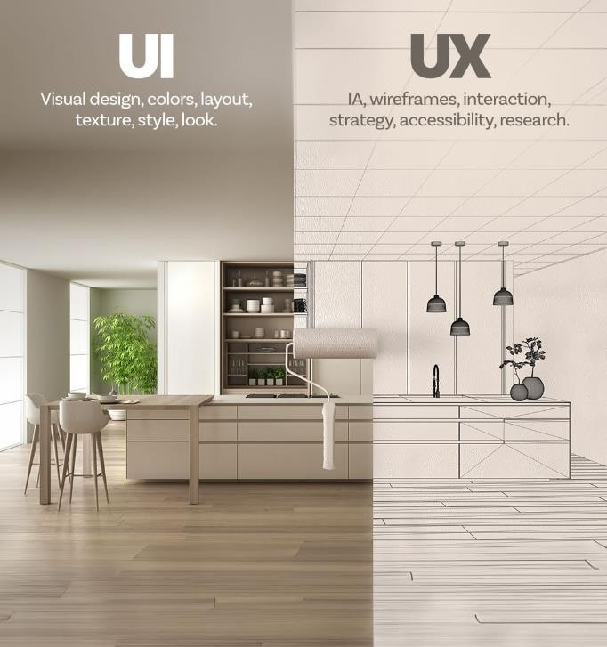

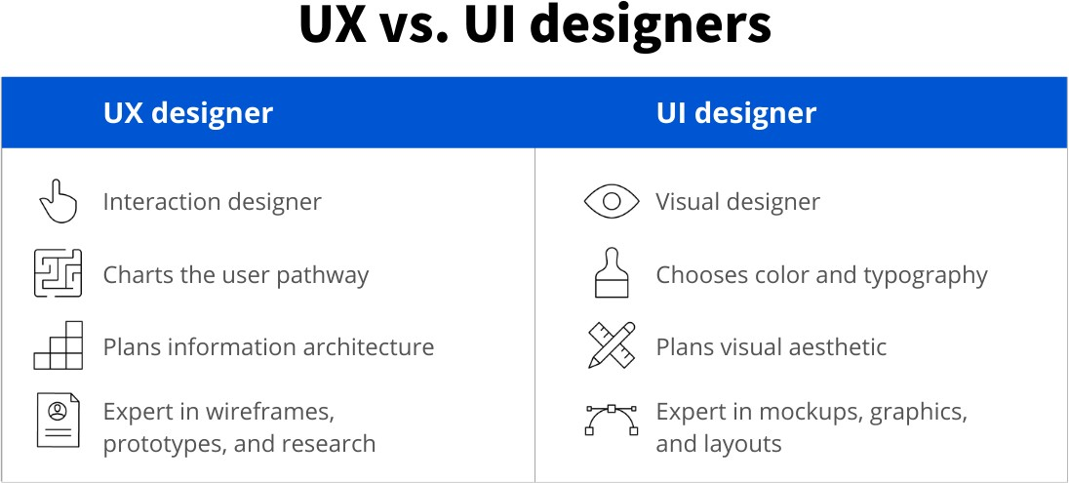

Aspect | User Interface (UI) | User Experience (UX)
Definition | UI focuses on the visual elements users interact with. | UX focuses on the overall experience users have.
Scope | Deals with the layout, design, and presentation. | Encompasses the entire journey of the user.
Purpose | Aims to provide an attractive and usable interface. | Aims to ensure the user's needs are met effectively.
Elements | Involves buttons, icons, menus, and other components. | Involves emotions, perceptions, and interactions.
Goal | Enhances the aesthetic appeal and usability of a product. | Enhances user satisfaction and fulfillment.
Interaction | Deals with how users interact with the interface. | Deals with how users feel during their interactions.
Measurability | Can be measured by visual appeal, consistency, etc. | Measured by user feedback, metrics, and satisfaction.
Medium | Primarily concerned with the visual aspects. | Involves both visual and psychological aspects.
Output | The end result is a visually appealing design. | The end result is a satisfying user experience.

Collaboration | Collaborates with UX to implement design elements. | Collaborates with UI to deliver a cohesive experience.

Design thinking’s value as a world-improving, driving force in business (global heavyweights such as Google, Apple and Airbnb have wielded it to notable effect) matches its status as a popular subject at leading international universities. With design thinking, teams have the freedom to generate ground-breaking solutions. Using it, your team can get behind hard-to-access insights and apply a collection of hands-on methods to help find innovative answers.

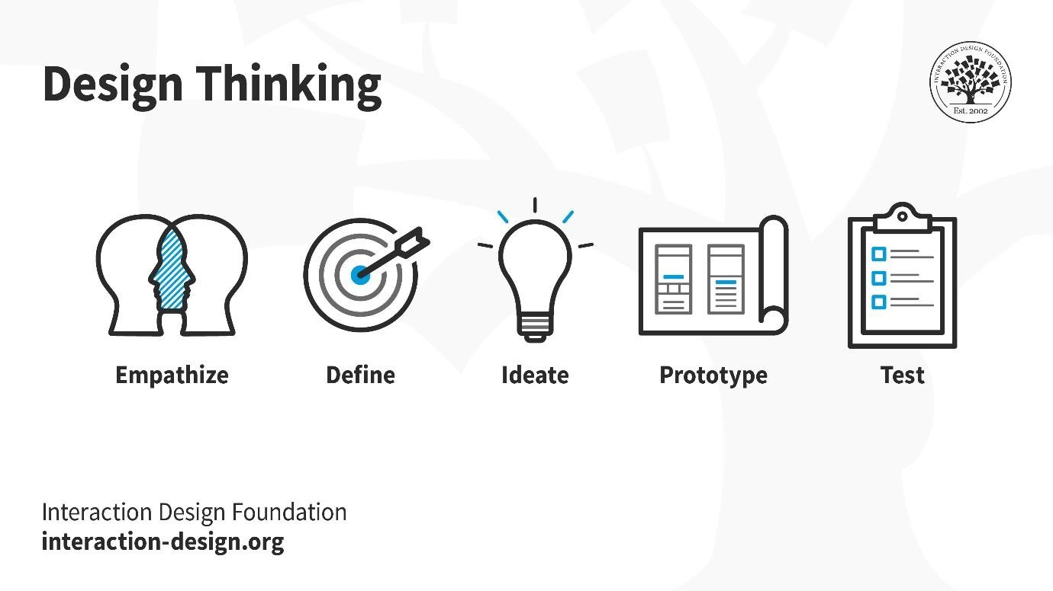

Design thinking is an iterative and non-linear process that contains five phases: 1. Empathize, 2. Define, 3. Ideate, 4. Prototype and 5. Test.

© Interaction Design Foundation, CC BY-SA 3.0

  - Stage 1: Empathize—Research Your Users' Needs

Here, you should gain an empathetic understanding of the problem you’re trying to solve, typically through user research. Empathy is crucial to a human-centered

design process such as design thinking because it allows you to set aside your own assumptions about the world and gain real insight into users and their needs.

  - Stage 2: Define—State Your Users' Needs and Problems

It’s time to accumulate the information gathered during the Empathize stage. You then analyze your observations and synthesize them to define the core problems you and your team have identified. These definitions are called problem statements. You can create personas to help keep your efforts human-centered before proceeding to ideation.

  - Stage 3: Ideate—Challenge Assumptions and Create Ideas

Now, you’re ready to generate ideas. The solid background of knowledge from the first two phases means you can start to “think outside the box”, look for alternative ways to view the problem and identify innovative solutions to the problem
statement you’ve created. Brainstorming is particularly useful here..

  - Stage 4: Prototype—Start to Create Solutions

This is an experimental phase. The aim is to identify the best possible solution for each problem found. Your team should produce some inexpensive, scaled-down versions of the product (or specific features found within the product) to investigate the ideas you’ve generated. This could involve simply paper prototyping.

  - Stage 5: Test—Try Your Solutions Out

Evaluators rigorously test the prototypes. Although this is the final phase, design thinking is iterative: Teams often use the results to redefine one or more further problems. So, you can return to previous stages to make further iterations, alterations and refinements – to find or rule out alternative solutions.

Overall, you should understand that these stages are different modes which contribute to the entire design project, rather than sequential steps. Your goal throughout is to gain the deepest understanding of the users and what their ideal solution/product would be.

Why Is Design Thinking so Important?

Design thinking is essential in UX design to adapt to rapid changes in users' behaviors and environments. Since its inception by Herbert A. Simon in 1969, it has evolved and been embraced across various fields. Today, organizations use it to solve complex problems and cater to human needs. Design teams leverage design thinking to tackle challenging issues and prioritize user-centric solutions. It encourages "thinking outside the box," leading to improved UX research, prototyping, and usability testing to meet users' evolving needs effectively.
9.Divergent Vs Convergent Thinking: What's the Difference?
Divergence and convergence is a problem-solving method that emphasizes empathy, experimentation, and iteration. It is a human-centered design approach that focuses on understanding people's needs, behaviors, and motivations to design creative solutions that meet those needs effectively.

This problem-solving process cycles between expansive and focused thinking to better understand problems people face and develop a solution. Coined by psychologist J.P.
Guilford in the 1950s, these cycles of thinking provide the structure for this iterative design thinking process.

In this article we’ll define divergence and convergence, provide examples, walk through each stage, suggest free templates you can use to try it out, and provide tips to help you get the most out of the creative process.

Divergence vs convergence
Divergence and convergence are like the inhale and exhale of the design thinking process. Divergence creates space and possibilities, while convergence brings focus and direction. Designers move back and forth between these two processes throughout the design thinking process, building on the insights and ideas generated during each cycle to refine and improve the solution.

Note: Divergent and convergent phases are non-linear, meaning that when facilitating this process, you may move back and forth as you discover new insights during convergence.

What is divergence?

Divergence is the process of exploring and generating a wide range of ideas and possibilities without any judgment or criticism. Divergent thinking allows designers to expand the possibilities and consider different perspectives, angles, and dimensions of the problem.

/

What is convergence?

Convergent thinking refers to the process of selecting, evaluating, and refining the most promising ideas from the divergent phase. It involves narrowing down and refining possibilities by selecting the best ideas and combining them to create a coherent and effective solution.

Benefits of divergent and convergent thinking

Increased creativity and innovation
Better decision-making
Human-centered design
Enhanced problem-solving
Improved collaboration

What is Brainstorming?
Brainstorming is a method design teams use to generate ideas to solve clearly defined design problems. In controlled conditions and a free-thinking environment, teams approach a problem by such means as “How Might We” questions. They produce a vast array of ideas and draw links between them to find potential solutions.
Resume
Watch how to get serious, and fun, results with Brainstorming.

How To Use Brainstorming Best
Brainstorming is part of design thinking. You use it in the ideation phase. It’s extremely popular for design teams because they can expand in all directions. Although teams have rules and a facilitator to keep them on track, they are free to use out-of-the-box and lateral thinking to seek the most effective solutions to any design problem. By brainstorming, they can take a vast number of approaches—the more, the better—instead of just exploring conventional means and running into the associated obstacles. When teams work in a judgment-free
atmosphere to find the real dimensions of a problem, they’re more likely to produce rough answers which they’ll refine into possible solutions later. Marketing CEO Alex Osborn,
brainstorming’s “inventor”, captured the refined elements of creative problem-solving in his 1953 book, Applied Imagination. In brainstorming, we aim squarely at a design problem and produce an arsenal of potential solutions. By not only harvesting our own ideas but also considering and building on colleagues’, we cover the problem from every angle imaginable.
“It is easier to tone down a wild idea than to think up a new one.”

Alex Osborn
Everyone in a design team should have a clear definition of the target problem. They typically gather for a brainstorming session in a room with a large board/wall for pictures/Post-Its. A good mix of participants will expand the experience pool and therefore broaden the idea space.

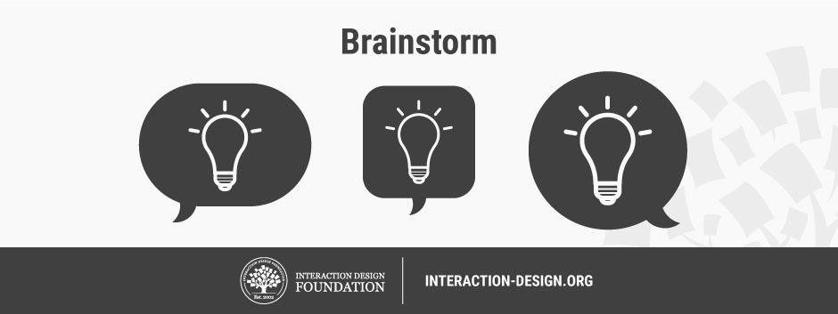
•

Brainstorming may seem to lack constraints, but everyone must observe eight house rules and have someone acting as facilitator.
Set a time limit – Depending on the problem’s complexity, 15–60 minutes is normal.
Begin with a target problem/brief – Members should approach this sharply defined question, plan or goal and stay on topic.
Refrain from judgment/criticism – No-one should be negative (including via body language) about any idea.
Encourage weird and wacky ideas – Further to the ban on killer phrases like “too
expensive”, keep the floodgates open so everyone feels free to blurt out ideas (provided they’re on topic).
Aim for quantity – Remember, “quantity breeds quality”. The sifting-and-sorting process comes later.
Build on others’ ideas – It’s a process of association where members expand on others’ notions and reach new insights, allowing these ideas to trigger their own. Say “and”—rather than discourage with “but”—to get ideas closer to the problem.

Stay visual – Diagrams and Post-Its help bring ideas to life and help others see things in different ways.

Allow one conversation at a time – To arrive at concrete results, it’s essential to keep on track this way and show respect for everyone’s ideas.

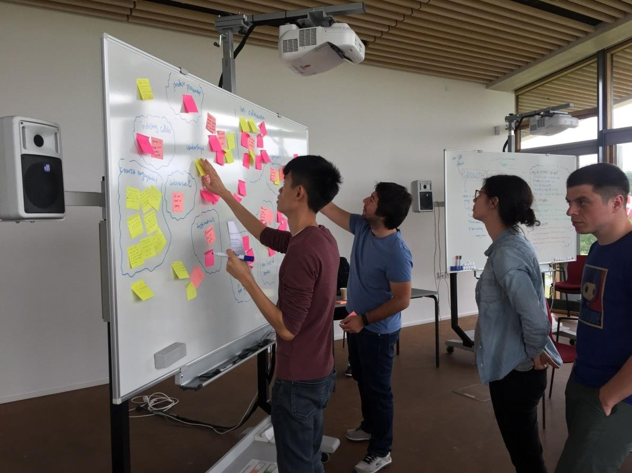

To capture everyone’s ideas in a brainstorming session, someone must play “scribe” and mark every idea on the board. Alternatively, write down your own ideas as they come, and share these with the group. Often, design problems demand mixed tactics: brainstorming and its sibling approaches – braindumping (for individuals),
and brainwriting and brainwalking (for group-and-individual mixes).

Take Care with Brainstorming
Brainstorming involves harnessing synergy – we leverage our collective thinking towards a variety of potential solutions. However, it’s challenging to have boundless freedom. In groups, introverts may stay quiet while extroverts dominate. Whoever’s leading the session must “police” the team to ensure a healthy, solution-focused atmosphere where even the shiest participants will speak up. A warm-up activity can cure brainstorming “constipation” – e.g., ask participants to list ways the world would be different if metal were like rubber.

What is gamestorming?

Gamestorming is a form of brainstorming that leverages the use of games.
As we all know, playing games enforces rules, effectively helping to overcome the usual brainstorming limitations. The way brainstorming avoids conflicts is by shifting group and thought dynamics.

To give you a real life example, at Collaboard we need to coordinate employees across multiple locations, and found that gamestorming (especially when facilitated through our app Collaboard) makes it easier to handle collaborative and creative processes.

We started to test it, mainly out of our love for innovation, and played the 3- 12-3 Brainstorm game, ideated by James Macanufo, involving employees in three different locations: Zurich, Munich and Milano. Keep reading to discover this amazing technique.

The 3-12-3 Brainstorming: a new approach to creative collaboration
So, how does this game work? There can be up to 10 players, who must follow these rules:

First of all, they must choose a two-word topic to focus on.
After the choice, phase one of the game begins: for 3 minutes, each team member brainstorms on his own and writes down their ideas on sticky notes.
When everyone’s done brainstorming, the team is divided into sub- teams of 2 people each. This is the beginning of phase 2.
For 12 minutes, teams pick three random cards and develop a full- fledged concept.
In phase 3, teams have 3 minutes each to present their ideas to everyone else.
All you need is Collaboard!

So, back to our experiment: we decided to brainstorm some ideas for Christmas Cards. For the sake of simplicity, we split our team into 3 sub- teams according to their physical location: Berlin, Zurich, Munich.

Phase One

This first phase is all about generating ideas. Each team member is on his own and must write on sticky notes whatever idea comes to mind.
This part felt very similar to classic brainstorming, but we quickly noticed two differences:

Each person was using their own device, so they didn’t fear judgment from their peers, and didn’t forget what they wanted to say/write while waiting for their turn.
The limited time of 3 minutes meant that there was no space for self- doubt. As sticky notes were being written, they were quickly moved into a grid library.

Phase Two

Once solo brainstorming was completed, each team member selected three random stick notes from the library to start developing concepts around them.

We found this phase a bit more challenging than the first one, as the cards could involve clashing ideas. But this is exactly where collaboration steps in: the team has to work together in order to consolidate the ideas into a final, collaborative project.

With Collaboard by our side, visualizing and working through sketches, images, prototypes and concepts made the process way easier

Phase Three

Finally, we approached the final phase. Using sketches created in phase two, we proceeded to present our final ideas to the team.

The integration with Skype for Business made the remote presentation extremely easy - we ended up with three different proposals (ready to be approved by the marketing manager) in less than 30 minutes, which is hard to imagine with a traditional brainstorming session!

Also, we all could leverage other teams’ ideas, nurturing collaboration and strengthening our connection.

Observational empathy is a crucial aspect of the design thinking process that involves closely observing and understanding the experiences, behaviors, and needs of users by immersing oneself in their environment. It is a method of gaining deep insights into users' lives, thoughts, and emotions, which helps designers create more meaningful and user-centered solutions.

In observational empathy, designers go beyond simply asking users about their preferences or needs. Instead, they spend time directly observing users in their natural context, without interrupting or interfering with their actions. This approach allows designers to understand how users interact with products, services, or environments and how they overcome challenges or frustrations.

Observational empathy
Key aspects of observational empathy include:

- **Active Observation**: Designers keenly observe users' behaviors, gestures, facial expressions, and body language to understand their emotions and reactions.

- **Listening and Note-taking**: They listen attentively to users' conversations and take notes on their experiences, pain points, and unmet needs.

- **Contextual Understanding**: Observational empathy takes place in the real environment where users use the product or service, providing context- rich information for design decisions.

- **Identifying Unspoken Needs**: Through observation, designers can identify needs that users may not explicitly communicate or may not be aware of themselves.

- **Avoiding Assumptions**: Observational empathy helps designers avoid making assumptions about users' preferences or behaviors, as it relies on direct evidence.

By practicing observational empathy, designers can gain a deeper and more holistic understanding of their target audience. This empathetic understanding forms the foundation for creating solutions that truly resonate with users and provide a positive impact on their lives. It is an essential step in the design thinking process, enabling designers to design with empathy and solve real problems effectively.

Unit-2 Foundations of UI Design

Visual and UI Principles- UI Elements and Patterns – Interaction Behaviors and Principles –Branding- Style Guides

2 Marks

- What are Visual Design Principles
5 key visual design principles that impact UX:
  - Scale: The relative size of elements in a design. It helps create emphasis, guide attention, and add visual interest.
  - Visual Hierarchy: The arrangement of elements to establish a clear order of importance. It guides users through content and makes information easier to understand.
  - Balance: Distributing visual weight evenly in a design to achieve stability. It ensures that no single element overpowers others, leading to a harmonious composition.
  - Contrast: Differences in color, size, or other attributes that create distinction between elements. Contrast enhances readability and draws attention to essential information.
  - Gestalt: The idea that our brains perceive elements as a whole rather than individual parts. It emphasizes how elements are organized to form a unified and coherent design.

- What are UI Design Principles

The seven principles of universal design are: Equitable use, flexibility in use, simple and intuitive use, perceptible information, tolerance for error, low physical effort, and size and space

- Why UI Elements required
UI Elements
UI elements are the building blocks of a user interface, the individual parts that users see and interact with on websites, apps, and other digital product
4. What is Interaction Design?
- Interaction design (IxD) is about designing how users interact with products, especially software products like apps and websites. The main goal is to create products that help users achieve what they want in the easiest and most effective way possible.

5. What is Gestalt Principles

Gestalt principles are a set of ideas from psychology that explain how humans make sense of complex images. Instead of seeing individual parts, our minds automatically organize them into a whole. This means we tend to perceive the complete picture rather than separate elements.
6. What is UI Pattern

User interface (UI) design patterns are reusable/recurring components which designers use to solve common problems in user interface design. For example, the breadcrumbs design pattern lets users retrace their steps. Designers can apply them to a broad range of cases, but must adapt each to the specific context of use.
7. Why is Interaction Design Important?
In today's digital world, creating a great interaction experience is crucial. It can be as simple as using a TV remote or as complex as using software. Smart tech companies understand that a pleasant interaction leaves users satisfied or delighted. Remember the first time you used an iPhone?

Steve Jobs, the founder of Apple, emphasized that design is not just about looks but also about how things work and how users feel about them.

Here are some important interaction design principles:
- Match user experience and expectations.
- Maintain consistency in design throughout the application.
- Follow functional minimalism by keeping things simple and useful.
- Reduce mental pressure and make the application easy to understand.
- Design interactively to keep users engaged.
- Allow users to have control, trust, and explore the product.
- Use intuitive and interactive media to invite interactions.
- Make user interactions easy to learn and remember.
- Take care to prevent errors and handle them effectively if they occur.
- Use familiar and physical-world interactions to make actions feel natural.

8. What are the Need for Branding in UI Design:**
- **Recognition:** Consistent branding elements help users identify the product with the company, even across different platforms and touchpoints.

- **Trust and Credibility:** A strong brand presence instills confidence in users, making them more likely to engage with the product.

- **Consistency:** Branding ensures a unified and cohesive experience, making the product feel more reliable and professional.

- **Differentiation:** In a competitive market, branding sets the product apart from competitors, making it stand out in users' minds.

9. What are the Stages of Branding in UI Design:**
- **Brand Strategy:** Define the brand's core values, target audience, and unique selling proposition (USP). This stage sets the foundation for the visual elements that will be used in the UI design.

- **Visual Identity Design:** Create the visual elements that represent the brand, such as the logo, color palette, typography, and iconography. These elements should align with the brand strategy.

- **UI Design Integration:** Incorporate the brand's visual identity into the UI design. Use the chosen colors, typography, and other elements to create a consistent and on-brand interface.

- **Brand Guidelines:** Document the brand guidelines that outline how the visual elements should be used in the UI design. These guidelines ensure consistency across different designers and projects.
- **User Testing:** Test the UI design with real users to ensure that the branding elements resonate with the target audience and provide a positive user experience.

By integrating branding into the UI design process, companies can create a memorable and cohesive user experience that reflects their identity and values, ultimately leading to increased user engagement and loyalty.

- What is Style Guide

Style guides in UI design are like detailed manuals that explain how a product or website should look and feel. They help designers, developers, and others follow consistent design rules for colors, fonts, icons, and more.

- What are the needs of Style guides

The need for style guides includes:
- Making sure everything in the design looks the same and works well.

- Saving time and effort by giving a reference for designers and developers to follow.
- Keeping a consistent brand image by defining how logos and colors should be used.

The stages of creating style guides are:
- Doing research about the brand and target audience.
- Creating the visual elements like colors and icons for the design.
- Making a library of reusable components like buttons and cards.
- Writing down all the design rules and guidelines in a document.
- Testing the design with real users and making improvements.
- Integrating the style guide into the design and development process.

15 Marks

- Explain about Visual Design Principles

When we look at something, we often instinctively know if it looks good or not, thanks to the emotional response it elicits. Though we may struggle to put it into words, certain design elements can make visuals more appealing and effective in user experience.
Here are 5 key visual design principles that impact UX:
  - Scale: The relative size of elements in a design. It helps create emphasis, guide attention, and add visual interest.
  - Visual Hierarchy: The arrangement of elements to establish a clear order of importance. It guides users through content and makes information easier to understand.
  - Balance: Distributing visual weight evenly in a design to achieve stability. It ensures that no single element overpowers others, leading to a harmonious composition.
  - Contrast: Differences in color, size, or other attributes that create distinction between elements. Contrast enhances readability and draws attention to essential information.
  - Gestalt: The idea that our brains perceive elements as a whole rather than individual parts. It emphasizes how elements are organized to form a unified and coherent design.
By adhering to these principles, designers can create engaging and user-friendly visuals that enhance the overall experience.

Scale
Scale in visual design involves using relative size to communicate importance and rank within a composition. Important elements are made larger than less significant ones, making them more noticeable. A visually appealing design typically uses up to three different sizes to create variety and establish a visual hierarchy. By emphasizing essential elements through size, users can easily understand and interact with the design

.
Medium for iPhone: Popular articles are visually larger than other articles. The scale directs users to potentially more-interesting article.

Visual Hierarchy

Visual hierarchy is about guiding the user's eye to focus on important elements first. It's achieved by using various design cues like size, color, spacing, and placement. A good layout with clear visual hierarchy makes it easy for users to understand the content and its importance. You can use different font sizes, bright colors for important items, and muted colors for less important ones to create a clear hierarchy.
Including small, medium,
and large elements in the design helps establish a balanced scale and reinforce the visual hierarchy..

Medium mobile app: There is a clear visual hierarchy of title, subtitle, and body text. Each component of the article is in a type size equal to its importance.
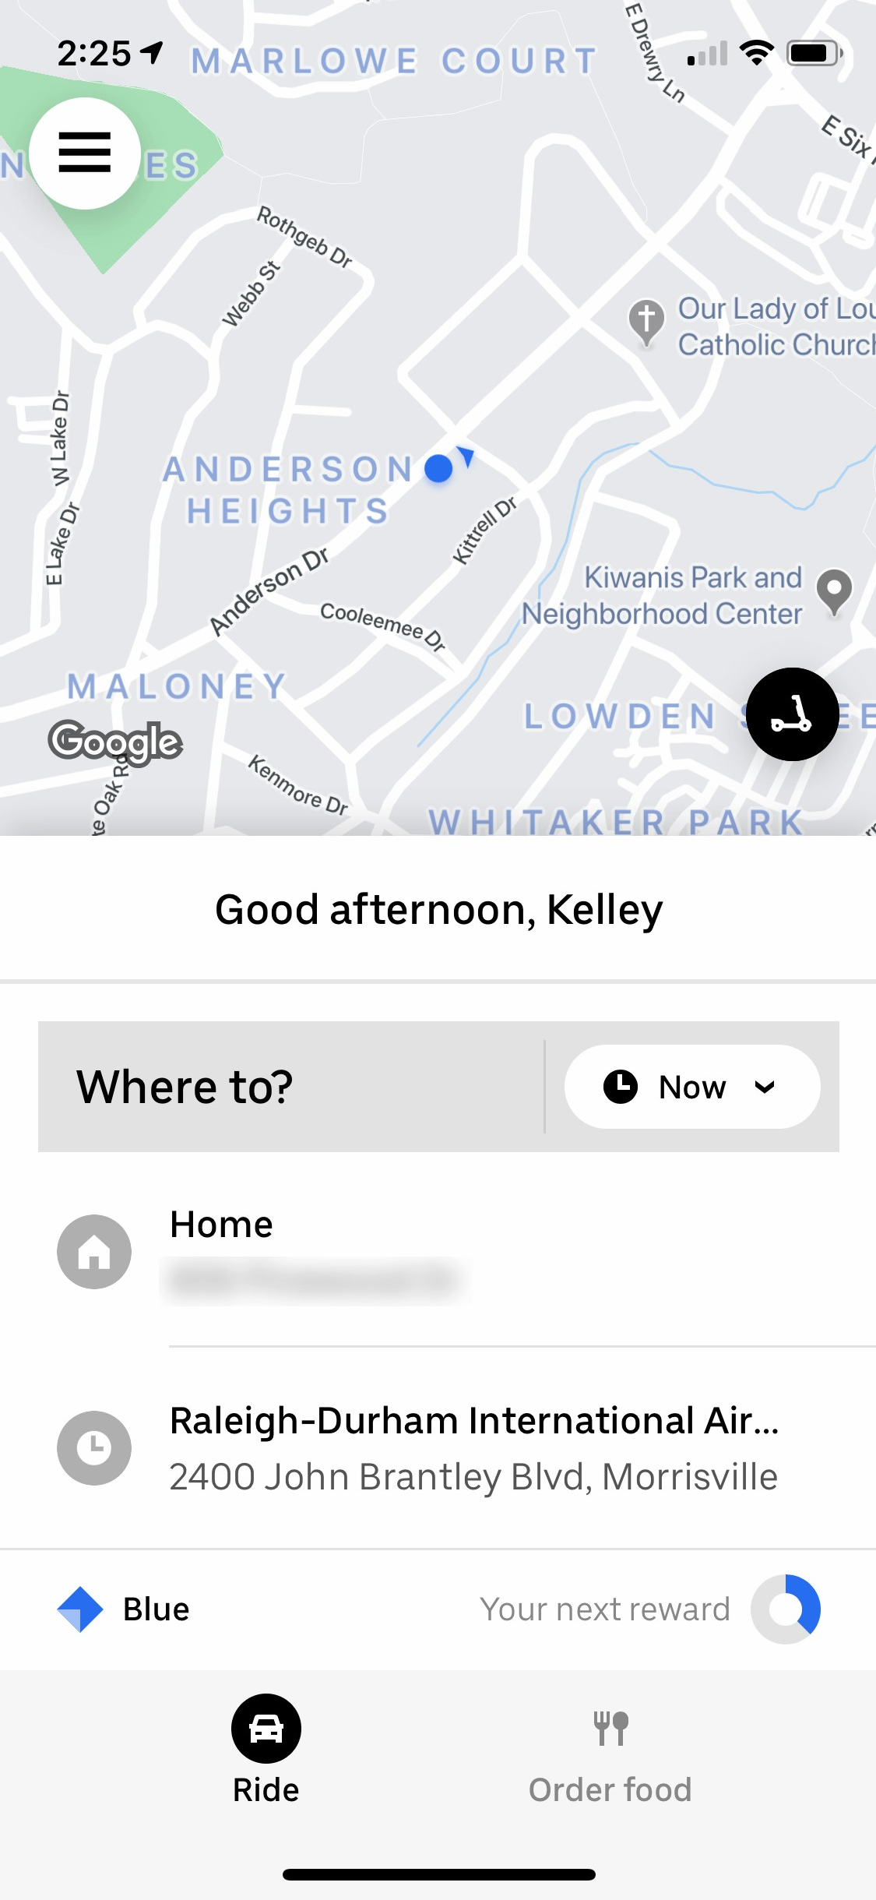

Uber mobile app: The visual hierarchy is clear in Uber’s mobile app. The screen is split in half between the map and input form (bottom half of screen), which enforces the thought that these components are equally important to the user. The eye is immediately drawn to the Where to? field because of its gray background, then to the recent locations below it, which are slightly smaller in font size

Balance
Balance in visual design is like a seesaw, where you arrange elements to create a pleasing proportion. It means having an equal distribution of visual elements on both sides of an imaginary line running through the middle of the screen. This line can be vertical or horizontal.

To achieve balance, you need to consider the size and space taken by elements, not just their number. If one side has a large element and the other side has a small one, the design feels unbalanced.

There are three types of balance:

- Symmetrical - elements are evenly distributed on both sides of the central axis.

- Asymmetrical - elements are unevenly distributed, creating a sense of movement and energy.

- Radial - elements radiate out from a central point, guiding the eye to the center of the composition.

The choice of balance depends on the message you want to convey. Asymmetry is dynamic and engaging, while symmetry is calm and static. Radial balance always draws attention to the center. Achieving balance ensures that no area overwhelms others, creating a harmonious and pleasing design.

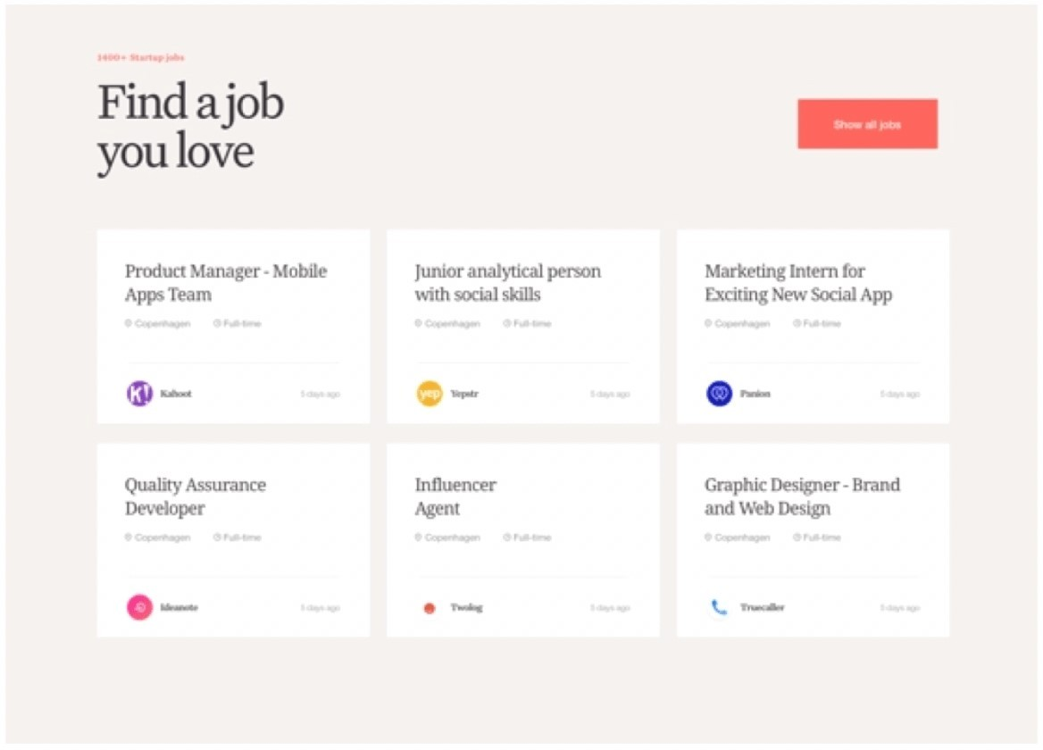
The Hub Style Exploration: The composition feels stable, which is especially appropriate when you’re looking for a job you love. The balance here is symmetrical. If you were to draw an imaginary vertical axis down the center of the website, elements are distributed equally on both sides of the axis. (Image source: dribbble.com)

Contrast
Contrast is a powerful principle in design that highlights differences between elements. It involves placing visually dissimilar things together to show that they belong in different categories or serve distinct purposes. For example, using bright colors like red to signify deletion in a UI design makes the element stand out from the rest, emphasizing its unique function. Contrast helps users quickly identify and understand important information, making the design more effective and user- friendly

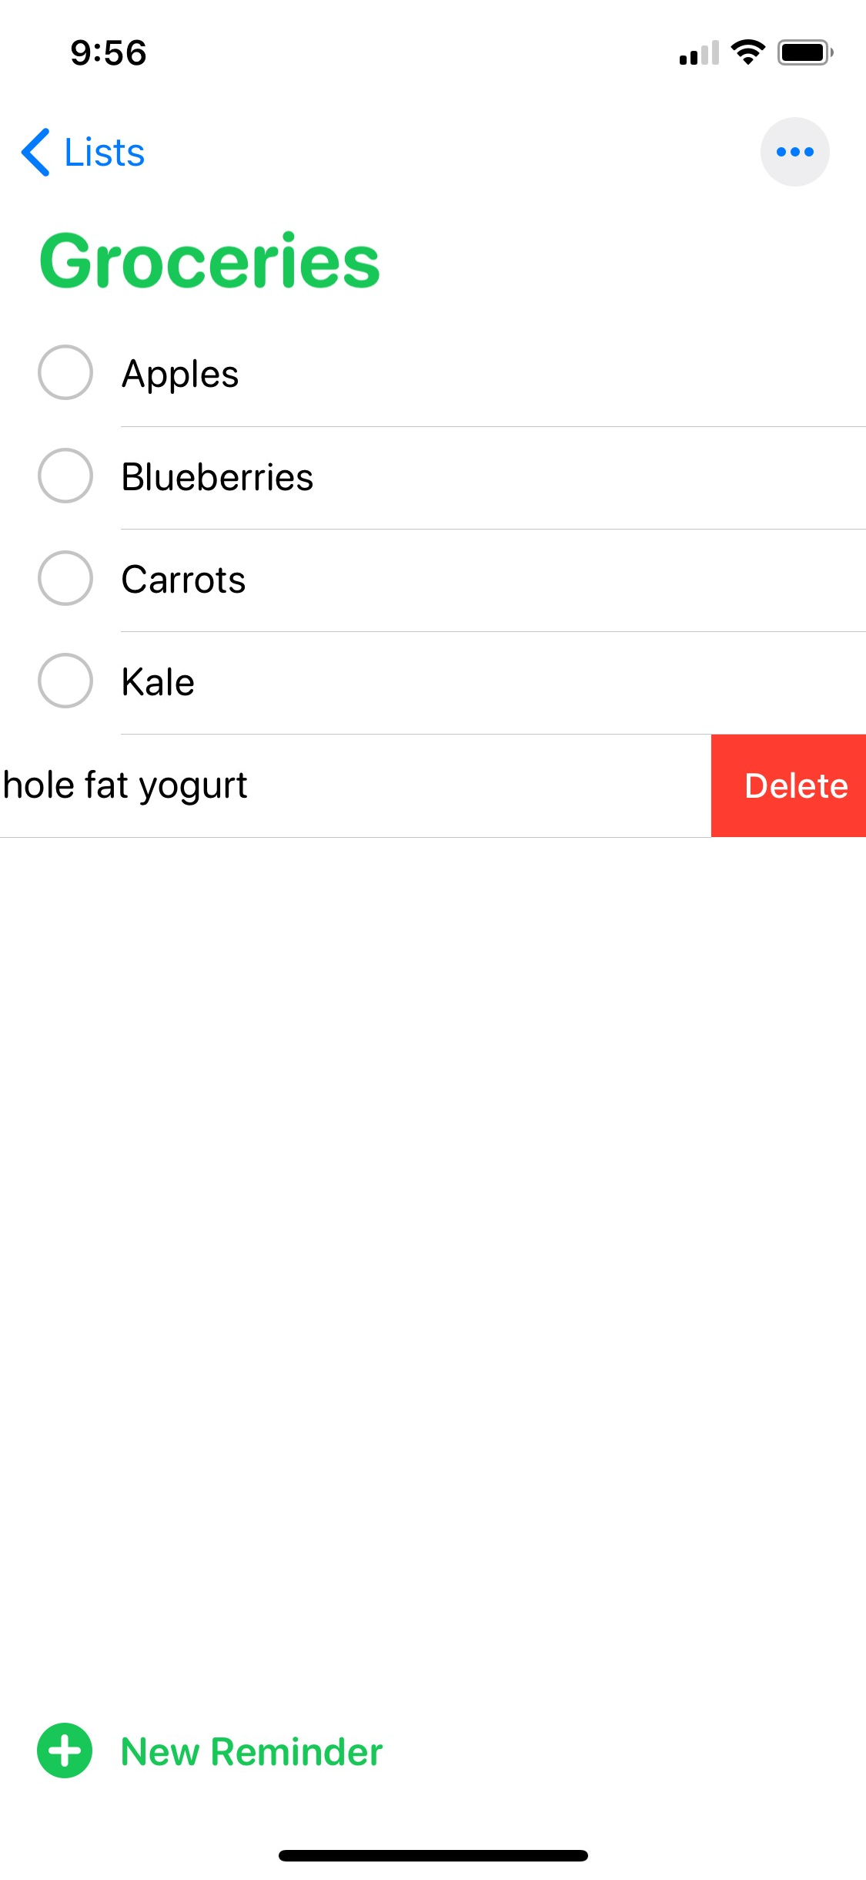
.
Reminders app on iOS: The color red, which has high contrast to its surrounding context, is reserved for deleting.

Often, in UX the word “contrast” brings to mind the contrast between text and its background. Sometimes designers deliberately decrease the text contrast in order to deemphasize less important text. But this approach is dangerous — reducing text contrast also reduces legibility and may make your content inaccessible. Use a
color-contrast checker to ensure that your content can still be read by all your target users.

Greenhouse Juice Co: The legibility of the text on the bottle relies on the color of juice. Although the contrast works beautifully for some juices,

labels for bottles with light colored juices are nearly impossible to read. (Image source: www.instagram.com)

Gestalt Principles
Gestalt principles are a set of ideas from psychology that explain how humans make sense of complex images. Instead of seeing individual parts, our minds automatically organize them into a whole. This means we tend to perceive the complete picture rather than separate elements.

These principles include similarity, continuation, closure, proximity, common region, figure/ground, and symmetry and order. One important principle for UX is proximity, which means that items visually close together are seen as belonging to the same group. These principles help designers create visuals that are easy for users to

understand and navigate.
It is the Gestalt closure principle that allows us to see two figures kissing instead of random shapes in Picasso’s painting. Our brains fill in the missing pieces to create two figures.

We also often see applications of the Gestalt theory in logos. In the NBC logo, there is no peacock in the white space, but our
brain understands there to be one.

- Explain about UI Design Principle:
The seven principles of universal design are: Equitable use, flexibility in use, simple and intuitive use, perceptible information, tolerance for error, low physical effort, and size and space for approach and use.

  - The seven principles of universal design are: Equitable use, flexibility in use, simple and intuitive use, perceptible information, tolerance for error, low physical effort, and size and space for approach and use.

Equitable Use: The design should be usable by all individuals, regardless of their age, abilities, or background. It ensures that everyone can access and interact with the product or environment in a fair and inclusive manner.
  - Flexibility in Use: The design should accommodate a wide range of individual preferences and abilities. It offers multiple ways to interact with the product or environment, allowing users to choose the approach that suits them best.
  - Simple and Intuitive Use: The design should be easy to understand and use, requiring minimal effort to figure out its operation. Clear instructions and logical layouts make it intuitive for users to navigate and perform tasks.
  - Perceptible Information: The design should present information effectively to all users, regardless of their sensory abilities. It ensures that important information is available through multiple senses (e.g., visual, auditory, tactile) so that users can perceive and comprehend it easily.
  - Tolerance for Error: The design should minimize the risk of errors and provide ways to recover from mistakes. It avoids critical consequences for unintended actions and offers clear feedback to guide users in correcting errors.
  - Low Physical Effort: The design should require minimal physical effort to use. It considers the needs of users with varying physical abilities, making interactions comfortable and not overly demanding on strength or dexterity.
  - Size and Space for Approach and Use: The design should provide adequate space and reach ranges to accommodate users of different sizes and mobility. It ensures that individuals using mobility aids or who have limited reach can comfortably access and use the design.

UI Elements
UI elements are the building blocks of a user interface, the individual parts that users see and interact with on websites, apps, and other digital product

- Buttons: Buttons are like interactive squares or circles that you can click or tap on. They perform actions like "Submit," "Next," or "Cancel."

- Text Fields:Text fields are areas where you can type in text, like when you search for something or enter your name.

- Checkboxes:Checkboxes are like little boxes that you can tick or un-tick to make a choice from a list of options.

- Radio Buttons: Radio buttons are like small circles or dots that you can select, but you can only choose one option from a group of choices.

- Icons:Icons are small pictures or symbols that represent actions or ideas, like a magnifying glass for search or a home symbol for the homepage.

- Dropdown Menus: Dropdown menus are like hidden lists that appear when you click on a button or a label. They show you more options to choose from.

- Sliders: Sliders are like bars or scales that you can slide left or right to adjust settings or choose a value.

- Tabs: Tabs are like labeled sections that you can click on to switch between different parts of a website or app.

- Tooltips: Tooltips are like small pop-up boxes that show extra information when you hover your mouse over something.

- Cards:Cards are like little containers that hold information, like a picture, a title, and a short description, neatly displayed together.
These UI elements help users interact with websites and apps by clicking, typing, or selecting options, making the overall experience more intuitive and enjoyable.

3. Explain about UI Patterns
User interface (UI) design patterns are reusable/recurring components which designers use to solve common problems in user interface design. For example, the breadcrumbs design pattern lets users retrace their steps. Designers can apply them to a broad range of cases, but must adapt each to the specific context of use.

Common UI Design Patterns
Some of the most common UI design patterns are:
- Breadcrumbs – Use linked labels to provide secondary navigation that shows the path from the front to the current site page in the hierarchy.
- Lazy Registration – Forms can put users off registration. So, use this sign-up pattern to let users sample what your site/app offers for free or familiarize themselves with it. Then, you show them a sign-up form. For example, Amazon allows unrestricted navigation and cart-loading before it prompts users to register for an account. Note:
  - When content is accessible only to registered users or users must keep entering details, offer them simplified/low-effort sign-up forms.
  - Minimize/Avoid optional information fields. Use the Required Field Markers pattern to guide users to enter needed data.
- Forgiving Format – Let users enter data in various formats (e.g., city/town/village or zip code).
- Clear Primary Actions – Make buttons stand out with color so users know what to do (e.g., “Submit”). You may have to decide which actions take priority.
- Progressive Disclosure – Show users only features relevant for the task at hand, one per screen. If you break input demands into sections, you’ll reduce cognitive load (e.g., “Show More”).
- Hover Controls – Hide nonessential information on detailed pages to let users find relevant information more easily.
- Steps Left – Designers typically combine this with a wizard pattern. It shows how many steps a user has to take to complete a task. You can
use gamification (an incentivizing design pattern) here to enhance engagement.
- Subscription Plans – Offer users an options menu (including “Sign-up” buttons) for joining at certain rates.
- Leaderboard – You can boost engagement if you use this social media pattern.

- Dark Patterns – Some designers use these to lead or trick users into performing certain actions, typically in e-commerce so they spend more or surrender personal information. Dark patterns range in harmfulness. Some designers leave an unchecked opt-out box as a default to secure customer information. Others slip items into shopping carts. To use dark patterns responsibly, you must be ethical and have empathy with your users. Dark patterns are risky because user mistrust and feedback can destroy a brand’s reputation overnight.

What is Interaction Design?
- Interaction design (IxD) is about designing how users interact with products, especially software products like apps and websites. The main goal is to create products that help users achieve what they want in the easiest and most effective way possible.

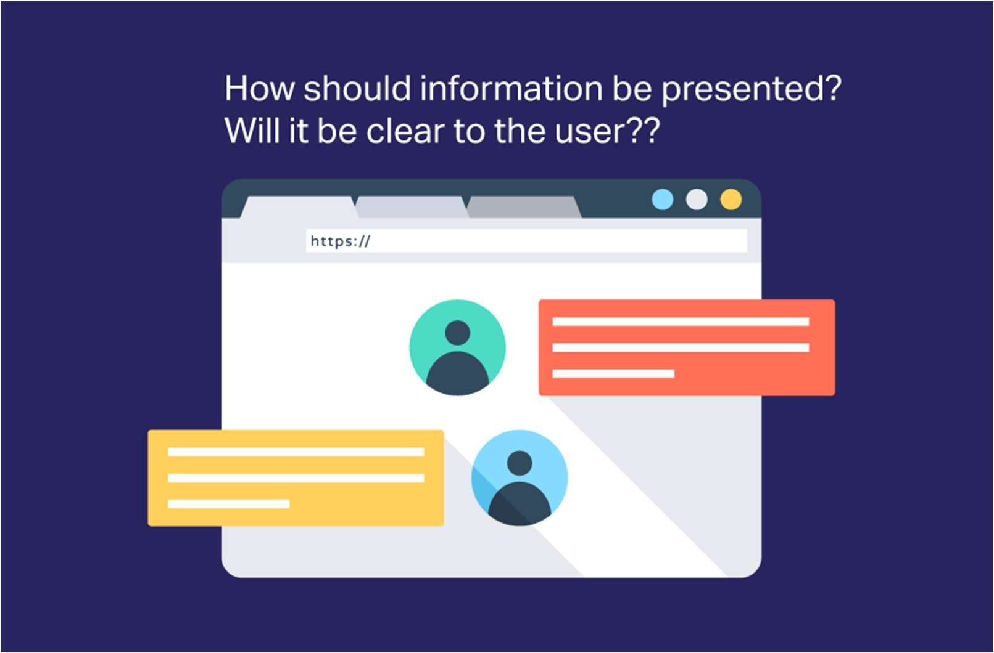
- Interaction designers work on various elements like how things look, move, sound, and the space they take up. For example, they might create sounds for user actions. They think about whether the product behaves in a way that users expect and if users can achieve their goals without much effort.
- In some cases, UX designers are also responsible for interaction design along with other aspects of product design. Overall, interaction design is about making products user-friendly and intuitive for people to use.

How Does Interaction Design Differ from UX Design?
- Interaction design and UX design have similarities, but they are not the same thing. Interaction design focuses on how users interact with a product, making sure the interactions are smooth and easy. It deals with elements like how things move, look, and sound to create a good user experience.

- On the other hand, UX design is broader. It involves understanding the users through research, creating user personas to know their needs, and testing the product with real users. UX designers ensure the entire experience of using the product is great, not just the interactions.

  - 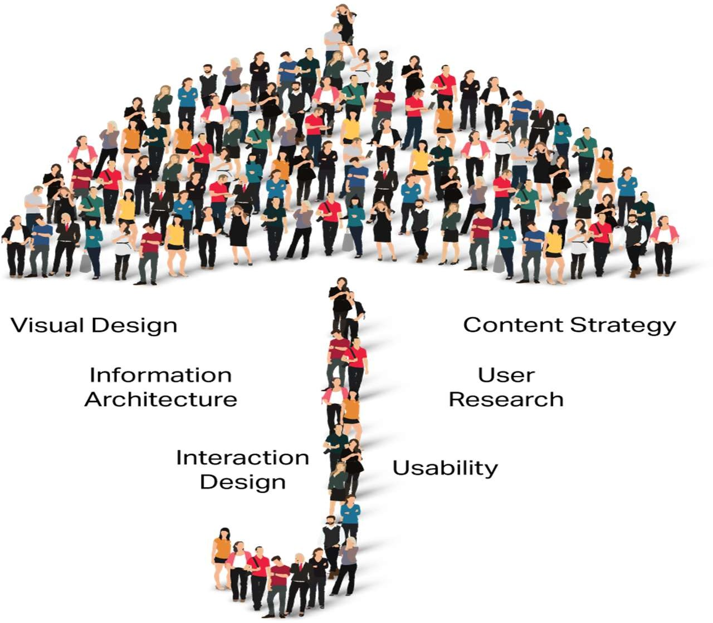In simple terms, interaction design is a part of UX design, but UX design covers more aspects beyond just the interactions.
- Interaction design is a part of UX design, which is about creating a great experience for users when they use a product. Interaction designers focus on improving the way users interact with the product. For example, making sure the TV remote or doorknob is easy to use.
- UX designers look at the whole user journey, not just the moment of interaction. They consider all aspects of the product that users interact with. Interaction design is like a small part of the bigger picture of user experience design. It's impossible to have good interaction design without considering the overall user experience.

Why is Interaction Design Important?
In today's digital world, creating a great interaction experience is crucial. It can be as simple as using a TV remote or as complex as using software. Smart tech companies understand that a pleasant interaction leaves users satisfied or delighted. Remember the first time you used an iPhone?

Steve Jobs, the founder of Apple, emphasized that design is not just about looks but also about how things work and how users feel about them.

Here are some important interaction design principles:
Match user experience and expectations.
Maintain consistency in design throughout the application.
Follow functional minimalism by keeping things simple and useful.
Reduce mental pressure and make the application easy to understand.
Design interactively to keep users engaged.
Allow users to have control, trust, and explore the product.
Use intuitive and interactive media to invite interactions.
Make user interactions easy to learn and remember.
Take care to prevent errors and handle them effectively if they occur.
Use familiar and physical-world interactions to make actions feel natural.

The interaction design process involves five stages:
- Discover users' real needs by observing, interviewing, and analyzing existing solutions.
- Design a potential solution based on design guidelines and principles, using techniques that match users' interaction preferences.

- Start prototyping to give users a glimpse of the product and gather feedback for improvement.
- Implement and deploy the final version of the product.
- The process is iterative, meaning it may take multiple rounds of testing and refinement to reach the best solution.

Understanding your users' needs and continuously adapting to their feedback is vital in the interaction design process. Design thinking is a helpful approach to gain insights and create features that truly serve users' needs and desires. By empathizing with users, designers can identify their real-world needs and provide better solutions.

5. Mention about Branding

Branding in UI design is the process of incorporating a company's visual identity and personality into the user interface of a product or website. It involves using consistent colors, typography, logos, and other design elements to create a recognizable and cohesive brand image. Branding is essential in UI design as it helps users associate the product with the company and builds trust and familiarity.

**The Need for Branding in UI Design:**
- **Recognition:** Consistent branding elements help users identify the product with the company, even across different platforms and touchpoints.

- **Trust and Credibility:** A strong brand presence instills confidence in users, making them more likely to engage with the product.

- **Consistency:** Branding ensures a unified and cohesive experience, making the product feel more reliable and professional.

- **Differentiation:** In a competitive market, branding sets the product apart from competitors, making it stand out in users' minds.

**The Stages of Branding in UI Design:**
- **Brand Strategy:** Define the brand's core values, target audience, and unique selling proposition (USP). This stage sets the foundation for the visual elements that will be used in the UI design.

- **Visual Identity Design:** Create the visual elements that represent the brand, such as the logo, color palette, typography, and iconography. These elements should align with the brand strategy.

- **UI Design Integration:** Incorporate the brand's visual identity into the UI design. Use the chosen colors, typography, and other elements to create a consistent and on-brand interface.

- **Brand Guidelines:** Document the brand guidelines that outline how the visual elements should be used in the UI design. These guidelines ensure consistency across different designers and projects.
- **User Testing:** Test the UI design with real users to ensure that the branding elements resonate with the target audience and provide a positive user experience.

By integrating branding into the UI design process, companies can create a memorable and cohesive user experience that reflects their identity and values, ultimately leading to increased user engagement and loyalty.

Style Guide

Style guides in UI design are like detailed manuals that explain how a product or website should look and feel. They help designers, developers, and others follow consistent design rules for colors, fonts, icons, and more.

The need for style guides includes:
- Making sure everything in the design looks the same and works well.

- Saving time and effort by giving a reference for designers and developers to follow.
- Keeping a consistent brand image by defining how logos and colors should be used.

The stages of creating style guides are:
- Doing research about the brand and target audience.
- Creating the visual elements like colors and icons for the design.
- Making a library of reusable components like buttons and cards.
- Writing down all the design rules and guidelines in a document.
- Testing the design with real users and making improvements.
- Integrating the style guide into the design and development process.

By using style guides, UI designers can create a user-friendly and cohesive interface that represents the brand well and gives a positive user experience.

CCS370 UI AND UX DESIGN

UNIT III FOUNDATIONS OF UX DESIGN
Introduction to User Experience - Why You Should Care about User Experience - Understanding User Experience - Defining the UX Design Process and its Methodology - Research in User Experience Design - Tools and Method used for Research - User Needs and its Goals - Know aboutBusiness Goals

2 Marks
- What are the factors of UX Design

Usability:
User-Centered Design:
Information Architecture:
Visual Design:
Interaction Design:.
Accessibility:
Performance:

- What are the key reasons why you should care about user experience:
Enhances Product Quality:
Meets User Expectations:
Boosts User Satisfaction:
Reduces Costs:
Drives Innovation:
Increases Accessibility:
Fosters Empathy:
Supports Business Goals:
Adapts to Evolving Technology:
Prepares for Industry Demand:

What is UX Design

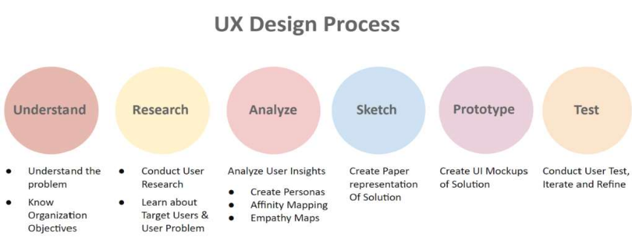
- What are the ways of con ucting User Test are
d

Usability Testing

Usability testing evaluates the degree to which the system specified users with
can be used by

effectiveness, efficiency and satisfaction in a specified context of use- ISO
9241 Ergonomics of hu an-system interaction
m

It is a great method Product. Usability refers
w
hich allows you to improve the to the ease with which a user can
Usability of the se a product in

order to achieve his/her goal and how useful the Product is. A product which is
u

high on usability makes it easy for user to accomplish his/her g
o

Concept testing
als.

When you have a big idea, it becomes important to check and evaluate whether
or not it would be accepted by people when launched in the arket . Concept
m
testing is done to evaluate consumer acceptance for a new product idea.

Concept testing helps to validate as well as refine a product concept by getting feedback directly from target market.

First Click Testing

First-click testing is the best way to improve your App/website designs. It allows you to analyze where the User clicks on the screen when the website or app is shown to them.

Tree Testing

Tree testing is a usability technique for evaluating the ease with which information can be found in a website. However, unlike Usability testing, Tree Testing is done on the simple version of site structure.

Beta Testing

In Beta testing, you test a near-complete product/software/application with end users (called Beta Testers) . Before Launching the product in the market, enough tests need to be carried out to test the functionalities and reporting bugs.

What are Empathy Mapping
An Empathy Map is another method to synthesize the observations to uncover unexpected insights around user needs. Moreover, it can be drawn on a board, paper or table and has four quadrants representing the four key user traits.

By Analysing and Synthesizing the information, you would be able yo Defining
your Point-of-view state ent which would Define the Right Problem or simply
m
define the Challenge to address.

15 Marks

INTRODUCTION TO USER EXPERIENCE (UX)
User Experience (UX) is a crucial aspect of design and technology that focuses on enhancing the overall satisfaction and usability of a product or service. In short, UX encompasses a wide range of factors, including:
Usability: UX ensures that a product or service is easy to use and navigate, making it accessible to a broad audience.
User-Centered Design: It involves designing products or services with the needs, preferences, and behaviors of users in mind. This approach often includes user research and testing.
Information Architecture: Organizing information and content in a logical and user-friendly manner to facilitate easy navigation.
Visual Design: Creating visually appealing and coherent interfaces that align with the brand and resonate with users.
Interaction Design: Focusing on how users interact with a product, including the design of buttons, forms, and other interactive elements.
Accessibility: Ensuring that the product can be used by people with disabilities, making it inclusive and compliant with accessibility standards.
Performance: Optimizing the speed and responsiveness of a product to prevent frustration and delays.
Emotional Design: Recognizing that users form emotional connections with products, and designing experiences that evoke positive emotions.
User Feedback and Testing: Continuously gathering feedback from users and conducting usability testing to identify and address issues.
**********

WHY YOU SHOULD CARE ABOUT USER EXPERIENCE
Here are some key reasons why you should care about user experience:
Enhances Product Quality: Emphasizing UX in design and development leads to products and services that are of higher quality. A positive UX can make the difference between a successful and unsuccessful product.
Meets User Expectations: In the digital age, users have high expectations for usability and functionality. Teaching UX helps students design products that meet or exceed these expectations.
Boosts User Satisfaction: Products and services that prioritize UX are more likely to satisfy users, leading to increased customer loyalty and positive word- of-mouth recommendations.
Reduces Costs: Identifying and fixing usability issues early in the design process is more cost-effective than addressing them after a product is launched. UX can save time and resources in the long run.
Drives Innovation: UX encourages innovative thinking by challenging students to find creative solutions to user problems and needs.
Increases Accessibility: Teaching UX includes considerations for accessibility, making technology more inclusive for people with disabilities, which is not only ethical but also often legally required.
Fosters Empathy: UX design requires students to understand and empathize with users, teaching them valuable soft skills such as empathy, communication, and teamwork.
Supports Business Goals: Good UX can lead to increased sales, conversions, and user engagement, which align with the goals of many businesses and organizations.
Adapts to Evolving Technology: UX principles are adaptable to various technologies and platforms, ensuring that students can apply their knowledge to a wide range of projects.
Prepares for Industry Demand: Many tech companies and startups actively seek professionals with UX expertise. Teaching UX prepares your students for in-demand careers.

Ethical Considerations: UX design also includes ethical considerations, such
as data privacy and user consent. Teaching these principles ensures responsible use of technology.

Global Reach: In an interconnected world, technology often serves a global
audience. UX design helps students create products that resonate with diverse user groups.

*************

UX Desig Process and Its Methodolo ies
n
g

UX Design process is a method which helps a
process of solving User Problem. It is an iterative UX Designer to continuously improve and polish

designs based on User Feedback.
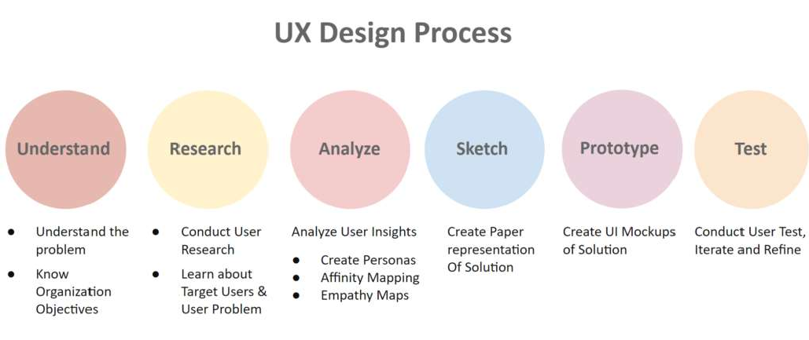

6 Steps of UX Design Process Step 1 : Understand
UX design is the process of solving a problem for user so that they can achieve their goals easily. In order to do this, the first step is to understand the problem you would solve and the objectives of the organization as well.

There can be multiple ways to do this

- If you working for an agency then ask your clients
- Working for an organization then ask the stakeholders
- Ask for previous research conducted which can include market research, User research, competitor analysis, etc.)

- Speak to the Product Managers as well
- Analyze requirements to understand and clarify them Getting understanding about two elements is crucial
- User
- Brand

Understanding these Key elements would help you create a Design Strategy that would align the goals and objectives of User and business . And forms a base for your next step where you would conduct user research to dig deep into the User Problem.

Outcome :-

By the end of Step 1, you would get a good understanding of the Design Strategy and objectives of the Organization. This would guide you on how to carry on User Research.

Step 2 : Research

User Experience (UX) research—serves many purposes throughout the design process. It not just helps us to get a clear picture of about users, but also answers key questions like what users think and why they do what they do.

And in order to do so you need to ‘walk their shoes’. You need to learn about the Target Audience Hence, it is extremely essential that user experience research and Design teams conduct user research regularly.

Additionally, It also helps us identify and prove or disprove our assumptions. In Bigger organization, research is conducted by a UX Researcher. However in smaller organizations/startups , a UX Designer has to wear multiple hats to perform multiple jobs.

Primarily, there are two UX Research methods

Qualitative Research : Exploratory form of the research where the researcher collects verbal, behavioral or observational data which is interpreted to get insights. Most common methods are

Focus Groups

Focus Group brings together 6-9 Participant users. The Goal of the Test is to discover what users want from the Product.

Furthermore, conducting Focus Groups allows you to learn about their attitude, opinion and reactions to concepts that you are testing with Users.

Contextual Interview

A contextual interview involves one-on-one interaction between user and researcher. And the interaction involves the researcher to watch and observe the user work in their environment; and then discuss those activities with them.

User Interview

User interview is one of the most common User research methods. In fact, it provides you the rich information and insights of what your target users think about your new product, site or service.

A User Interview is typically conducted by 2 UX researchers, one to conduct the interview and other to record the interview and take notes.

Ethnography Study

Ethnography is a kind of social research. It is type of qualitative research which provides a detailed and in depth description of everyday life and practice taking a wider picture of culture.

Quantitative Research : Structured way of collecting and analyzing data in numeric form. Analysis, interpretation and presentation of numerical data is done by using Statistical techniques .

Survey

Surveys consists of a set of questions to gather wide information on a wide range of topics.It is one of the most common types of quantitative research methods. Survey is an easy way of collecting quantitative data from a large number of users within lesser amount of time.

The questionnaire, or survey is completed by the person being surveyed which may be

  - an online questionnaire
  - a face-to-face interview
  - or a telephone interview.

Outcome :-

By the end of Step 2, you would get lot of User insights. This information needs to be then analysed in order to make a sense out of it and learn about key User issues.

Step 3 : Analyze

After you have conducted your Research, you would a plethora of insights which can be quantitative or qualitative. In the next step you have to analyse the information gathered and make connections around it so that you draw some conclusions.

Framing the right problem is the only way to create the right solution. Moreover, Only after you have detailed information of the wants, needs, and pain-points, you can synthesize the information into an actionable problem statement.

“If I had an hour to solve a problem, I’d spend 55 minutes thinking about the problem and 5 minutes thinking about solutions.”– Albert Einstein
There are multiple UX Techniques that you can use to Analyze the information

Creating User Personas

User Persona is a fictional yet realistic representation of Target user of the product. Creating User Personas helps you to identify what the user requirements by understanding their needs, experiences, behaviors and goals.

Affinity Mapping

Affinity Mapping is about finding the user needs from the observations gathered. The goal is to synthesize information gathered into common themes and patterns to discover interesting findings which will help in defining user focused Problem and creating design solution.

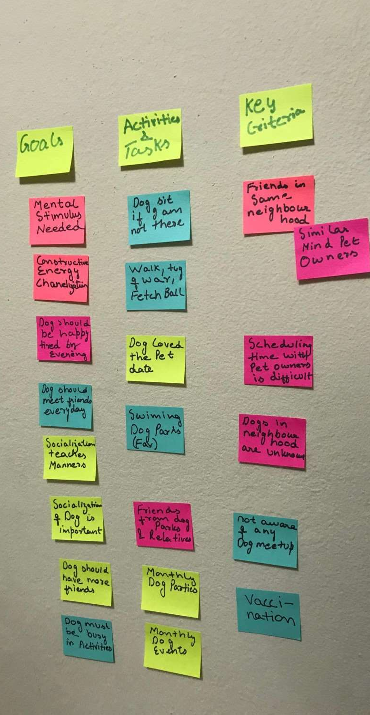Empathy Mapping

An Empathy Map is another method to synthesize the observations to uncover unexpected insights around user needs. Moreover, it can be drawn on a board, paper or table and has four quadrants representing the four key user traits.

By Analysing and Synthesizing the information, you would be able yo Defining
your Point-of-view state ent which would Define the Right Problem or simply
m
define the Challenge to address.
Based on the information we go ahead and depict paths a user would take to solve the identified problem. Creating these paths help us understand what user will be going through when using product or service. Infact, Only by identifying
and depicting such path then you build the best product for the . Some of the ways you can do it are
m

User Flows

Creating User flow is creating Visual representation of specific routes that a

user might take while navigating a website or app in order to The route starts at an entry point and then covers all the steps t to reach a certain outcome.
h
achieve a goal. e user must take

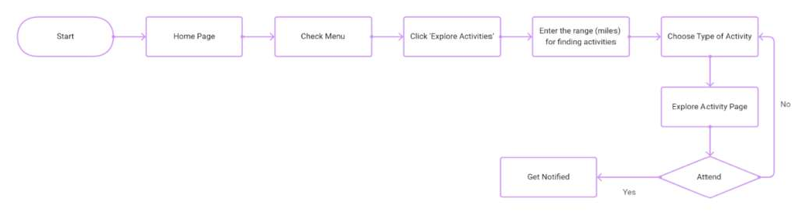

User Journey Map

User Journey map talks

bout the complete path a User takes while interacting
a

with your company which starts from the awareness stage when they realize
u

they have a need, through all the points of interaction with yo moment they are satisfied (or not).

Outcome :-
r brand, and the

By the end of Step 3, you would get a clear understanding of User Issues that would help you to define your Problem Statement. All of this would help you to brainstorm and come up with solutions to solve the User Problem

Step 4 : Sketch Designs

Now, it’s time to actually define how the content on each page should be

organized. Furthermore, together in a way that f easy to navigate.
o
g
n
you have to define how these pa r user finds that they find the desig
es would work it intuitive and

Easiest way to do this is by creating Paper Sketches. Infact creating paper
sketches and Prototyping on paper is a quick and cost-effective way to test ideas
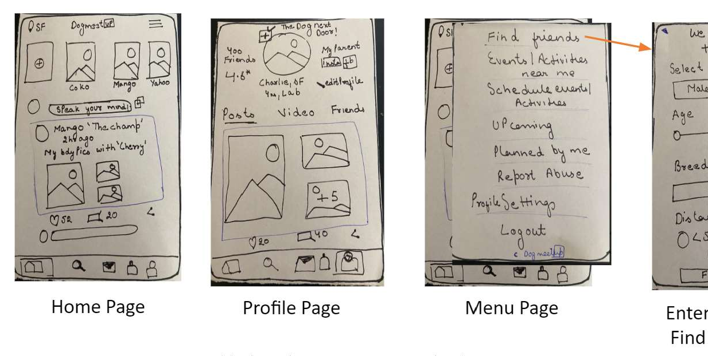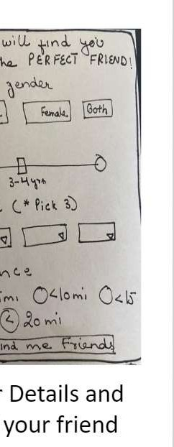in the early stages of Pro uct development.
d

It is very common for designers to move ahead and create A tual UI screens,
c
however it is the best practice to stick the lo-fi first. See, you must spend time

on exploring the design
s
lets you do just that.

Creating a Digital App Draw different sketches
and not creating the designs. And Paper Prototypes

or showing multiple steps to use a physical product- of the user interface on different piece of paper and

simulate interactivity by linking and moving series of paper on table. This is quick and easy, best in the early stages of Product Development.

Make sure you review the design with team members and then move ahead to design it.

Tools Used – Pen and Paper

Outcome :-

By the end of Step 4, you would have a Paper representation of your solutions, validated by your Team members and stakeholders. The solution would be then designed in the next step.

Step 5 : Wireframes and Prototype

A wireframe is a static representation or blueprint of the initial product concept however, prototype is a working model of an app or a webpage. Wireframes and prototypes can be low/medium as well as high fidelity.

Wireframing is the stage where you take a concept or design and shape it into something tangible so that you can thoroughly review your work with users and stakeholders and ensure it makes sense.

Creating Wireframes gives Designers the flexibility to play around and do lot of Experimentation . Prototyping helps to review and refine it with the help of User Feedback to turn it into a Polished version that can be Developed to an End Product.

This is often when UI designer comes into the picture to design the high fidelity mockups of the product. It is important to mention here that though UX and UI design needs different skill sets, however Sometimes UX and UI are done by the same person.

Tools Used- There are a lot of tools in the market. some are free and for some you have to pay. Check out this article where you would find 8 important UI tools that you can use to create Designs.

Outcome :-

By the end of Step 5, you would get Mockups of your solution to tested with Target Users .

Step 6 : Test Design and Iterate

The next step is to go out and test the Design with end users to

gather feedback on it. T
h
f
is feedback will form the basis for
urther iterations

and refinement. You must learn about how they feel and think about it. Learn how they interact with the prototype. Pay attention on the User interactions.
e

So Test the Design, Get
a constructive feedback and iterate
it. Get as much

critical feedback you can as it will help you to move faster in the Design
Process. Additionally, it saves time, effort and money by catching bugs errors
usability issues, that you might not have anticipated.

You’ll get to learn if
our solution has been validated or
if it has to be

improved. It might be possible that end user will invalidate the solution and you will have to redefine the problem by empathizing with user. And repeat the entire process again.
y

Some of the ways of con ucting User Test are
d

Usability Testing

Usability testing evaluates the degree to which the system specified users with
can be used by

effectiveness, efficiency and satisfaction in a specified context of use- ISO
9241 Ergonomics of hu an-system interaction
m

It is a great method Product. Usability refers
w
hich allows you to improve the to the ease with which a user can
Usability of the se a product in

order to achieve his/her goal and how useful the Product is. A product which is
u

high on usability makes it easy for user to accomplish his/her g
o

Concept testing
als.

When you have a big idea, it becomes important to check and evaluate whether
or not it would be accepted by people when launched in the arket . Concept
m
testing is done to evaluate consumer acceptance for a new product idea.

Concept testing helps to validate as well as refine a product concept by getting feedback directly from target market.

First Click Testing

First-click testing is the best way to improve your App/website designs. It allows you to analyze where the User clicks on the screen when the website or app is shown to them.

Tree Testing

Tree testing is a usability technique for evaluating the ease with which information can be found in a website. However, unlike Usability testing, Tree Testing is done on the simple version of site structure.

Beta Testing

In Beta testing, you test a near-complete product/software/application with end users (called Beta Testers) . Before Launching the product in the market, enough tests need to be carried out to test the functionalities and reporting bugs.

Outcome :-

By the end of Step 6, you would get a lot of User Inputs weather the solution solved user problem and uncover Usability Issues. All of this information would be then used to iterate the solution further.

**************

RESEARCH IN USER EXPERIENCE DESIGN – TOOLS AND METHODS
User Experience (UX) research—serves many purposes throughout the design process. It not just helps us to get a clear picture of about users, but also answers key questions like what users think and why they do what they do.

And in order to do so you need to ‘walk their shoes’. You need to learn about the Target Audience Hence, it is extremely essential that user experience research and Design teams conduct user research regularly.

Additionally, It also helps us identify and prove or disprove our assumptions. In Bigger organization, research is conducted by a UX Researcher. However in

smaller organizations/startups , a UX Designer has to wear multiple hats to perform multiple jobs.

Primarily, there are two UX Research methods

Qualitative Research : Exploratory form of the research where the researcher collects verbal, behavioral or observational data which is interpreted to get insights. Most common methods are

Focus Groups

Focus Group brings together 6-9 Participant users. The Goal of the Test is to discover what users want from the Product.

Furthermore, conducting Focus Groups allows you to learn about their attitude, opinion and reactions to concepts that you are testing with Users.

Contextual Interview

A contextual interview involves one-on-one interaction between user and researcher. And the interaction involves the researcher to watch and observe the user work in their environment; and then discuss those activities with them.

User Interview

User interview is one of the most common User research methods. In fact, it provides you the rich information and insights of what your target users think about your new product, site or service.

A User Interview is typically conducted by 2 UX researchers, one to conduct the interview and other to record the interview and take notes.

Ethnography Study

Ethnography is a kind of social research. It is type of qualitative research which provides a detailed and in depth description of everyday life and practice taking a wider picture of culture.

Quantitative Research : Structured way of collecting and analyzing data in numeric form. Analysis, interpretation and presentation of numerical data is done by using Statistical techniques .

Survey

Surveys consists of a set of questions to gather wide information on a wide range of topics.It is one of the most common types of quantitative research methods. Survey is an easy way of collecting quantitative data from a large number of users within lesser amount of time.

The questionnaire, or survey is completed by the person being surveyed which may be

  - an online questionnaire
  - a face-to-face interview
  - or a telephone interview.

******************

User Experience (UX) Design: User Needs and Goals

User Needs:
Understanding Users: UX design begins with a deep understanding of the target users. Designers must gather information about users' demographics, behaviors, and preferences to identify their needs accurately.
User Research: Conduct user research through surveys, interviews, and usability testing to uncover specific pain points, challenges, and desires that users have when interacting with a product or service.
Empathy: Developing empathy for users is essential. Designers should put themselves in the users' shoes to grasp their perspectives and emotions, allowing for more user-centric design.
Task Analysis: Analyze the tasks users need to accomplish using the product or service. Identify bottlenecks, inefficiencies, or areas where users may struggle.
User Personas: Create user personas – fictional representations of different user types – to encapsulate various user needs, behaviors, and goals. These personas guide design decisions.

User Goals:
Defining Goals: Clearly define the goals users aim to achieve when interacting with a product or service. These goals can vary from informational (learning something) to transactional (making a purchase).
Primary and Secondary Goals: Identify primary goals that are essential for users and secondary goals that enhance the user experience but are not as critical.
Alignment with Business Goals: Ensure that user goals align with the business goals of the product or service. A successful UX design balances both sets of objectives.
Task Flows: Design task flows that guide users toward achieving their goals efficiently. Remove unnecessary steps and obstacles in the user journey.
Measuring Success: Establish key performance indicators (KPIs) to measure the success of user goals. Common metrics include conversion rates, completion times, and user satisfaction scores.
Feedback Loops: Implement feedback mechanisms to allow users to express their satisfaction or dissatisfaction with goal achievement. Feedback helps refine the user experience.
Iterative Design: UX designers iterate on their designs to better align with user goals. User feedback and usability testing play a vital role in refining the design over time.
Accessibility: Ensure that the design caters to users with various abilities and disabilities, allowing them to achieve their goals effectively. This inclusivity is a critical aspect of UX.
User-Centered Design: Throughout the design process, prioritize user goals over aesthetic or technical considerations. User-centered design ensures that the final product meets user needs.
Adaptability: Recognize that user goals can change over time or in different contexts. Design with flexibility to accommodate evolving user needs and goals.

Communication: Clearly communicate how users can achieve their goals within the interface. Use intuitive navigation, labels, and visual cues to guide them.
In UX design, the synergy between understanding user needs and aligning them with user goals is essential for creating products and services that are not only functional but also satisfying and enjoyable for the end-users. Designers should continuously strive to meet user needs while achieving both user and business goals.

*************

UX DESIGN: UNDERSTANDING BUSINESS GOALS

Business Objectives:
UX designers must have a clear understanding of the overarching objectives of the business or organization. This involves knowing what the company aims to achieve, such as increased revenue, market expansion, or customer retention.

Alignment with User Goals:
While keeping business goals in mind, it's essential to align them with the needs and goals of the users. Successful UX design finds a balance that ensures a positive user experience while advancing business objectives.

Target Audience:
Identifying the target audience is crucial. UX designers should know who the primary customers or users are and tailor the design to meet their specific needs and preferences.

Value Proposition:
Understand the unique value proposition of the product or service. What sets it apart from competitors? Ensure that the UX design highlights and reinforces this value.

Key Performance Indicators (KPIs):
Define the KPIs that will measure the success of the project. These might include conversion rates, user engagement metrics, or customer satisfaction scores.

Customer Journey:
Map out the customer journey to visualize how users interact with the product or service at different touchpoints. Identify areas where the user experience can impact business outcomes.

ROI Considerations:
UX design decisions should take into account the potential return on investment (ROI). Assess how design changes may impact revenue, cost savings, or other financial metrics.

Market Research:
Stay informed about market trends, competitive landscape, and user preferences. This knowledge helps in making design choices that align with the current market.

Product Roadmap:
Understand the product or service roadmap, including upcoming features or enhancements. UX design should align with the long-term vision for the product.

Brand Identity:
Ensure that the UX design aligns with the brand identity and messaging of the company. Consistency in branding helps build trust and recognition among users.

Usability and Efficiency:
While achieving business goals is essential, the UX design should also prioritize usability and efficiency. Users are more likely to engage with a product that is easy to use and efficient.

Iterative Improvement:
Recognize that UX design is an ongoing process. Continuously collect user feedback and use it to refine the design to better meet both user and business goals.

Communication and Collaboration:
Effective communication and collaboration with stakeholders, including marketing, product management, and development teams, are vital to ensure that UX design aligns with business goals.

Risk Assessment:
Evaluate potential risks and challenges that may arise in achieving business objectives through UX design. Develop strategies to mitigate these risks.

Adaptability:
Be prepared to adapt the UX design strategy if business goals or market conditions change. Flexibility is essential in dynamic business environments.

Ethical Considerations:
Ensure that the UX design aligns with ethical principles and values. Avoid practices that could harm users or damage the reputation of the business.
Understanding and aligning with business goals is a fundamental aspect of UX design. By integrating user needs and business objectives, UX designers can create experiences that not only delight users but also contribute to the success and growth of the organization.

***************

CCS370- UI AND UX DESIGN
UNIT IV WIREFRAMING, PROTOTYPING AND TESTING
Sketching Principles - Sketching Red Routes - Responsive Design – Wireframing
- Creating Wireflows - Building a Prototype - Building High-Fidelity Mockups - Designing Efficiently with Tools - Interaction Patterns - Conducting Usability Tests
- Other Evaluative User Research Methods - Synthesizing Test Findings - Prototype Iteration

2 Marks
- What are Sketching Principles
Sketching is a fundamental skill in various fields, including art, design, architecture, engineering, and more. Here are some essential principles to keep in mind when sketching:
Observation:

Simplify Complexity:

Line Quality:

Proportion and Scale:

Negative Space:

Composition:

Perspective:

- What are Sketching red routes
"Sketching red routes" typically refers to the process of visually identifying and mapping out the most critical or high-priority user journeys or tasks within a user interface or user experience design. Red routes are essential because they represent the core functionalities or interactions that users need to accomplish their goals.
- What are Key Principles of Responsive Design:

- Fluid Grid Layout:

Percentage-Based Widths: Instead of fixed pixel widths, elements are defined in percentages, allowing them to scale based on the screen size.
Flexible Grids: Grid layouts are designed to be fluid, adjusting seamlessly to different screen dimensions.
- Flexible Images:

CSS Media Queries: Images can be made responsive using CSS media queries, ensuring they resize and adapt based on the screen width.
Max-Width Property: Images are set to have a m
- Media Queries:

Breakpoints: Media queries are used to apply specific CSS styles based on the device's characteristics, such as width, height, or orientation.
Adaptive Styling: Different CSS rules are applied for different screen sizes, ensuring optimal layout and readability.
- Mobile-First Approach:

Start Small: Design and develop for mobile devices first, then progressively enhance the design for larger screens.
Enhancement Principle: Advanced features and styles are added as the screen size increases, ensuring a baseline experience for all devices.
- Viewport Meta Tag:

Initial-Scale: The viewport meta tag controls the initial zoom level when the page is first loaded, ensuring proper scaling on different devices.
Width: Setting the viewport width to device width allows the website to adapt to the specific device's screen width.
aximum width of 100% of their parent element, preventing them from overflowing their containers.

- What is Wireframing
Wireframing is a visual representation of a website or application's user interface. It outlines the basic structure and layout of the interface without design elements like colors and images, focusing on functionality, user interactions, and content hierarchy.
- What are the Purpose of Wireframing:

Conceptual Visualization: Provides a conceptual overview of the interface, allowing stakeholders to understand the structure and layout of the application.
Functional Blueprint: Serves as a functional blueprint for developers and designers, guiding the development process.
User-Centric Design: Helps in understanding user interactions and user experience (UX) by emphasizing navigation, information architecture, and content placement.
Cost-Efficient Prototyping: Enables quick and cost-effective changes during the early stages of design, saving time and resources in later development phases.
- What are High Fidelity Mockups
High-fidelity mockups are detailed, visually polished representations of a digital interface, showcasing the final look and feel of a product. These mockups incorporate precise colors, typography, images, and interactive elements, providing a realistic preview of the user interface.
- Purposes of High-Fidelity Mockups:
Visual Representation: High-fidelity mockups present a visually accurate representation of the final product, incorporating brand guidelines and design aesthetics.
User Experience Evaluation: Designers and stakeholders can evaluate the user experience (UX) and user interface (UI) elements in a realistic context, identifying potential issues before development.
Client Communication: High-fidelity mockups facilitate clear communication with clients and stakeholders, allowing them to visualize the project's direction and make informed decisions.
Developer Reference: Detailed mockups serve as precise references for developers, ensuring that the implemented interface aligns with the intended design.

15 Marks

SKETCHING PRINCIPLES

Sketching is a fundamental skill in various fields, including art, design, architecture, engineering, and more. Here are some essential principles to keep in mind when sketching:
Observation:

Carefully observe the subject you're sketching, whether it's an object, a person, or a scene. Pay attention to details, proportions, and relationships between elements.
Simplify Complexity:

Begin by simplifying complex subjects into basic shapes and forms. This simplification makes it easier to capture the essence of the subject.
Line Quality:

Vary your line weight and style to convey depth, texture, and dimension. Light lines can represent highlights, while heavier lines can indicate shadows or bold outlines.
Proportion and Scale:

Ensure that the proportions and scale of your sketch accurately represent the subject. Use basic measuring techniques like comparative measurement to maintain accuracy.
Negative Space:

Pay attention to the spaces between objects or within the subject. Sketching the negative space can help define the positive shapes more accurately.
Composition:

Consider the arrangement of elements within your sketch. Use principles like the rule of thirds or golden ratio to create balanced and visually pleasing compositions.
Perspective:

Understand perspective principles to give your sketches depth and three-dimensionality. Use techniques like one-point, two-point, or three-point perspective to create realistic spatial relationships.

Contrast and Values:

Use contrast in line weight, shading, and values to create depth and emphasize focal points. Darker areas can recede, while lighter areas can come forward.
Texture:

Depict texture through variations in line quality and shading. Different textures, such as rough, smooth, or reflective, can add realism to your sketches.
Consistency:

Maintain a consistent style and approach throughout your sketch. This helps create a cohesive and unified visual language.
Experimentation:

Don't be afraid to experiment with different sketching techniques, materials, and styles. Exploring new approaches can lead to creative breakthroughs.
Practice:

Regular practice is essential to improve your sketching skills. Set aside time to sketch regularly, even if it's just for a few minutes each day.
Gesture and Flow:
Capture the essence and movement of your subject with gestural lines. Allow your hand to flow naturally as you sketch, emphasizing motion and energy.
Erase Strategically:

Don't hesitate to erase and refine your sketch as needed. Erasing can help correct mistakes and refine details.
Feedback and Learning:

Seek feedback from peers, mentors, or teachers to gain insights and improve your sketching skills. Take advantage of tutorials, books, and online resources to continue learning.
Creativity and Expression:

Sketching is not just about technical accuracy; it's also a means of expressing your creativity and personal style. Don't be afraid to infuse your sketches with your unique artistic voice.
Remember that sketching is a skill that improves with practice and patience. Whether you're sketching for art, design, or any other purpose, these principles will help you develop your abilities and create compelling sketches.

**********

SKETCH RED ROUTES

"Sketching red routes" typically refers to the process of visually identifying and mapping out the most critical or high-priority user journeys or tasks within a user interface or user experience design. Red routes are essential because they represent the core functionalities or interactions that users need to accomplish their goals. Here's how you can sketch red routes:
Identify Key User Tasks:

Begin by identifying the key tasks or user journeys that are central to your design or application. These tasks should align with your project's objectives and user needs.
Prioritize Red Routes:

Determine which of these tasks are the most critical or "red routes." These are the actions that, if poorly designed or implemented, can have a significant negative impact on the user experience or the success of the project.
Sketching Workflows:

For each red route, start by sketching the user's workflow or journey. This involves visually mapping out the series of steps and interactions that the user will follow to complete the task.
Storyboarding:

Create a series of simple sketches or storyboards that illustrate each step in the workflow. Use arrows or lines to indicate the flow of the user's actions.
Annotations:

Add annotations or notes to your sketches to describe what's happening at each step. Explain the user's actions, system responses, and any decision points or interactions.
User Interface Elements:

Include basic user interface elements in your sketches, such as buttons, forms, menus, and screens. Focus on the essential elements necessary to complete the task.
Visual Hierarchy:

Consider the visual hierarchy and layout of your sketches. Use visual cues like size, position, and emphasis to highlight critical elements or actions.
Feedback and Error Handling:

Depict how the system provides feedback to the user at different stages of the red route. Show how errors or issues are handled and communicated.
Usability Testing:

If possible, use your sketches to conduct usability testing with real users. This can help identify potential usability issues and refine the red routes.

Iterate and Refine:

Based on feedback and insights from sketching the red routes, iterate and refine your designs. Make adjustments to improve the clarity and efficiency of the user journeys.
Documentation:

Document the red routes, including sketches, annotations, and any usability findings. This documentation can be valuable for the design and development teams.
Communication:

Share your red route sketches and findings with project stakeholders, including designers, developers, and product managers. This helps ensure that everyone understands the critical user journeys and their importance.
Sketching red routes is a valuable design practice for ensuring that the most vital user interactions in your project receive the attention and design focus they deserve. It helps prioritize user experience efforts and contributes to the overall success of the design
*********

RESPONSIVE DESIGN

Definition:

Responsive Design is an approach to web design that makes web pages render well on various devices and window or screen sizes. It ensures that websites adapt and respond fluidly to different user contexts, such as desktops, laptops, tablets, and smartphones, providing an optimal viewing and interaction experience.
Key Principles of Responsive Design:

- Fluid Grid Layout:

Percentage-Based Widths: Instead of fixed pixel widths, elements are defined in percentages, allowing them to scale based on the screen size.
Flexible Grids: Grid layouts are designed to be fluid, adjusting seamlessly to different screen dimensions.
- Flexible Images:

CSS Media Queries: Images can be made responsive using CSS media queries, ensuring they resize and adapt based on the screen width.
Max-Width Property: Images are set to have a maximum width of 100% of their parent element, preventing them from overflowing their containers.

- Media Queries:

Breakpoints: Media queries are used to apply specific CSS styles based on the device's characteristics, such as width, height, or orientation.
Adaptive Styling: Different CSS rules are applied for different screen sizes, ensuring optimal layout and readability.
- Mobile-First Approach:

Start Small: Design and develop for mobile devices first, then progressively enhance the design for larger screens.
Enhancement Principle: Advanced features and styles are added as the screen size increases, ensuring a baseline experience for all devices.
- Viewport Meta Tag:

Initial-Scale: The viewport meta tag controls the initial zoom level when the page is first loaded, ensuring proper scaling on different devices.
Width: Setting the viewport width to device width allows the website to adapt to the specific device's screen width.
Benefits of Responsive Design:

- Enhanced User Experience:

Consistency: Users have a consistent experience across various devices, fostering familiarity and ease of use.
Improved Accessibility: Responsive design ensures accessibility for users with disabilities on different devices.
- SEO Benefits:

Improved Ranking: Search engines favor mobile-friendly websites, leading to improved search engine rankings for responsive sites.
Single URL: Responsive design uses a single URL, avoiding duplicate content issues common with separate mobile sites.
- Cost-Effectiveness:

Maintenance Efficiency: Managing a single responsive site is more efficient than maintaining multiple versions for different devices.
Future-Proofing: Responsive sites are adaptable to new devices and screen sizes, reducing the need for frequent redesigns.
- Higher Conversion Rates:

Optimal User Experience: Users are more likely to engage, interact, and convert on websites that offer a seamless experience on their preferred devices.

Challenges and Considerations:

- Performance Optimization:

Image Compression: Heavy images can impact loading times, requiring careful optimization for various screen resolutions.
Code Efficiency: Efficient coding practices are crucial to maintain fast load times, especially on mobile networks.
- Testing Across Devices:

Device Diversity: The wide array of devices and screen sizes requires extensive testing to ensure consistent functionality and appearance.
Emulators and Testing Tools: Various emulators and online testing tools aid in evaluating responsive designs across multiple devices.
Conclusion: Responsive design has become essential in the modern web development landscape. By embracing fluid grids, flexible images, media queries, and a mobile-first approach, websites can deliver optimal user experiences across diverse devices, leading to higher user engagement, improved SEO rankings, and ultimately, business success in the digital realm.

*************

WIREFRAMING

Definition:

Wireframing is a visual representation of a website or application's user interface. It outlines the basic structure and layout of the interface without design elements like colors and images, focusing on functionality, user interactions, and content hierarchy.
Purpose:

Conceptual Visualization: Provides a conceptual overview of the interface, allowing stakeholders to understand the structure and layout of the application.
Functional Blueprint: Serves as a functional blueprint for developers and designers, guiding the development process.
User-Centric Design: Helps in understanding user interactions and user experience (UX) by emphasizing navigation, information architecture, and content placement.
Cost-Efficient Prototyping: Enables quick and cost-effective changes during the early stages of design, saving time and resources in later development phases.

Key Elements of Wireframes:

Layout: Defines the arrangement of elements, such as headers, footers, navigation bars, and content areas.
Content: Represents textual and visual content placement, including images, videos, and text.

Functionality: Illustrates interactive elements like buttons, forms, and links, showcasing how users will interact with the interface.
Hierarchy: Establishes the visual hierarchy of information, indicating which elements are more important through size, placement, or formatting.
Navigation: Demonstrates the flow between different pages or sections, including menus, sub-menus, and links.

Types of Wireframes:

Low-Fidelity Wireframes: Simple, basic representations focusing on structure and placement, often created using pen and paper or wireframing tools. They lack details and are quick to produce.
High-Fidelity Wireframes: More detailed and polished versions, including specific colors, fonts, and some visual elements. They provide a closer approximation of the final product.
Best Practices for Wireframing:

Understand User Needs: Research user requirements and preferences to inform the wireframe design.
Keep It Simple: Focus on essential elements and functionality; avoid unnecessary details.

Iterative Design: Embrace feedback and iterate on wireframes based on user and stakeholder input.

Consistency: Maintain consistency in layout, navigation, and design elements across the wireframes.

Collaboration: Involve key stakeholders, including designers, developers, and users, in the wireframing process to gather diverse perspectives.
Conclusion: Wireframing is a fundamental step in the UX and UI design process, providing a clear, visual representation of the application's structure and functionality. By emphasizing user interactions and content organization, wireframes lay the foundation for intuitive and user-friendly digital experiences.

***********

CREATING WIREFLOWS

Definition:

Wireflows combine the concepts of wireframing and user flow diagrams, offering a holistic view of both the structure and user interactions within a digital interface. It integrates the functional aspects of wireframes with the sequential user interactions represented in flowcharts.
Purpose:

Integration of Structure and Flow: Unlike standalone wireframes or flowcharts, wireflows seamlessly blend the structural layout of a user interface with the sequential flow of user interactions.
Enhanced Communication: Wireflows facilitate effective communication between designers, developers, and stakeholders, ensuring a shared understanding of both the layout and the user journey.
Improved User Experience: By visually representing both structure and flow, designers can ensure that the user interface is not only logically organized but also optimized for a smooth user experience.
Key Elements of Wireflows:

Wireframe Components: Include wireframe elements such as headers, footers, menus, buttons, forms, and content areas, defining the layout and structure of the interface.
User Flows: Represent the sequential steps a user takes to achieve specific tasks, including navigation paths, interactions, and decision points.
Annotations: Provide explanations and additional details about specific elements, interactions, or functionalities within the wireflow.
Steps to Create Effective Wireflows:

Define User Personas: Understand the target audience, their needs, preferences, and behaviors to design user-centered wireflows.
Identify User Scenarios: Define common user scenarios or tasks that the interface should support.

Create Wireframes: Develop wireframes for key screens, ensuring clarity in layout, content placement, and interactive elements.
Map User Flows: Establish the sequential steps users will follow to accomplish tasks, connecting wireframes in a logical order.
Annotate Elements: Add relevant annotations to explain specific functionalities, interactions, or user decisions.
Review and Iterate: Collaborate with stakeholders to review the wireflows, gather feedback, and make necessary revisions to enhance clarity and functionality.
Best Practices for Creating Wireflows:

Consistency: Maintain consistent design elements, terminology, and interactions across all wireframes and flowcharts.

Clarity: Ensure that wireflows are clear and easy to understand, even for someone unfamiliar with the project.
Collaboration: Foster collaboration between design, development, and stakeholder teams to ensure a comprehensive and accurate representation of the interface.
Versioning: Keep track of versions and changes made during the iterative design process to maintain a clear development path.
User Testing: Consider user testing to validate the wireflows, ensuring that they align with user expectations and behaviors.
Conclusion: Wireflows provide a powerful method to visualize both the structure and user interactions of a digital interface, enabling teams to create user-friendly designs that meet both functional and experiential requirements. Through a meticulous combination of wireframing and flowcharting, wireflows serve as a bridge between design and functionality, ensuring a seamless and intuitive user journey.

*************

Building a Prototype

Definition:

Prototyping is the process of creating a preliminary version of a product or system to visualize, test, and validate its design, functionality, and user experience before the final product is developed. Prototypes can vary in fidelity, from low-fidelity paper sketches to high-fidelity interactive digital models.
Purposes of Prototyping:

Visualization: Prototypes provide a tangible representation of the product, allowing stakeholders to visualize the design and layout.
User Feedback: Prototypes facilitate user testing and feedback, enabling designers to understand user interactions and preferences early in the design process.
Clarification: Prototypes help in clarifying requirements, functionalities, and design elements among team members and stakeholders.
Risk Reduction: By identifying potential issues and challenges early, prototypes assist in reducing risks associated with the final product development.

Steps in Building a Prototype:

- Define Objectives:

Clearly outline what you want to achieve with the prototype. Identify specific features, interactions, and design elements to focus on.

- Choose the Prototype Type:

Decide whether you need a low-fidelity prototype (for quick ideas and concepts) or a high-fidelity prototype (for detailed design and functionality testing).
- Sketch or Wireframe:

Start with rough sketches or wireframes to map out the basic layout and elements of your prototype. This helps in visualizing the initial concept.
- Develop Interactive Prototypes:

Utilize prototyping tools and software to create interactive prototypes with clickable buttons, menus, and basic functionalities. This step is crucial for user testing.
- Test and Gather Feedback:

Conduct usability testing with real users. Gather feedback on the prototype's usability, user experience, and any issues encountered.
- Revise and Refine:

Based on user feedback, make necessary revisions to the prototype. Address usability issues, refine design elements, and improve user interactions.
- Repeat the Process:

Depending on the complexity of the project, iterate through the prototyping process multiple times. Each iteration helps in refining the design and enhancing user satisfaction.
Best Practices for Prototyping:

Involve Stakeholders: Include stakeholders in the prototyping process to ensure alignment with project objectives and expectations.
Iterative Approach: Prototyping is an iterative process. Be prepared to refine the prototype based on user feedback and team evaluations.
Realism vs. Speed: Balance between creating a realistic representation of the final product and the speed of prototyping. High-fidelity prototypes might take longer to develop but provide a more accurate user experience.
User-Centric Design: Prioritize user feedback and preferences. The prototype should align with user needs and expectations.
Conclusion: Prototyping is an invaluable step in the product development lifecycle, offering a practical way to visualize ideas, gather feedback, and mitigate risks. By following a systematic approach, involving stakeholders, and focusing on user experience, prototypes become powerful tools for creating successful and user-friendly products and applications.
***********

Building High-Fidelity Mockups
Definition:

High-fidelity mockups are detailed, visually polished representations of a digital interface, showcasing the final look and feel of a product. These mockups incorporate precise colors, typography, images, and interactive elements, providing a realistic preview of the user interface.
Purposes of High-Fidelity Mockups:
Visual Representation: High-fidelity mockups present a visually accurate representation of the final product, incorporating brand guidelines and design aesthetics.
User Experience Evaluation: Designers and stakeholders can evaluate the user experience (UX) and user interface (UI) elements in a realistic context, identifying potential issues before development.
Client Communication: High-fidelity mockups facilitate clear communication with clients and stakeholders, allowing them to visualize the project's direction and make informed decisions.
Developer Reference: Detailed mockups serve as precise references for developers, ensuring that the implemented interface aligns with the intended design.
Key Steps in Building High-Fidelity Mockups:
- Gather Requirements:

Client Inputs: Understand client preferences, brand guidelines, and specific design requirements to incorporate them into the mockups.
User Research: If applicable, analyze user feedback and behavior data to inform design decisions.
- Create Wireframes:

Basic Structure: Develop wireframes outlining the fundamental layout and structure of the interface, focusing on content placement and functionality.

- Design Detailed Mockups:

Color Scheme: Apply the project's color palette consistently, ensuring harmony and contrast for readability and visual appeal.
Typography: Choose appropriate fonts and styles for headings, body text, and interactive elements, maintaining readability across different devices.

Images and Icons: Integrate high-resolution images, icons, and graphics relevant to the content, ensuring they are clear and visually appealing.
Interactive Elements: Design buttons, forms, navigation menus, and other interactive elements with attention to size, spacing, and feedback animations.
- Use Design Tools:

Graphic Design Software: Utilize tools like Adobe XD, Sketch, or Figma, which offer extensive features for creating high-fidelity mockups.
Prototyping: Some tools allow for basic interactive prototyping, enabling the visualization of transitions and user flows.
- Iterate and Gather Feedback:

Internal Review: Conduct internal reviews with the design team to identify improvements and refinements.
Stakeholder Feedback: Share the mockups with stakeholders and clients, gathering feedback to make necessary adjustments.
- Handoff to Developers:

Annotations: Provide detailed annotations, specifying colors, fonts, dimensions, and interactive behaviors.
Assets: Prepare and organize all assets (images, icons, etc.) required for development, ensuring they are easily accessible.

Best Practices for High-Fidelity Mockups:
Consistency: Maintain consistent design elements, such as buttons, fonts, and colors, across all screens for a cohesive user experience.
Realism vs. Simplicity: Achieve a balance between realism and simplicity. Focus on clarity and user understanding while ensuring a visually appealing design.
Accessibility: Ensure that color choices and contrast ratios meet accessibility standards, making the interface usable for all users.
Responsive Design: Design mockups with responsiveness in mind, showcasing how the interface adapts to various screen sizes and orientations.
Version Control: Use version control systems or naming conventions to keep track of different iterations and changes made during the design process.
***********

Designing Efficiently with Tools
Introduction: Efficient designing processes are crucial in various fields, including project management, software development, and problem-solving. Utilizing appropriate tools enhances clarity, collaboration, and precision in defining tasks, requirements, and objectives. Here's a guide on defining efficiently with tools.
- Mind Mapping Tools:

Purpose: Mind mapping tools like MindMeister and XMind help visualize complex concepts, breaking them down into manageable, interconnected ideas.
Benefits: Improve brainstorming, identify relationships, and organize thoughts hierarchically for clearer definitions.
- Flowchart Tools:

Purpose: Tools like Lucidchart and draw.io allow the creation of flowcharts, illustrating processes, workflows, and decision trees.
Benefits: Clarify procedures, identify bottlenecks, and define step-by-step sequences for efficient task execution.
- Wireframing and Prototyping Tools:

Purpose: Tools like Adobe XD and InVision aid in creating wireframes and prototypes, defining user interfaces and interactions.
Benefits: Visualize designs, simulate user experiences, and gather feedback early in the development process, leading to precise definitions.
- Project Management Tools:

Purpose: Tools like Trello, Asana, and Jira assist in defining tasks, assigning responsibilities, setting deadlines, and tracking progress.
Benefits: Clearly define project scopes, tasks, and goals, fostering efficient team collaboration, communication, and task management.
- Version Control Systems:

Purpose: Git and SVN are version control tools ensuring efficient tracking of changes, collaboration, and definition of codebases.
Benefits: Define software versions, track modifications, and manage collaborative coding projects efficiently, reducing conflicts and errors.
- Collaborative Document Editing Tools:

Purpose: Google Docs, Microsoft Teams, and Dropbox Paper enable real-time collaborative editing and commenting on documents.

Benefits: Define project requirements, reports, and documentation efficiently with simultaneous input from team members, ensuring accuracy and clarity.
- Data Modeling Tools:

Purpose: Tools like ERDPlus and Microsoft Visio assist in defining database structures, relationships, and data entities.
Benefits: Precisely define database schemas, improving data integrity, querying efficiency, and application performance.
- Requirements Management Tools:

Purpose: Tools like IBM DOORS and Jama Connect aid in defining, tracking, and managing project requirements throughout the development lifecycle.
Benefits: Define detailed and traceable project requirements, ensuring alignment with stakeholder expectations and regulatory standards.
- Collaborative Whiteboard Tools:

Purpose: Tools like Miro and Microsoft Whiteboard facilitate collaborative brainstorming, diagramming, and defining ideas visually.
Benefits: Enhance remote team collaboration, allowing teams to define concepts, processes, and designs collectively in real-time.

***********

Interaction Patterns
Definition:

Interaction Patterns refer to recurring, predictable ways in which users interact with digital interfaces. These patterns are established based on user behaviors, cognitive processes, and design conventions, aiming to create intuitive, user-friendly experiences across various applications and platforms.
Key Aspects of Interaction Patterns:
- Consistency:

Visual Consistency: Common visual elements (buttons, icons) across interfaces enhance familiarity and ease of use.
Behavioral Consistency: Predictable behaviors (e.g., clicking a button to submit a form) create intuitive interactions.

- Predictability:

User Expectations: Interaction patterns align with users' mental models, meeting their expectations and reducing cognitive load.
Feedback Loops: Immediate feedback (e.g., button color change on hover) reinforces users' understanding of the system's response.
- Efficiency:

Minimized Steps: Streamlined patterns reduce the number of steps users need to perform tasks, enhancing efficiency.
Progressive Disclosure: Complex interactions are revealed progressively, preventing overwhelming users with information.
- Learnability:

Intuitive Design: Patterns are based on familiar real-world analogies, making it easier for users to understand and remember how to interact.
Onboarding: Guided interactions during onboarding introduce users to interaction patterns, aiding in quick learning.
- Accessibility:

Inclusive Design: Patterns are designed to accommodate users with diverse abilities and disabilities, ensuring equal access to functionality.
Keyboard and Screen Reader Support: Patterns are implemented to support keyboard navigation and screen reader technologies for accessibility.
Common Interaction Patterns:
- Click/Tap:

Purpose: Activating buttons, links, or interactive elements by clicking (desktop) or tapping (mobile) with a finger.
Example: Clicking a 'Submit' button to send a form.

- Scroll:

Purpose: Navigating through content vertically, especially in long documents or web pages. Example: Scrolling down to read an article.
- Swipe:

Purpose: Moving content horizontally, often used in carousels or galleries on touch-enabled devices.

Example: Swiping left or right to view different images.

- Drag and Drop:

Purpose: Allowing users to drag objects and drop them onto designated areas, enabling tasks like file uploads or reordering items.
Example: Dragging a file from the desktop and dropping it into an email attachment area.

- Hover:

Purpose: Displaying additional information or interactive options when the mouse pointer hovers over an element (desktop only).
Example: Hovering over a product image to view a brief description.

- Form Input:

Purpose: Allowing users to input data through text fields, checkboxes, radio buttons, and dropdown menus.
Example: Filling out a registration form with name, email, and password

************

Conducting Usability Tests
Definition: Usability testing is a user-centered evaluation method where real users interact with a product's representative tasks, identifying usability issues and providing valuable feedback. It involves observing users as they perform tasks to understand how intuitive, efficient, and satisfying the product is.
Key Steps in Conducting Usability Tests:
- Define Objectives:

Clearly outline the goals of the usability test. Determine what aspects of the product's usability you want to evaluate and improve.
- Recruit Participants:

Select participants who represent the product's target audience. Aim for diversity to capture a broader range of perspectives.
- Create Scenarios and Tasks:

Develop realistic scenarios and tasks that participants can perform using the product. Tasks should align with common user goals.

- Prepare the Testing Environment:

Set up a quiet, distraction-free room with necessary equipment. Ensure that the product, prototypes, or wireframes are ready for testing.
- Conduct the Test Sessions:

Instruct participants clearly about the tasks without biasing their responses. Encourage them to think aloud, explaining their thought processes.
- Observe and Take Notes:

Watch participants interact with the product, noting their actions, comments, and struggles. Record both qualitative and quantitative data.
- Collect Feedback:

After each session, ask participants open-ended questions about their experience. Encourage them to share their opinions and suggestions.
- Iterate and Redesign:

Analyze the data collected, identify patterns, and prioritize usability issues. Use this feedback to make design improvements.
Best Practices for Usability Testing:
Moderator Neutrality: The moderator should remain neutral, refraining from influencing participants' actions or responses.
Realistic Scenarios: Use scenarios that mirror real-life situations to elicit genuine user behaviors and reactions.
Pilot Testing: Conduct a pilot test with a small group to identify any issues with the test setup or tasks before the actual sessions.
Remote Testing: Consider remote usability testing, especially for online products, using screen-sharing tools to observe users in their natural environment.
Iterative Testing: Conduct multiple rounds of usability testing throughout the design process to ensure continuous improvements.
Clear Reporting: Present the findings in a clear, actionable manner, including both issues and positive feedback, to aid the design team.
Benefits of Usability Testing:
User-Centric Design: Ensures the product meets users' needs, preferences, and expectations, leading to higher satisfaction.

Issue Identification: Uncovers usability issues, allowing for targeted improvements and a more intuitive user interface.
Data-Driven Decisions: Provides concrete data for design decisions, reducing reliance on assumptions or subjective opinions.
Improved Conversion: Enhances the user experience, leading to increased user engagement, retention, and conversion rates for products.
Competitive Advantage: Products with superior usability stand out, fostering customer loyalty and positive word-of-mouth.

*************

Other Evaluative User Research Methods
Introduction: Evaluative user research methods are essential for assessing existing designs, prototypes, or products. These methods provide valuable insights into user experiences, allowing designers to identify issues, validate design decisions, and iterate effectively. Apart from usability testing, several other evaluative research methods offer unique perspectives on user interactions and preferences.
- Heuristic Evaluation:
Definition: Heuristic evaluation involves experts evaluating a user interface against a set of established usability principles (heuristics).
Purpose: Identifies usability problems quickly and cost-effectively by leveraging expert opinions.
Benefits: Provides valuable insights before user testing, highlighting potential issues for further investigation.
- Cognitive Walkthrough:

Definition: Cognitive walkthroughs involve evaluators simulating users' mental processes, step-by-step, to assess how well a system's design supports task completion.
Purpose: Focuses on identifying potential obstacles or confusing points in the user's thought process.
Benefits: Provides a detailed understanding of user decision-making during task execution.

- Card Sorting:

Definition: Card sorting involves users organizing topics into categories, providing insights into their mental models and how they expect information to be structured.

Purpose: Helps in information architecture, ensuring intuitive navigation and content organization.
Benefits: Reveals user preferences and mental models, aiding in effective content grouping and labeling.
- Tree Testing:

Definition: Tree testing involves users navigating a simplified site structure (without visual design) to find specific information or complete tasks.
Purpose: Assesses the findability and navigational efficiency of content and menu structures.

Benefits: Highlights areas where users struggle to locate information, guiding improvements in site structure.
- A/B Testing:

Definition: A/B testing compares two versions of a webpage or product to determine which performs better based on user engagement metrics.
Purpose: Evaluates design changes, feature implementations, or content variations to optimize user interactions.
Benefits: Provides quantitative data on user preferences, informing data-driven design decisions.
- Surveys and Questionnaires:

Definition: Surveys collect quantitative data through structured questions, gauging user opinions, preferences, or demographics.
Purpose: Provides insights into user satisfaction, preferences, or general attitudes toward a product.
Benefits: Allows for large-scale data collection, offering a broader perspective on user opinions.
- Eyetracking Studies:

Definition: Eyetracking studies use specialized equipment to monitor and record users' eye movements while interacting with a design.
Purpose: Identifies where users focus their attention, helping designers understand visual hierarchy and information prioritization.
Benefits: Offers precise insights into visual attention patterns, guiding the placement of important elements.

*************

Synthesizing Test Findings
Introduction: Synthesizing test findings is a critical step in the user experience (UX) design process. It involves analyzing and integrating the data collected from various evaluative methods like usability tests, interviews, surveys, and heuristic evaluations. The goal is to distill this diverse information into meaningful insights that guide design decisions and improvements.
Key Steps in Synthesizing Test Findings:
- Data Collection Review:

Thoroughly review all raw data collected during usability tests, interviews, surveys, and other evaluative research methods. This includes user behaviors, comments, and quantitative metrics.
- Identify Patterns and Themes:

Look for recurring patterns, common issues, and themes across different participants and methods. Categorize findings to simplify the analysis process.
- Prioritize Findings:

Rank the identified issues based on severity, frequency, and impact on the user experience. Focus on critical problems that significantly affect usability and user satisfaction.
- Create Personas and User Journeys:

Develop user personas based on the collected data. Understand different user segments, their goals, pain points, and behaviors. Map out user journeys to visualize their interactions with the product.
- Use Affinity Diagrams:

Affinity diagrams help in organizing findings into related groups. Post-it notes or digital tools can be used to group similar issues together, providing a visual representation of the data's structure.
- Create Empathy Maps:

Empathy maps help in understanding users' emotions, thoughts, and pain points. Use the data to fill out empathy maps, gaining a deeper understanding of users' perspectives.
- Visualize Data:

Use charts, graphs, and infographics to visualize quantitative data. Visual representations make complex data more accessible and aid in identifying trends at a glance.

- Generate Insights:

Translate the identified patterns and themes into actionable insights. Clearly articulate the implications of the findings on the design and user experience.
- Share Findings Effectively:

Prepare a concise, visually appealing report or presentation to communicate the synthesized findings. Use visuals, quotes, and real user stories to make the insights relatable.
- Collaborate with Stakeholders: - Engage stakeholders, including designers, developers, and product managers, in discussions about the findings. Encourage collaborative brainstorming sessions to generate ideas for solutions.
Benefits of Synthesizing Test Findings:
Informed Decision-Making: Synthesized findings provide a clear understanding of user needs and pain points, guiding informed design decisions.
Focus on Priorities: Prioritized findings help teams focus on addressing critical issues first, ensuring optimal use of resources and efforts.
Enhanced Collaboration: Sharing synthesized insights fosters collaboration and alignment among cross-functional teams, leading to cohesive problem-solving approaches.
User-Centered Solutions: By understanding user perspectives deeply, synthesized findings pave the way for designing solutions that resonate with users' expectations and preferences.
Continuous Improvement: Synthesizing findings is an iterative process, fostering continuous improvement in product design and user experience through multiple testing cycles.

***************

Prototype Iteration
Enhancing Design through Iterative Development

Introduction: Prototype iteration is a fundamental aspect of the design process, particularly in user-centered design methodologies like iterative prototyping and agile development. It involves the continuous refinement and enhancement of design prototypes based on user feedback, usability testing, and evolving project requirements. This iterative approach ensures that the final product aligns closely with user needs and expectations.
Key Aspects of Prototype Iteration:
- Gathering User Feedback:

Purpose: Collect feedback from real users through usability testing, surveys, and interviews to understand their interactions, preferences, and pain points.
Benefits: Provides actionable insights into user experience, highlighting areas for improvement and innovation.
- Identifying Design Issues:

Purpose: Analyze user feedback and identify design flaws, inconsistencies, or features that don’t meet user expectations.
Benefits: Pinpoints specific problems, allowing for targeted solutions in subsequent iterations.
- Prioritizing Enhancements:

Purpose: Prioritize identified issues based on their impact on user experience, focusing on critical elements that significantly affect usability.
Benefits: Guides the design team on where to concentrate their efforts for the most substantial improvements.
- Implementing Design Changes:

Purpose: Introduce design modifications, feature enhancements, and usability improvements based on feedback and identified issues.
Benefits: Ensures that the prototype evolves, addressing user concerns and aligning with project objectives.
- Usability Testing:

Purpose: Conduct usability tests on the updated prototype to validate design changes and assess their impact on user experience.
Benefits: Provides concrete data on the effectiveness of design modifications, helping in further refinements.

- Continuous Refinement:

Purpose: Continuously refine the prototype, integrating user feedback and making incremental improvements in subsequent iterations.
Benefits: Results in a highly polished and user-friendly final product, shaped by continuous user input and testing.
Benefits of Prototype Iteration:
User-Centered Design: Ensures that the final product aligns with user needs and preferences, leading to higher user satisfaction.
Early Issue Identification: Identifies design problems and usability issues in the early stages, reducing the likelihood of costly fixes later in the development process.
Enhanced Usability: Through iterative refinement, the prototype becomes increasingly intuitive and user-friendly, enhancing the overall usability.
Flexible Adaptation: Allows for flexibility in adapting to changing project requirements and evolving user expectations, ensuring the product remains relevant.
Data-Driven Decision Making: Relies on concrete data from usability tests and user feedback, guiding design decisions based on real user experiences.

**********

CCS370 - UI AND UX DESIGN
UNIT V: RESEARCH, DESIGNING, IDEATING & INFORMATION ARCHITECTURE
Identifying and Writing Problem Statements - Identifying Appropriate Research Methods - Creating Personas - Solution Ideation - Creating User Stories - Creating Scenarios - Flow Diagrams - Flow Mapping - Information Architecture

2 Marks

Defining the Problem Clearly:
  - Clarity: Ensure the problem statement is clear, concise, and easy to understand for a broad audience. Avoid technical jargon or overly complex language.
  - Specificity: Be specific about the problem. Avoid vague statements and provide details about the who, what, when, where, and why of the problem.
  - Scope: Define the boundaries of the problem. What is included in the problem, and what is not? Clearly outline the scope to avoid ambiguity.

- Research methods in UI/UX design are crucial for understanding user behavior, preferences, and needs. Choosing the right methods ensures that designers make informed decisions leading to user-friendly interfaces

15 Marks

IDENTIFYING AND WRITING PROBLEM STATEMENTS

- Identifying the Problem:
  - Observation: Start by observing your surroundings, workplace, or community. Look for patterns, inefficiencies, or areas where improvements are needed.
  - Listening: Pay attention to the concerns of people around you, colleagues, students, or community members. Their challenges can often be a source of meaningful problems.
  - Research: Stay updated with current literature, research, and news in your field. Identify gaps or unresolved issues that can be explored further.

Defining the Problem Clearly:
  - Clarity: Ensure the problem statement is clear, concise, and easy to understand for a broad audience. Avoid technical jargon or overly complex language.
  - Specificity: Be specific about the problem. Avoid vague statements and provide details about the who, what, when, where, and why of the problem.
  - Scope: Define the boundaries of the problem. What is included in the problem, and what is not? Clearly outline the scope to avoid ambiguity.

Explaining the Impact:
  - Significance: Explain why the problem is significant. Describe the potential impact on individuals, organizations, or the community if the problem is not addressed.

  - Consequences: Detail the negative consequences of the problem. This can include financial losses, decreased efficiency, environmental impact, or any other relevant factors.

Providing Relevant Data:
  - Statistics: If applicable, include relevant statistics or data that highlight the extent of the problem. Statistical information adds credibility to the statement.
  - Research Findings: Refer to existing research findings or studies that support the existence and importance of the problem you are addressing.

Proposing a Solution (Optional):
  - Tentative Solution: While not necessary, you can briefly mention a potential solution. However, emphasize that further research or investigation is needed to validate and implement the solution.
  - Innovation: If your problem statement is for a research project, consider how your approach could be innovative and contribute to the existing body of knowledge.

Keeping it Concise and Focused:
  - Brevity: Problem statements should be concise, usually a few sentences to a short paragraph. Avoid unnecessary details or background information that does not directly contribute to understanding the problem.
  - Focus: Stay focused on the main issue. Do not try to address multiple problems within a single statement. Each problem should have its own clearly defined statement.

****************

IDENTIFYING APPROPRIATE RESEARCH METHODS
Research methods in UI/UX design are crucial for understanding user behavior, preferences, and needs. Choosing the right methods ensures that designers make informed decisions leading to user-friendly interfaces. Here are key points on identifying appropriate research methods in UI/UX:

User Interviews:
    - Conduct one-on-one interviews with users to gain in-depth insights into their experiences, expectations, and pain points.
    - Use open-ended questions to encourage participants to share their thoughts freely.

Surveys and Questionnaires:
    - Deploy surveys to collect quantitative data from a large user base.
    - Craft questions carefully to gather specific feedback on UI/UX elements and overall user satisfaction.

Observational Studies:
    - Observe users interacting with the interface in real-time.
    - Note their behaviors, gestures, and facial expressions to understand their natural interactions.

Usability Testing:
    - Create tasks for users to perform using the interface.
    - Observe their actions, errors, and time taken to complete tasks to evaluate usability.

Card Sorting:
    - Ask users to categorize information into groups, revealing their mental models.
    - Helps in organizing content and navigation based on user expectations.

Prototyping and Wireframing:
    - Develop low-fidelity prototypes or wireframes to visualize interface concepts.
    - Gather user feedback early in the design process, allowing for iterative improvements.

Eye Tracking:
    - Use eye-tracking technology to monitor where users focus their attention on the screen.
    - Helps in understanding visual hierarchy and optimizing important elements' placement.

A/B Testing:
    - Compare two versions of a design to determine which performs better.
    - Useful for testing specific elements like buttons, colors, or layout variations.

Heatmaps and Click Tracking:
    - Generate heatmaps to visualize where users click, scroll, or spend the most time.
    - Identify popular areas and optimize them for better user engagement.

Contextual Inquiry:
    - Observe users in their natural environment, understanding how the interface fits into their daily tasks.
    - Provides insights into real-world usage patterns and challenges faced by users.

Expert Reviews:
    - Have UX experts evaluate the interface against established usability principles.
    - Offers insights from professionals, highlighting potential issues and improvements.

Remote Testing:
    - Conduct usability tests remotely, allowing participants to engage from their own locations.
    - Enables testing with a diverse user group regardless of geographical constraints.
Choosing the right combination of these methods depends on the project goals, budget, and timeline. A mix of qualitative and quantitative methods often provides a comprehensive understanding of user behavior and preferences, leading to successful UI/UX design.

CREATING PERSONAS
Definition: Personas are detailed, fictional characters representing different user types within a target audience. They help designers and developers understand users' needs, behaviors, and expectations, guiding UI/UX decisions to create user-centered designs.

Steps to Create Personas:
User Research:
    - Gather data through interviews, surveys, and observations.
    - Identify common patterns, behaviors, and demographics among users.

Identify User Groups:
    - Categorize users into distinct groups based on similarities.
    - Consider factors like age, profession, goals, and technology proficiency.

Create Detailed Profiles:
    - Develop comprehensive personas for each user group.
    - Include personal details, goals, challenges, preferences, and motivations.

Name and Visual Representation:
    - Assign a name and, if possible, a photo to each persona.
    - Humanizes the persona, making it easier for the team to relate to them.

Goals and Scenarios:
    - Define the primary goals each persona aims to achieve using the product.
    - Create scenarios outlining how personas interact with the interface to achieve their goals.

Attitudes and Behaviors:
    - Describe attitudes, behaviors, and pain points of each persona.
    - Understand how personas might respond to different design elements.

Needs and Pain Points:
    - Identify what each persona needs from the product.
    - Pinpoint their challenges and frustrations while using similar products or services.

Incorporate Empathy:
    - Encourage the team to empathize with personas.
    - Understand their feelings, needs, and aspirations, ensuring a user-centric approach.

Validation:
    - Validate personas through user testing and feedback.
    - Refine personas based on real user interactions and experiences.

Benefits of Creating Personas:
Focuses Design Decisions:
    - Guides design choices based on user needs and preferences.
    - Helps prioritize features that matter most to the target audience.

Enhances Empathy:
    - Encourages empathy within the team, leading to designs that resonate with users emotionally.

Facilitates Communication:
    - Provides a common understanding of the target audience.
    - Improves communication among team members, ensuring a shared vision.

Reduces Subjectivity:
    - Reduces reliance on personal opinions and biases.
    - Grounds design decisions in user data and research.

Improves Usability:
    - Designs tailored to specific personas enhance overall usability.
    - Increases the likelihood of user satisfaction and positive experiences.
By understanding users deeply, designers can craft interfaces that meet user needs effectively, leading to more successful and user-friendly products.

**************

SOLUTION IDEATION
Definition: Solution ideation is a structured brainstorming process aimed at generating innovative and practical ideas to address specific problems or challenges. It involves collaborative and creative thinking to explore diverse solutions that can lead to breakthrough innovations.

Key Steps in Solution Ideation:
Define the Problem:
    - Clearly articulate the problem or challenge that needs to be addressed.
    - Understand its context, impact, and relevance to the users or stakeholders.

Diverse Team Collaboration:
    - Form a diverse team with members from different backgrounds and expertise.
    - Encourage open communication and mutual respect among team members.

Research and Insights:
    - Gather relevant data, user feedback, and market research findings.
    - Understand user behaviors, preferences, and pain points to inform ideation.

Creative Techniques:
    - Use creative techniques such as brainstorming, mind mapping, or reverse thinking.
    - Encourage wild ideas without immediate judgment to foster creativity.

Inspiration from Outside Fields:
    - Draw inspiration from unrelated fields or industries.
    - Explore how solutions in other domains can be adapted to the current problem.

Prototyping and Visualization:
    - Create rough prototypes or visual representations of ideas.
    - Use sketches, diagrams, or digital tools to illustrate concepts visually.

Iterative Process:

    - Embrace an iterative approach, refining and combining ideas.
    - Solicit feedback from team members and stakeholders to enhance concepts.

Constraints as Catalysts:
    - Consider constraints like budget, time, or technology as catalysts for creativity.
    - Constraints can inspire innovative solutions within limitations.
User-Centric Focus:
    - Keep the end-users at the center of ideation.
    - Evaluate ideas based on how well they meet user needs and enhance user experience.

Evaluation and Selection:
    - Evaluate generated ideas based on feasibility, desirability, viability, and alignment with project goals.
    - Prioritize ideas that offer the best balance of innovation and practicality.

Documentation and Communication:
    - Document the selected ideas comprehensively.
    - Clearly communicate the rationale behind chosen solutions to stakeholders.

Benefits of Solution Ideation:
Innovation and Creativity:
    - Promotes innovative thinking by exploring a wide range of ideas.
    - Encourages creative solutions that might not have been considered initially.

Collaboration and Team Building:
    - Fosters collaboration and teamwork among diverse team members.
    - Enhances communication and mutual understanding within the team.

User-Centric Designs:
    - Ensures that solutions are tailored to meet the needs of the users.
    - Enhances user satisfaction by addressing specific pain points effectively.

Adaptability and Problem-Solving:
    - Equips teams with the ability to adapt to changing circumstances.
    - Enhances problem-solving skills, enabling teams to tackle future challenges effectively.

Market Competitiveness:
    - Drives the development of unique and competitive products or services.
    - Enables organizations to stand out in the market with innovative offerings.
Solution ideation is a dynamic and essential phase in the design thinking process. By fostering a creative environment and leveraging diverse perspectives, teams can generate solutions that have the potential to transform ideas into impactful realities.

**************

CREATING USER STORIES
Definition: User stories are concise, informal descriptions used in Agile software development to capture the functionality and requirements from an end-user perspective. They focus on the who, what, and why of a feature, providing a clear understanding of user needs and expectations.

Key Components of User Stories:
Role (Who):
    - Identify the user or stakeholder involved.
    - Define their role or persona within the context of the story.

Action (What):
    - Specify the action or task the user needs to perform.
    - Describe the desired outcome or goal of the action.

Benefit (Why):
    - Explain the benefit or value the user gains from completing the action.
    - Clarify the purpose and significance of the user story.
Format of a User Story: "As a [type of user/persona], I want to [perform an action/task] so that [achieve a specific benefit/value]."

Key Considerations in Creating User Stories:
User-Centric Perspective:
    - Emphasize the user's needs and experiences.
    - Focus on how the feature enhances user satisfaction and addresses user pain points.

Independence and Modularity:
    - Keep user stories independent and modular.
    - Each story should deliver a specific, valuable functionality on its own.

Negotiable and Flexible:
    - User stories are negotiable; details can be refined during discussions.
    - Flexibility allows for adaptability based on changing priorities and feedback.

Acceptance Criteria:
    - Define clear and concise acceptance criteria.
    - Criteria outline conditions for the story to be considered complete and functional.

Conversation and Collaboration:
    - Encourage continuous conversation between developers, stakeholders, and users.
    - Collaborative discussions ensure shared understanding and refine user stories over time.

Estimation and Prioritization:
    - Estimate the effort required for each user story.
    - Prioritize stories based on business value, urgency, and dependencies.

User Feedback and Iteration:
    - Regularly gather user feedback on implemented stories.
    - Iterate based on feedback, enhancing subsequent stories for continuous improvement.

Benefits of Creating User Stories:
Clarity and Focus:
    - Provides a clear, understandable description of user needs and expectations.
    - Keeps the development team focused on delivering specific user value.

Improved Communication:
    - Enhances communication between development teams, stakeholders, and users.
    - Bridges the gap between technical and non-technical stakeholders.

Flexibility and Adaptability:
    - Allows for changes and adaptations as project requirements evolve.
    - Facilitates agile development by accommodating shifting priorities.

User Engagement:

    - Engages users in the development process, ensuring their perspectives are considered.
    - Enhances user satisfaction by delivering features aligned with their requirements.

Efficient Development:
    - Guides developers by providing a roadmap for feature development.
    - Reduces ambiguity, enabling efficient implementation and testing.

Creating user stories is a foundational practice in Agile development, ensuring that software solutions are developed with a deep understanding of user needs. By capturing user requirements in a user-centric, concise format, development teams can create products that genuinely resonate with users and deliver exceptional user experiences.

*****************

FOR DESIGN
CREATING SCENARIOS: CRAFTING REALISTIC USER STORIES

Scenarios are detailed narratives that describe specific situations or contexts in which users interact with a product or service. They provide a rich,
Definition:
contextual description of user actions, motivations, and emotions, helping designers understand how users engage with the system in real-world situations.
Key Elements of Scenarios:
Context Setting:

    - Establish the setting, including the user, their goals, environment, and any relevant background information.
    - Describe the scenario's context to provide a clear understanding of the user's situation.
User Actions:

    - Outline the actions the user takes within the scenario.
    - Describe their interactions with the system, detailing each step they perform.

User Motivations:

    - Explore the user's motivations, needs, and goals.
    - Understand what drives the user to engage with the product or service in the given context.
Challenges and Obstacles:

    - Highlight potential challenges or obstacles the user might face.
    - Identify pain points and difficulties users encounter during their interactions.
Emotions and Feedback:

    - Express the user's emotions, feelings, and feedback.
    - Capture both positive and negative emotions, indicating user satisfaction or frustration.
Resolution or Outcome:

    - Describe how the scenario concludes.
    - Highlight the resolution of the user's task or any changes in their situation.
Benefits of Creating Scenarios:
User-Centric Design:

    - Scenarios provide deep insights into user behavior, enabling user- centered design decisions.
    - Designers can empathize with users' experiences, leading to more intuitive interfaces.
Contextual Understanding:

    - Scenarios offer a holistic view of user interactions within specific contexts.
    - Understand the nuances of user behavior influenced by their environment and motivations.
Identifying Design Opportunities:

    - Uncover design opportunities and pain points through detailed scenario analysis.

    - Focus on resolving specific issues encountered by users in real-life situations.
Effective Communication:

    - Scenarios facilitate effective communication among team members, stakeholders, and clients.
    - Storytelling engages stakeholders, conveying user needs in a compelling manner.
Iterative Improvement:

    - Iterate scenarios based on user feedback and usability testing results.
    - Refine scenarios to reflect evolving user needs and design iterations.
Enhanced User Empathy:

    - Scenarios foster empathy by immersing designers in users' everyday experiences.
    - Enhance understanding of users' challenges, leading to more thoughtful design solutions.
Mitigating Assumptions:
    - Scenarios help clarify assumptions about user behavior.
    - Test assumptions against real-world scenarios, ensuring design decisions are grounded in reality.

In summary, creating scenarios is a foundational practice in user experience design. By delving into the details of user interactions, emotions, and motivations, designers can develop solutions that truly resonate with users. Scenarios empower designers to step into users' shoes, resulting in interfaces and experiences that are intuitive, empathetic, and tailored to real-world user needs.

***************

FLOW DIAGRAM AND FLOW MAPPING IN USER EXPERIENCE DESIGN

FLOW DIAGRAM
Definition: A flow diagram, also known as a flowchart, is a visual representation of a process, system, or user journey. In the context of user experience design, flow diagrams are used to illustrate the sequential steps that a user follows to accomplish a task or achieve a goal within a digital interface.

Key Elements of a Flow Diagram:
Nodes:
    - Represent specific actions or states within the process.
    - Nodes can indicate tasks, decisions, start/end points, or user interactions.

Arrows/Connections:
    - Show the sequence and direction of the flow.
    - Arrows indicate the progression from one node to another, depicting the user's journey.

Decision Points:
    - Represent points in the process where the flow can diverge based on user choices or system responses.
    - Decision diamonds show different paths based on conditions.

Annotations:
    - Provide additional information about specific nodes or connections.
    - Annotations clarify the purpose of nodes or explain decision logic.

Purposes of Flow Diagrams:
Task Analysis:
    - Analyze user tasks and interactions systematically.
    - Understand the logical flow of actions, helping in the design of intuitive interfaces.

Communication:
    - Communicate complex processes clearly to stakeholders, developers, and team members.

    - Enhance collaboration and shared understanding among project participants.

Identifying Issues:
    - Identify bottlenecks, redundancies, or potential usability issues in the user journey.
    - Pinpoint areas for improvement and optimization in the interface.

Planning and Documentation:
    - Plan the structure and navigation of digital interfaces.
    - Serve as documentation for development, guiding programmers in implementing the desired user interactions.

***************

FLOW MAPPING

Definition: Flow mapping in user experience design refers to the process of visually mapping out user interactions and experiences within a digital product or service. It provides a detailed view of how users navigate through screens, features, and tasks, highlighting their interactions and decision points.

Key Aspects of Flow Mapping:
Screen Sequencing:
    - Illustrate the sequence of screens or pages that users encounter.
    - Show the logical order of information and actions, indicating the natural progression.

User Interactions:
    - Detail user interactions with each screen, including clicks, inputs, or gestures.
    - Highlight how users engage with elements such as buttons, forms, or menus.

Navigation Paths:
    - Visualize the paths users take to move from one screen to another.

    - Identify primary navigation routes and potential alternative paths.

User Choices:
    - Illustrate decision points where users make choices leading to different outcomes.
    - Show how these choices influence subsequent interactions and screens.

Annotations and Notes:
    - Include annotations to explain specific user actions, system responses, or design intentions.
    - Notes provide context for stakeholders and developers, ensuring a shared understanding.

Purposes of Flow Mapping:
User Journey Analysis:
    - Understand the complete user journey from entry to task completion.
    - Analyze user interactions, helping in optimizing the user experience.

Usability Testing Preparation:
    - Prepare scenarios and tasks for usability testing.
    - Ensure that test cases cover the entire user flow, allowing comprehensive evaluations.

Feature Integration:
    - Plan the integration of new features or updates into existing user flows.
    - Assess how new functionalities fit seamlessly into the existing user experience.

Collaboration and Alignment:
    - Facilitate collaboration among design, development, and business teams.
    - Ensure alignment on user interactions, reducing misunderstandings and misinterpretations.

*************

INFORMATION ARCHITECTURE:
(Structuring Digital Content for Optimal User Experience)

Definition: Information architecture (IA) refers to the structural design of
shared information environments, such as websites and software applications. It involves organizing, structuring, and labeling content to support usability and

findability, ensuring users can navigate and interact with efficiently.
digital products

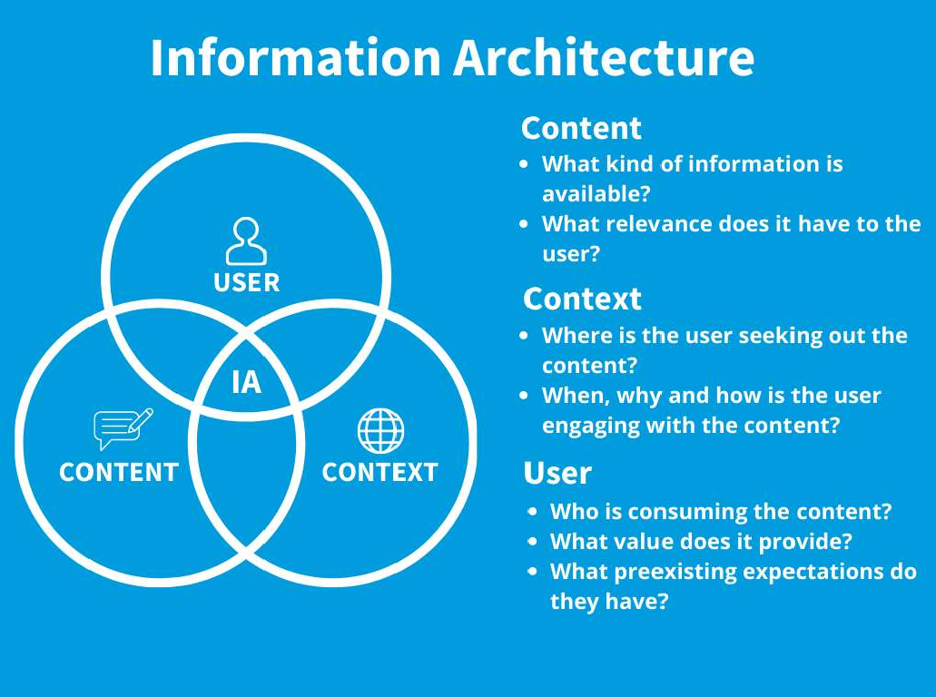

    - Context relates to
business goals, funding, culture, technology, politics,

resources and constraints.
    - Content consists of the document or data types, content objects, volume and existing structures.
    - Users comprise the audience, tasks, needs, experiences and how they seek information.

Key Components of Information Architecture:
Organization Schemes:
    - Hierarchical: Content is structured in a top-down manner, resembling a tree-like structure with parent and child categories.

    - Sequential: Content is organized in a linear sequence, suitable for guiding users through a process or a story.
    - Matrix: Information is organized using multiple dimensions, allowing users to view content based on various categories simultaneously.

Navigation Systems:
    - Global Navigation: Primary menus or navigation bars that provide access to main sections of the website.
    - Local Navigation: Sub-menus or links specific to sections, guiding users within a particular category.
    - Faceted Navigation: Allows users to filter content based on multiple attributes, refining search results.

Labeling Systems:
    - Descriptive Labels: Clear and meaningful names for categories and links, aiding users' understanding of content.
    - Consistent Terminology: Ensures uniformity in naming conventions, preventing confusion among users.
    - Informational Labels: Provide additional context or explanations, especially for complex terminology or industry-specific terms.

Search Functionality:
    - Search Bar: Allows users to directly search for specific content or products, providing an alternative navigation method.
    - Search Results Page: Displays search results clearly, allowing users to refine queries or explore related topics.

Site Maps and Wireframes:
    - Site Maps: Visual representations of the website's structure, showing the hierarchy and relationships between pages or sections.
    - Wireframes: Low-fidelity representations of web pages, outlining the layout and placement of elements without detailed design.

Importance of Information Architecture:
Enhanced User Experience:
    - Well-organized IA ensures users can quickly find relevant information, leading to a seamless and satisfying user experience.

    - Intuitive navigation reduces frustration, encouraging users to explore the website further.

Improved Accessibility:
    - Clear organization benefits users with disabilities, as screen readers and assistive technologies rely on logical structure and labeling.

Supports Content Strategy:
    - IA aligns with content strategy by structuring information in a way that supports the communication of key messages and objectives.

Boosts SEO:
    - Logical and organized content enhances search engine optimization (SEO), making it easier for search engines to index and rank pages.

Facilitates Scalability:
    - Well-planned IA allows for easy expansion and addition of content over time, maintaining coherence as the website grows.

Facilitates Collaboration:
    - IA serves as a common language between stakeholders, designers, developers, and content creators, ensuring everyone understands the structure and purpose of the digital platform.
In summary, information architecture is a foundational element in web and application design. It focuses on creating a user-friendly, organized, and accessible structure, laying the groundwork for a positive user experience and effective communication of information.
Information Architecture guide for UX designers:
https://www.youtube.com/watch?v=akWDacn5lIA&t=222s

*********************

Information Architecture Design: A Step-By-Step Guide

Information architecture is a discipline that focuses on organizing information within digital products clearly and logically. It helps users answer the question, “Where can I find the information I’m looking for?”

This guide will discuss 10 steps you need to go through to design information architecture for your product.

Step 1: Understand user goals
In product design, it is essential to understand who you are designing for. People look for information in different ways, and different people look for different kinds of information. You need to understand what users are trying to achieve using your product.

You need to find the answer to the questions:

- Who will be using a product?

- What are they going to do?

- What do they want to achieve?

Its vital to invest in user research. Through research, information architects can learn how the target audience thinks when they interact with a product, and this will help them organize the information in a way that meets the user’s needs.

You should create user personas (archetypes of ideal users).

and define the mental models of your users. You need to structure the information based on the mental models. Show exactly what users expect to see at places where they expect to see it.

Step 2: Define business objectives
After identifying user goals, you need to understand how information architecture should help the company achieve business goals. It is better to conduct a brainstorming session with stakeholders to set clear business objectives. You need to identify primary and secondary business goals.

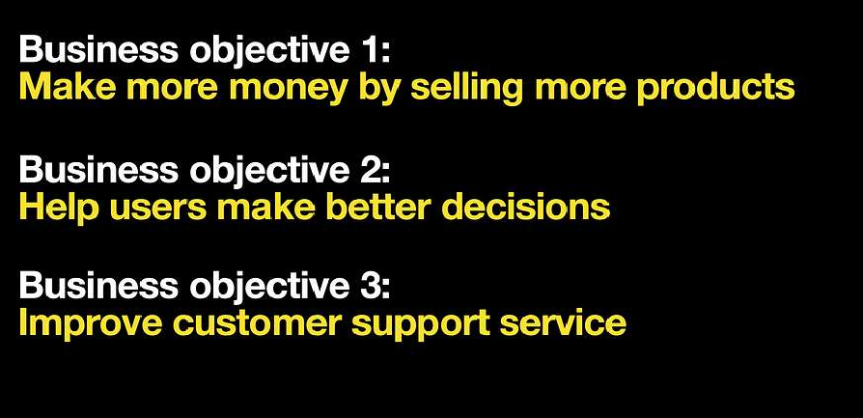

List of the business objectives for eCommerce website.

Step 3: Conduct competitor analysis

After you define user nd business goals, it’s time to conduct competitor
a
analysis. The information architecture design should be base on your users’
d
expectations about your product, and an analysis of similar products available on the market will give you an idea of what your customers expect. Take a look at
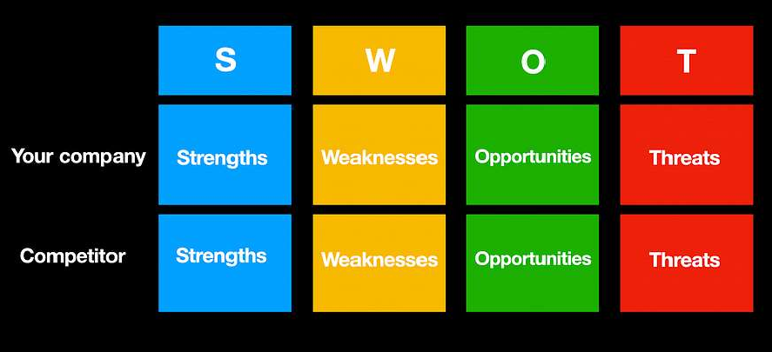what your competitors are doing and conduct a SWOT analysi : your goal is to
s
identify the strengths and weaknesses of the content organization that your
competitors have. It will elp you to identify opportunities that you can explore.
h

SWOT analysis.

Step 4: Define content
Next, you need to define your content. Information architects should have a good understanding of the content that the product offers. If you are redesigning an
existing product, you should conduct content inventory first. B low you can see
e
a template for a content inventory spreadsheet for websites. It typically includes

page ID, page level in description.
the hierarchy, URL, content type,
keywords, and

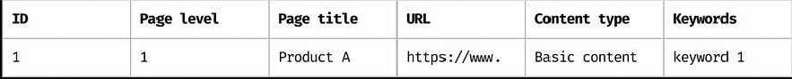

Content inventory spreadsheet for a website

Collect all content that
our product has and then conduct a
content audit —

decide what you want to eep and remove (based on user and business needs).
y
k

Step 5: Categorize & prioritize content

Then you need to categ
o
rize and prioritize content. You nee
to decide what

content should go on the website. Categorize content and group similar content
d
together to create logical chunks. Web analytics tools like Goo le Analytics and
g
techniques like card sorting and contextual inquiries will help you learn how to structure content.

Here is how a card-sorting exercise works. Suppose you desig an e-commerce
n
website that sells electronics. You write items on cards, define certain categories, and ask test participants to sort cards into categories.
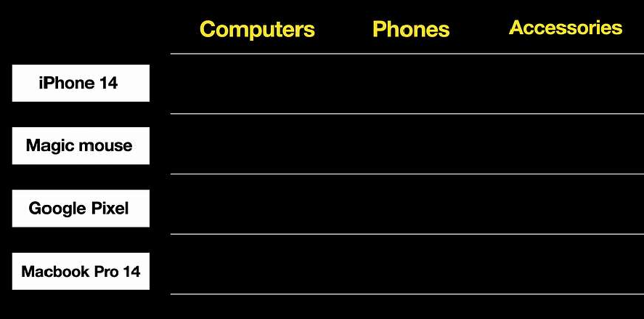

Card sorting: cards (white blocks) and categories (yellow text).

And test participants will group the items according to the categories. It is also

possible to leave categories open-ended so participants can categories that make sense to them.
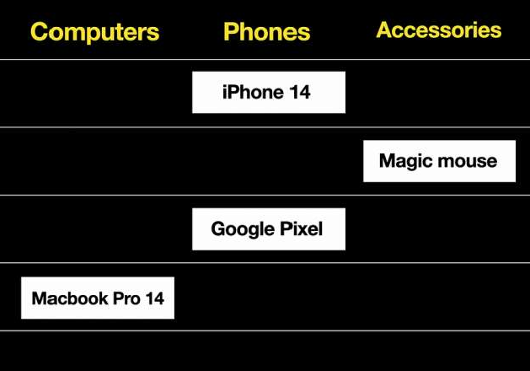
Results of card sorting.
create their own

Step 6: Create a sitema
p
Based on the content gr

ups you’ve established in the previous step, you can
o

create a sitemap, a visual representation of the content available on your website
or in your app. The site ap contains parent and child pages. It helps us see the
m
hierarchy of content and structure of the overall website or app — what leads to what.
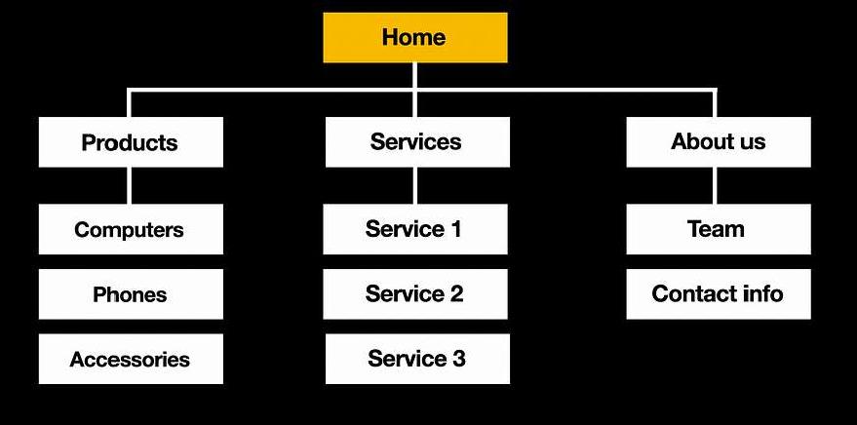

A sitemap for an eCommerce website that sells electronics.

A sitemap should not be fancy; you can create it using tabs like in the example

below. This format works well when you need to communicat other people.
e
the structure to

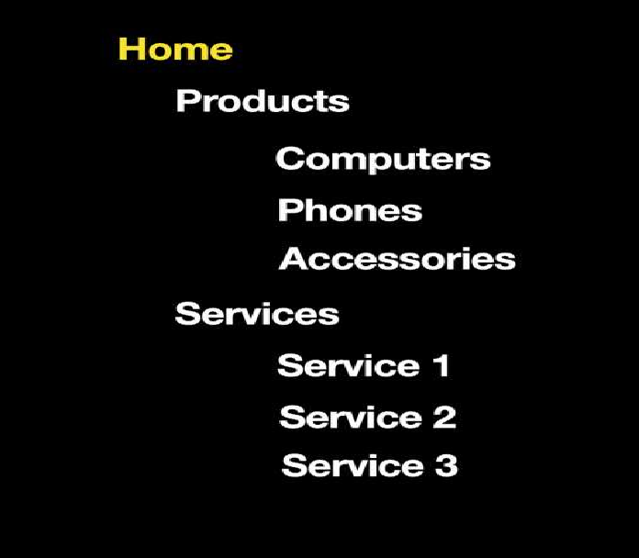

Sitemap in a format of tabs.

Labels will help people orient themselves on your website. A label can be a page name, the name of a category in the menu, or a section name. Labels tell users what they can expect when they choose a particular option. For example, when users see a category with the label ‘Macbooks’, they think that when they click this category, they will navigate to a page with MacBooks.

You want to ensure that labels are clear and concise so that users can understand their meaning at a glance.
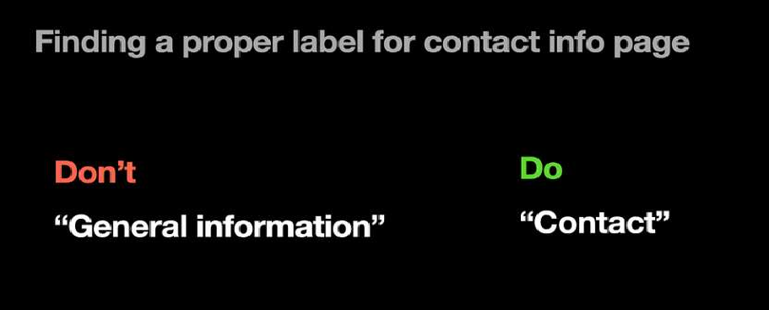
Finding a proper label for the contact info page.

Step 8: Design navigation system & user flows
Next, you need to outline the navigation system and user flo system will help you understand how users will navigate fro
w
m

s. A navigation A to B. It will

make it evident how content on your product is interlinked and how users will

navigate from one page
to another. A navigation system will
include menus,

breadcrumbs, and internal links. Your goal in this step is to establish all possible pathways users can take to navigate a particular page.
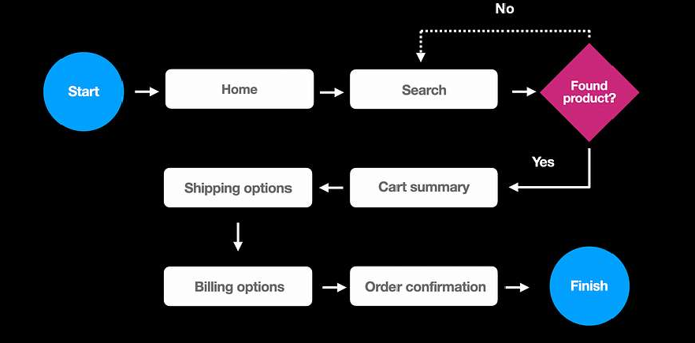

User flow example for eCommerce website.

Step 9: Prototype user flow
The goal of creating a prototype is to define a visual hierarchy of content on

individual pages and see
how different pages work together.
Visual hierarchy

defines the order in whi h users will explore the content on individual pages.
c
You need to ensure that the visual hierarchy you have helps users achieve their goals and, at the same time, increase your conversion rate.

Usually, IA architects create clickable wireframes that have a limited number of

graphic elements because it is enough to demonstrate t information and navigation.
h
e hierarchy of

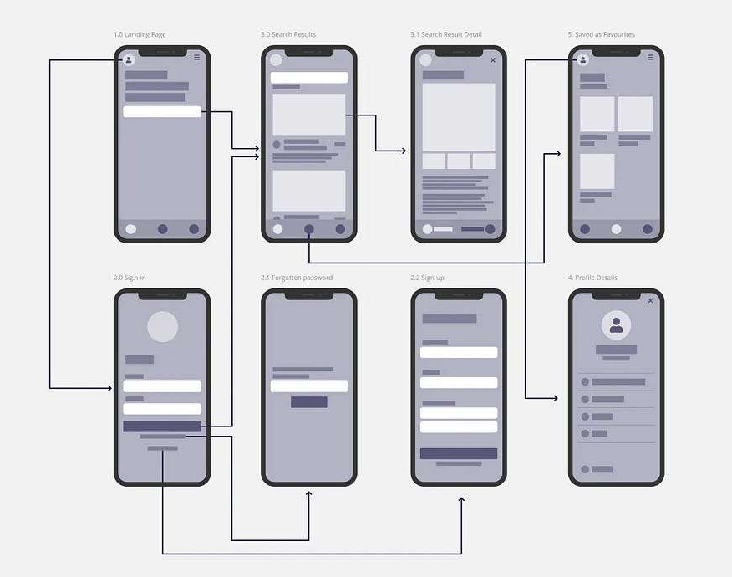

Clickable wireframes.

Step 10: Validate your design
You need to conduct usability testing to ensure your users can go through your
system to complete their tasks. Prepare a set of tasks, in ite people who
v
represent your target audience, and let them complete the tasks using your
design. For example, if y u design an eCommerce website, the task can be “Find
o
a laptop that you like and buy
it.”

You also need to define metrics for each task you want to perf rm. Testing will
o
also help you identify where users need more information to make an informed decision.
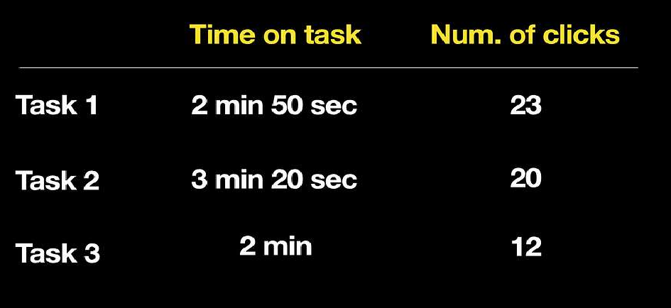
Results of usability testing.

Conclusion
Information architecture

creates a foundation for efficient

user experience.

Content is the heart of every product. Well-organized content will help your
e
users interact with your app or website, leading to a great experience.

