A REPORT ON TECHNICAL EVENT
PAPER PRESENTATION
PAPER PRESENTATION was organized by the Department of Science and Humanities on 10th March 2023. First year students and students from external colleges are participated in this event.
The Paper Presentation was coordinated by Dr.P.Sivagami
(S&H BLOCK) from 9.30  11.30 AM
And witnessed by all the faculties of the Department of Science and Humanities

PAPER PRESENTATION was Judged by Dr.Dhamotharan (Mech Department) Dr.P.Sivagami. Best two were selected as winner and runner out of 15 Teams. The winner and runner was presented with winner and runner certificates and also was awarded with a Trophy .
This event was conducted to exhibit their talent in Paper Presentation
~ ~ ~ ~ ~ ~ ~ ~ ~ ~ ~ ~ ~ ~ ~ ~ ~ ~ ~ ~ ~ ~ ~ ~ ~ ~ ~ ~ ~ ~ ~
STUDENT CO-ORDINATORS DETAILS :
S.NO | STUDENT NAME | SECTION/BRANCH
1 | Shrujana | AI&DS
2 | Shinee | AI&DS
3 | Ashwin | CSE
4 | Abisolin | CSE
5 | Sham Benial | IT

~ ~ ~ ~ ~ ~ ~ ~ ~ ~ ~ ~ ~ ~ ~ ~ ~ ~ ~ ~ ~ ~ ~ ~ ~ ~ ~ ~ ~ ~ ~ ~ ~ ~ ~

PAPER PRESENTATION DETAILS :
S.NO | PARTICIPANTS | TOPIC
1 | Yuvaraja Kumar  Yagnesh | Application of Artificial Intelligence&  cyber secuirity
2 | Subbu Karthik  Pranav Kumar | Covid-19 insights
3 | Melvin  Syed Basha | Recent devolopment in E-vehicles
4 | Nebinng  Suriya Prasad | Application of Artificial Intelligence&  cyber secuirity
5 | Senthil Velan  Keerthi Vasan | Recent devolopment in E-vehicles
6 | Sowmiya  Maria Rejo | Global warming and mordernisation
7 | Bernice Matutina  Danisha | Application of Artificial Intelligence&  cyber secuirity
8 | Akshaya  Aaron Shany | Challenges of mordern society
9 | Darenthiran  Vishal | Application of Artificial Intelligence&  cyber secuirity
10 | Karishmma  Joshna Mariya | Covid-19 insights
11 | Agnes Vinoliya  Megha | Covid-19 insights
12 | Surveshwaran  Karingan | Covid-19 insights
13 | Praveen  Nithesh Balaji | Recent devolopment in E-vehicles
14 | Ashwin  Harish | Challenges of mordern society
15 | Judah | Challenges of mordern society
16 | Monika.S Sharmila. C | Application of Artificial Intelligence&  cyber secuirity

~ ~ ~ ~ ~ ~ ~ ~ ~ ~ ~ ~ ~ ~ ~ ~ ~ ~ ~ ~ ~ ~ ~ ~ ~ ~ ~ ~ ~ ~ ~
Winner of Paper Presentation :
Monika.S & Sharmila. C -Agni college of Technology
Runner of Paper Presentation :
Shinee Rakshitha & Shrujana - Jeppiaar Engineering College

~ ~ ~ ~ ~ ~ ~ ~ ~ ~ ~ ~ ~ ~ ~ ~ ~ ~ ~ ~ ~ ~ ~ ~ ~ ~ ~ ~ ~ ~ ~
WINNER:
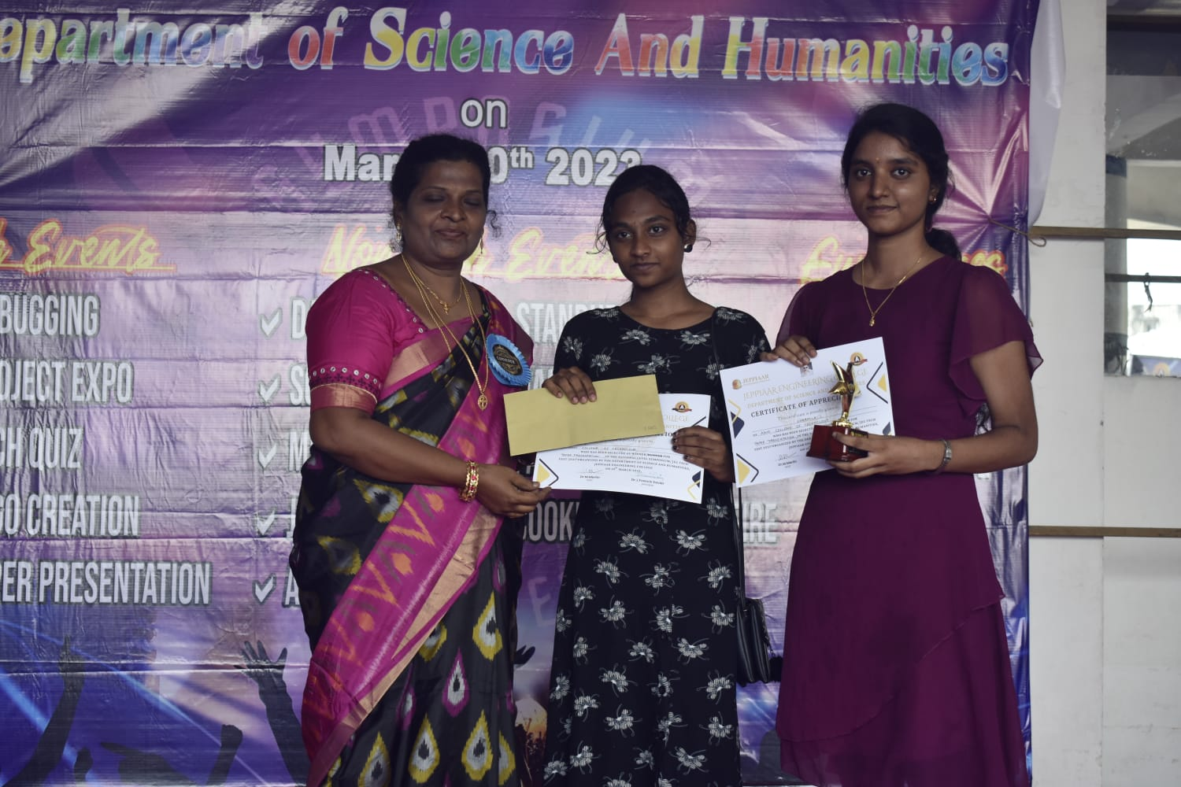

RUNNER:

