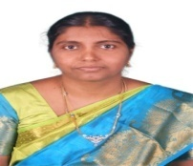

STAFF DETAILS

|  |  |  |
| --- | --- | --- |
| Staff Name | : | Dr. ANITA TITUS |
| Faculty ID | : | 10601 |
| Date of Joining | : | 18.06.2018 |
| Designation | : | PROFESSOR & HEAD OF THE DEPARTMENT |
| Qualification | : | M.E., Ph.D |
| Teaching Experience | : | 28 Yrs. |
| Area of specialization | : | Medical Image Processing |
| Subjects handled | : | Circuit Analysis, Electron Devices, Linear Integrated Circuits, Digital Electronics, Digital Principles and System Design, Communication Engineering, VLSI Design, Antenna and Wave Propagation, Satellite Communication, Digital Image Processing, Testing of VLSI, ASIC Design. |
| Journals published | : | 8 |
| Conference / workshop attended | : | 12 Conferences / 15Workshops |
| Patent details | : | 2 |
| Awards & Achievements | : | Best Coordinator Award 2017 by ICT Academy Tamilnadu (State Level)  Dr. Abdul Kalam Award for Teaching Excellence  Dr. Radhakrishnan Award for Imparting Knowledge  100 % results in Satellite Communication, Testing of VLSI and ASIC Design |